Abstract

Word count = 9059

Advik Chitre 02019365

Ben Smith 02086844

Cameron Wade 02050631

David Cai 02019587

Digo Yu 02024612

Mengjie Zhang 02041373

Michael Yau 02106869

Xudong Tong 01853786

Imperial College London

May-June 2022

EEERover

EEE1 Electronics Design Project ELEC40006 Dr Edward Stott

A remotely controlled device is required to navigate an artificial environment so that it can detect and identify rocks. There are six types of rock, but they are not distinguishable by appearance. They do however, each emit a unique combination of up to 2 signals, including modulated radio, acoustic, magnetic, and infrared signals.

There is a budget of £60 for the rover. The set of sensors used should be chosen to maximise efficiency and reliability. Weight is also important as there is a transport cost in the scenario.

A prototype should be produced and assessed within the artificial environment in the lab during a competition where the total time to detect all rocks is the main factor.

The project brief can be viewed in Appendix A: Project Brief.

# Specifications

The various properties of each rock were given as shown in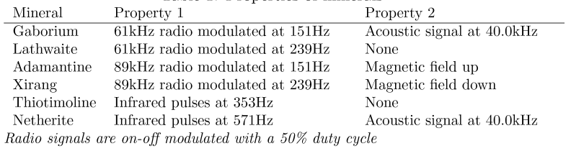 *figure 1*.

*figure 1 - rock properties* [1]

It is also stated in the project brief that the design will be assessed based on the following criteria:

* Correct identification of all mineral types
* Weight and cost effectiveness
* Manoeuvrability
* Robustness and reliability
* Intuitive and easy-to-use remote-control interface

These were used as guidelines when selecting components and making design choices.

Contents

Specifications 1

Summary of strategy 3

Expansion Kit Breakdown 4

Project Management 5

Sensors 6

IR 6

How It Works 6

Amplification 8

Final Design 10

Radio 12

Theory & Initial Design 12

Final Design 15

Testing 17

Ultrasonic 18

How It Works 18

Amplification 19

Final Design 21

Magnetic 22

Power 24

Battery 24

Power Distribution 25

Drive 25

Motors 25

Motor Driver 26

CAD 27

Design summary 27

Iteration 1 27

Iteration 2 28

Iteration 3 30

Electronics Mounting 30

Programming 32

User Interface 32

Control 34

UDP implementation 38

Sensor Rock Identification 39

Final Build & Overall Testing 40

Conclusions & Future Work 43

Bill of Materials 45

Appendices 46

Appendix A: Project Brief 46

Appendix B: analogue_average Flowchart 51

Appendix C: analogue_standard_deviation Flowchart 52

Appendix D: analogue_frequency Flowchart 53

Appendix E: Identify Algorithm Flowchart 54

Bibliography 55

Table of Figures 56

# Summary of strategy

A modular design was thought best since the components could be made separately, and problems would be easier to diagnose. Modularity also meant the construction of the rover could be easily split between the group, so different systems could be worked on in parallel.

The strategy was to design and test all 4 sensors individually. Once satisfied, they would be finalised on stripboard for compactness and integrated into the rover. The finalised circuits would be mounted on the rover using custom 3D printed brackets.

After selecting the motors, a chassis which would have space for all the components while ensuring cost and weight effectiveness was designed. This could then be laser cut or 3D printed depending on the design.

Once all the components were tested, they could start to be connected and tested further. This would be repeated this until the whole design was constructed. At the end, final testing would be done before the competition.

# Expansion Kit Breakdown

An expansion kit of components was provided on top of the lab-in-a-box that had been received previously. Despite not using all of it, the contents of the kit are documented below:

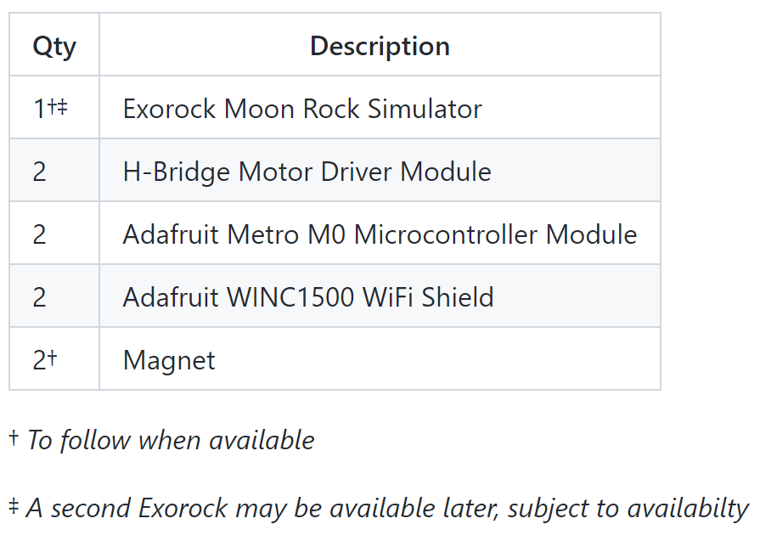

**Exorock Moon Rock Simulator**

An example rock allowed evaluation of the constructed sensors to ensure that they would work in a similar environment to the testing. The rock casing would attenuate the signal so having a sample rock ensured that there was a realistic signal to analyse.

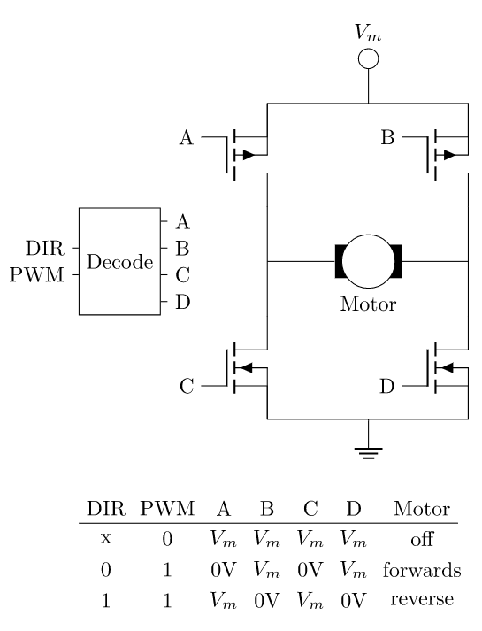

*figure 2 - contents of expansion kit*

**H-Bridge Motor Driver Module**

A motor driver decodes the control for one motor, with inputs DIR which controls the motor direction and PWM which is a square wave of which the duty cycle can be varied to change the motor speed. The inputs can be connected to the outputs of the Metro board.

**Adafruit Metro M0 Microcontroller Module**

A microcontroller is a board which has one or more CPUs and programmable memory. This microcontroller is an embedded computing platform based on the ARM M0 microcontroller and compatible with Arduino IDE. It is programmed in C++. It has both digital inputs and outputs, can convert digital inputs to analogue outputs and can output a PWM signal which the motor driver needs. The logic level of the board is 3.3V.

*figure 3 - motor schematic*

**Adafruit WINC1500 Wi-Fi Shield**

The Wi-Fi Shield connects to the M0 microcontroller and allows for connection to a wireless network. This enabled wireless connection to the microcontroller and hence control of the rover.

**Magnet**

The magnet, like the example Exorock, was given so that the magnetic sensor could be tested. The poles of the magnet were known so the sensor could be calibrated.

# Chart, treemap chart Description automatically generatedProject Management

To start, a When2meet event [2] was created, and everyone filled in their availability. This showed that the best times were during the afternoons, apart from on Wednesdays. The initial plan was to meet 3 times a week (Tuesday, Thursday, and Friday), but this changed depending on how much needed to be done, and whether it needed to be done in person.

To organise the documentation and files, a shared OneNote notebook was created where updates to parts of the project were written when progress was made. There was also a shared folder on Fusion 360 which was used to collaborate on designing parts for 3D printing and laser cutting, as well as testing if parts would fit together.

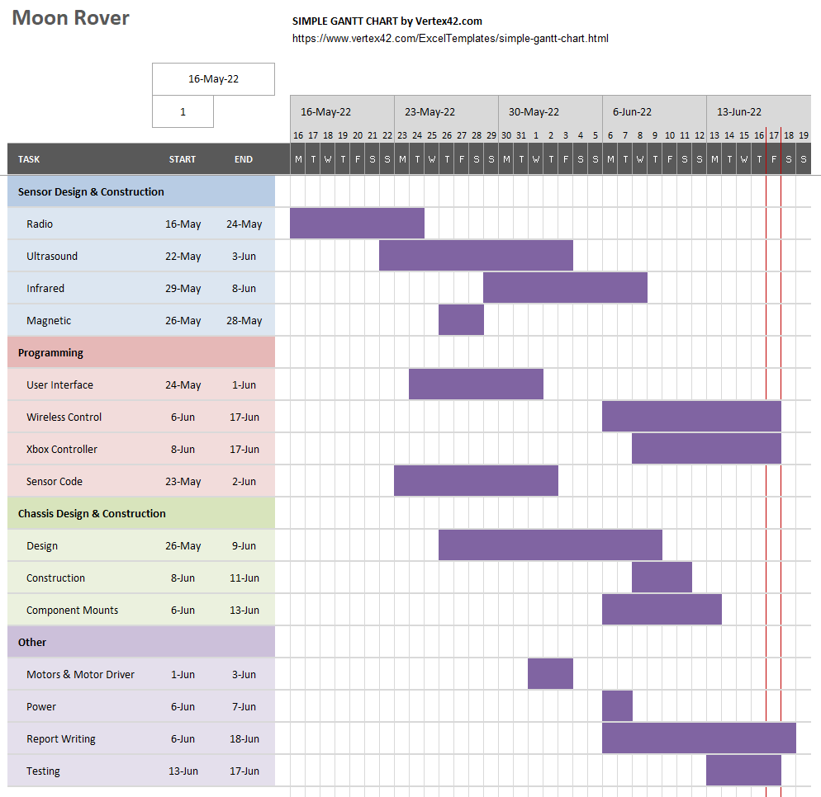

*figure 4 – When2meet table*

*figure 5 - project management Gantt chart*

A Gantt chart was created on excel using a default template [3] to plan what work needed to be done. This chart is shown in *figure 4*. People were then assigned to carry out each task.

# Sensors

While the specification of the project does not require the use of all sensor types to be able to determine all 6 rocks, the decision was made to make all four types of sensor so that rock identification would be more reliable.

If there was enough time, signal multiplexing could be considered to reduce the number of amplifiers used, but since BJT amplifiers are quite small, this is not really an issue.

## IR

### How It Works

The OP593 was chosen as the infrared detection sensor, shown in *figure 6*. This sensor was designed to be sensitive to infrared light around 850nm in wavelength, as shown in *figure 7*. OP593 is a phototransistor containing a black coating which effectively blocks visible light. This reduces noise from the environment.

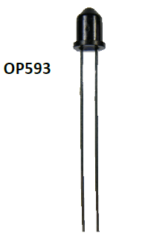

*figure 6 - OP593 infrared phototransistor* [4]

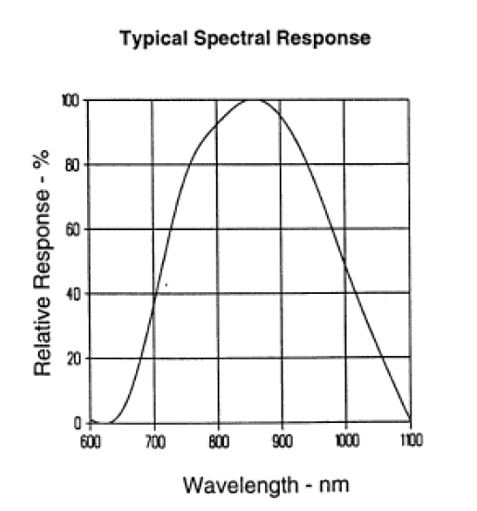

*figure 7 - wavelength response curve from OP593 datasheet* [4]

To obtain the output of this sensor, an emitter follower circuit was designed as shown in *figure 8*. The base voltage of OP593 varies with infrared intensity. It returns a signal when infrared wavelengths are detected.

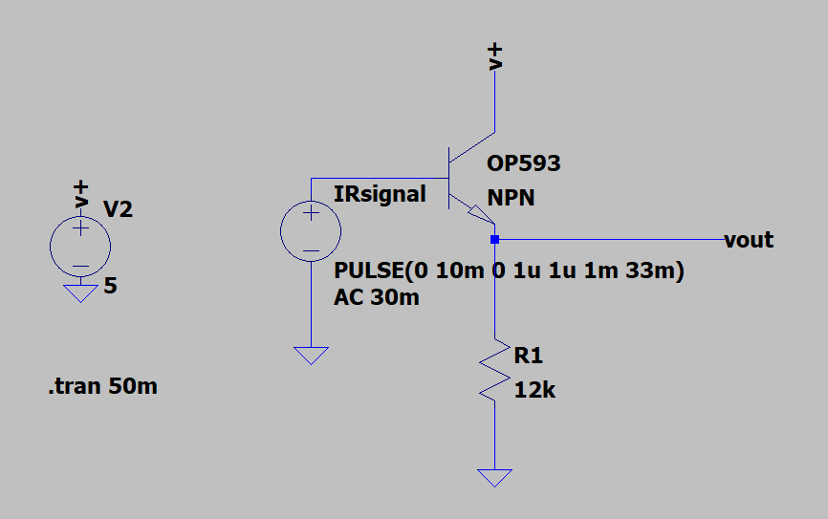

*figure 8 - sensor circuit, the NPN transistor represents OP593 in this case*

A test was carried out with the IR signal source without the shell. The source was set to generate an infrared pulse with 571Hz frequency. The sensor was placed 3cm away from the signal source as shown in *figure 9*. A pulse with 4.245V amplitude and 577.1Hz frequency was received as shown in *figure 10*.

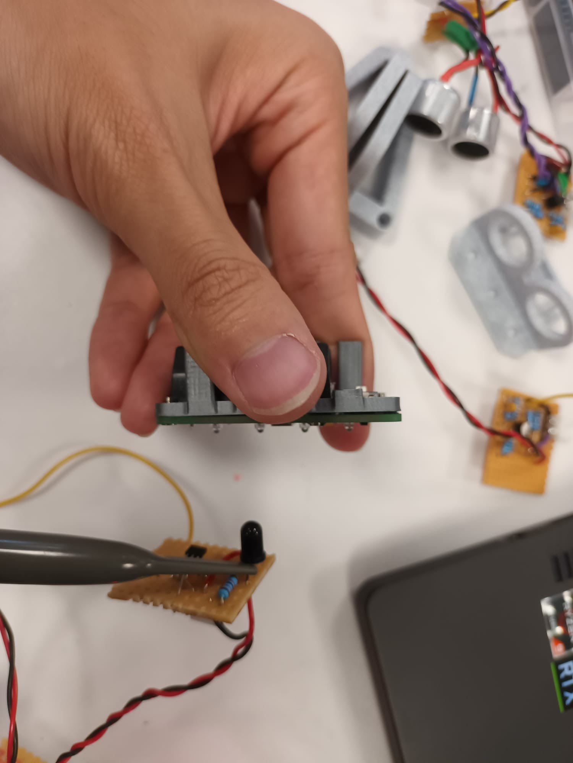

*figure 9 - test with bare signal source*

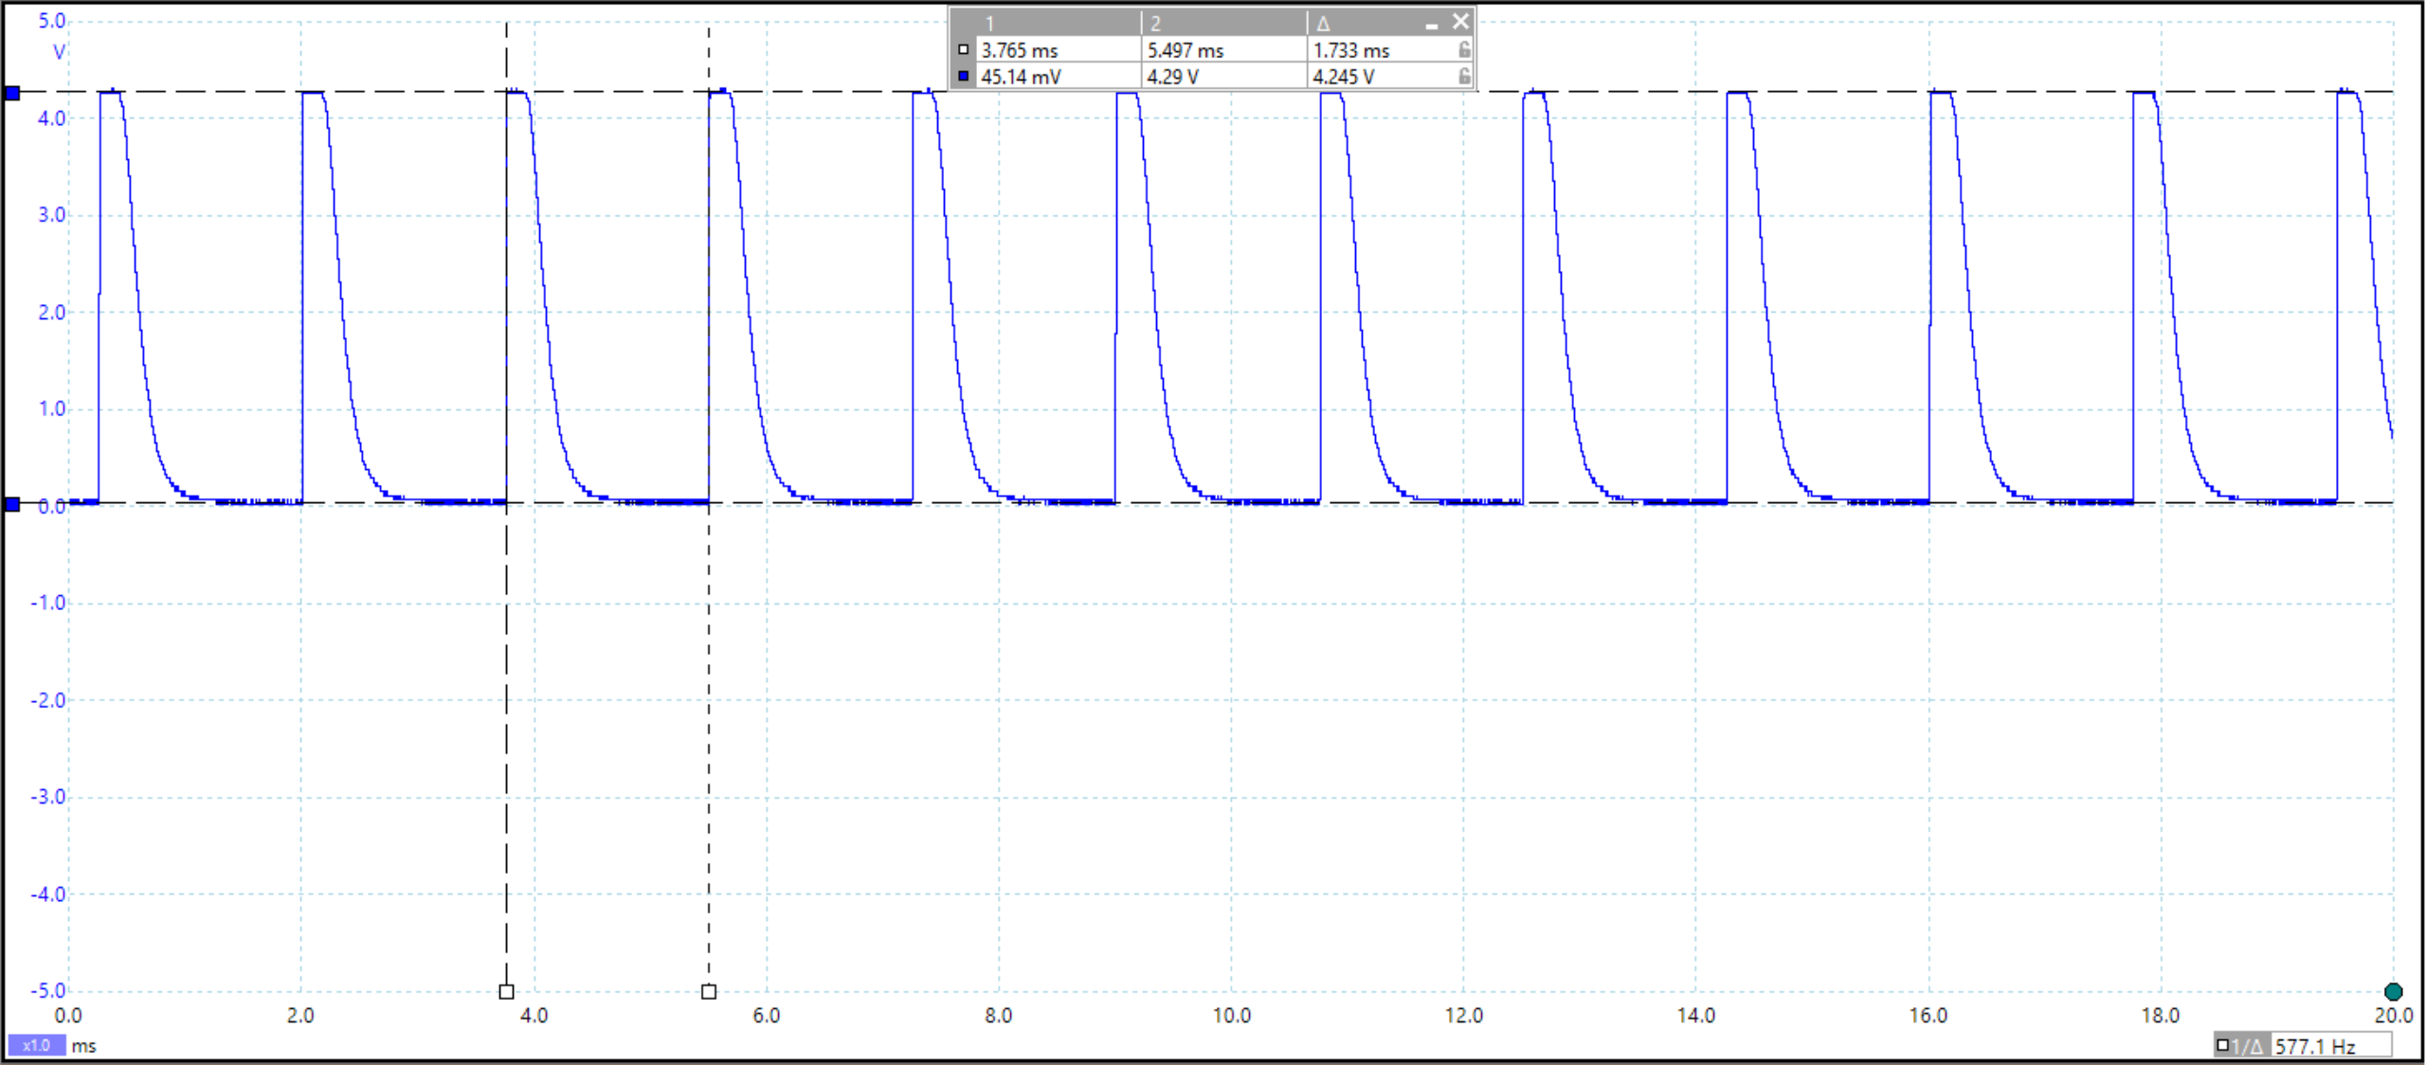

*figure 10 - testing result, 4.245V amplitude and 577Hz frequency*

Another test was conducted with the signal source covered. Note that only specific points in the shell were light transparent as shown in *figure 11*, so the sensor was placed around these areas in this test. The result gave a pulse with 81.58mV amplitude and 563.2Hz frequency as shown in *figure 12*. This was only at a very short range however, so amplification was needed to achieve longer-range detection.

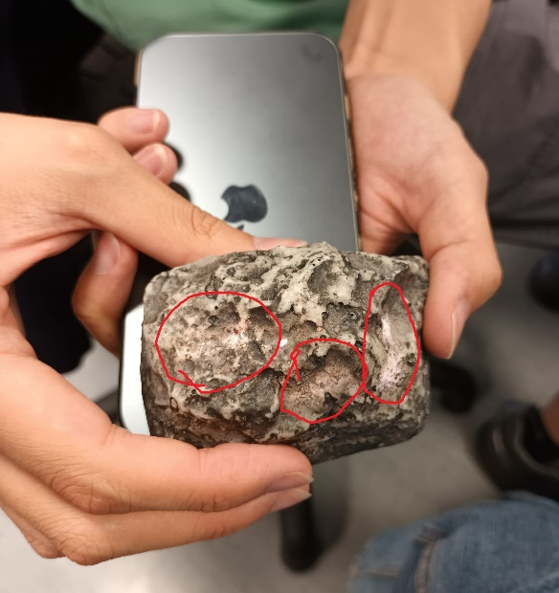

*figure 11 - the rock shell, the circled areas are more transparent*

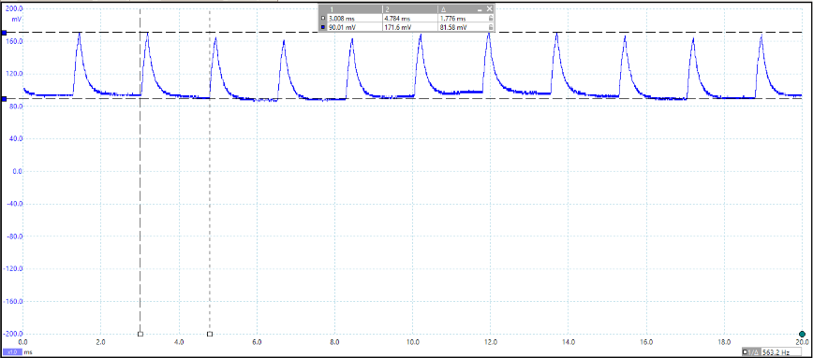

*figure 12 - testing result, signal with 81.58mV amplitude and 563.2Hz frequency*

### Amplification

An amplification circuit was deigned to make the IR detection work from further away. A common emitter (CE) amplifier with emitter degeneration and an emitter bypass capacitor was built. The collector was biased at around 2.5V for equal head and leg room, and the input was capacitively coupled to the base of the transistor. The circuit is shown in *figure 13*. The potential divider was used to limit the output voltage to a maximum of 3.3V so that the Metro board could function properly.

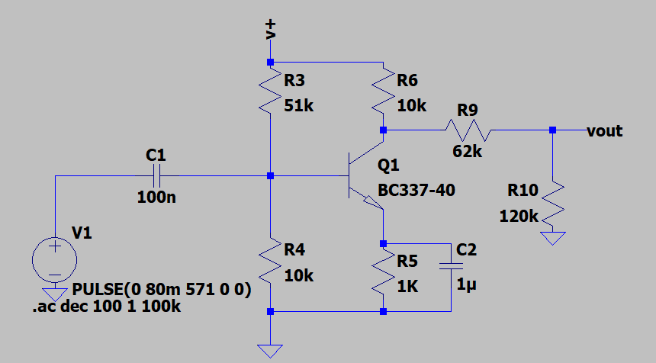

*figure 13 - the amplification circuit for IR detection*

The gain from simulation was about 25dB at the signal frequency as shown in *figure 14*.

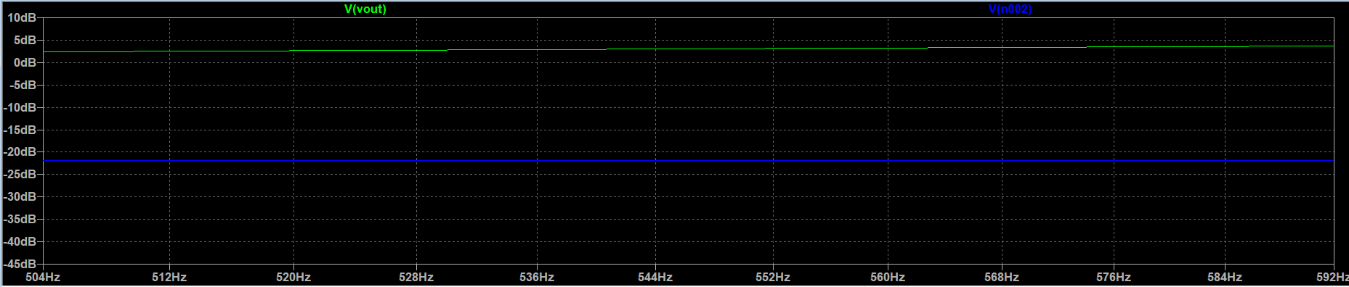

*figure 14 - simulation result, about 25dB at the signal frequency*

Tests were conducted with the circuit on stripboard, and the sensor was placed 2cm above the covered signal source. The output signal was 304.5mV peak-to-peak and 577.1Hz frequency. (As shown in *figure 15* & *figure 16*).

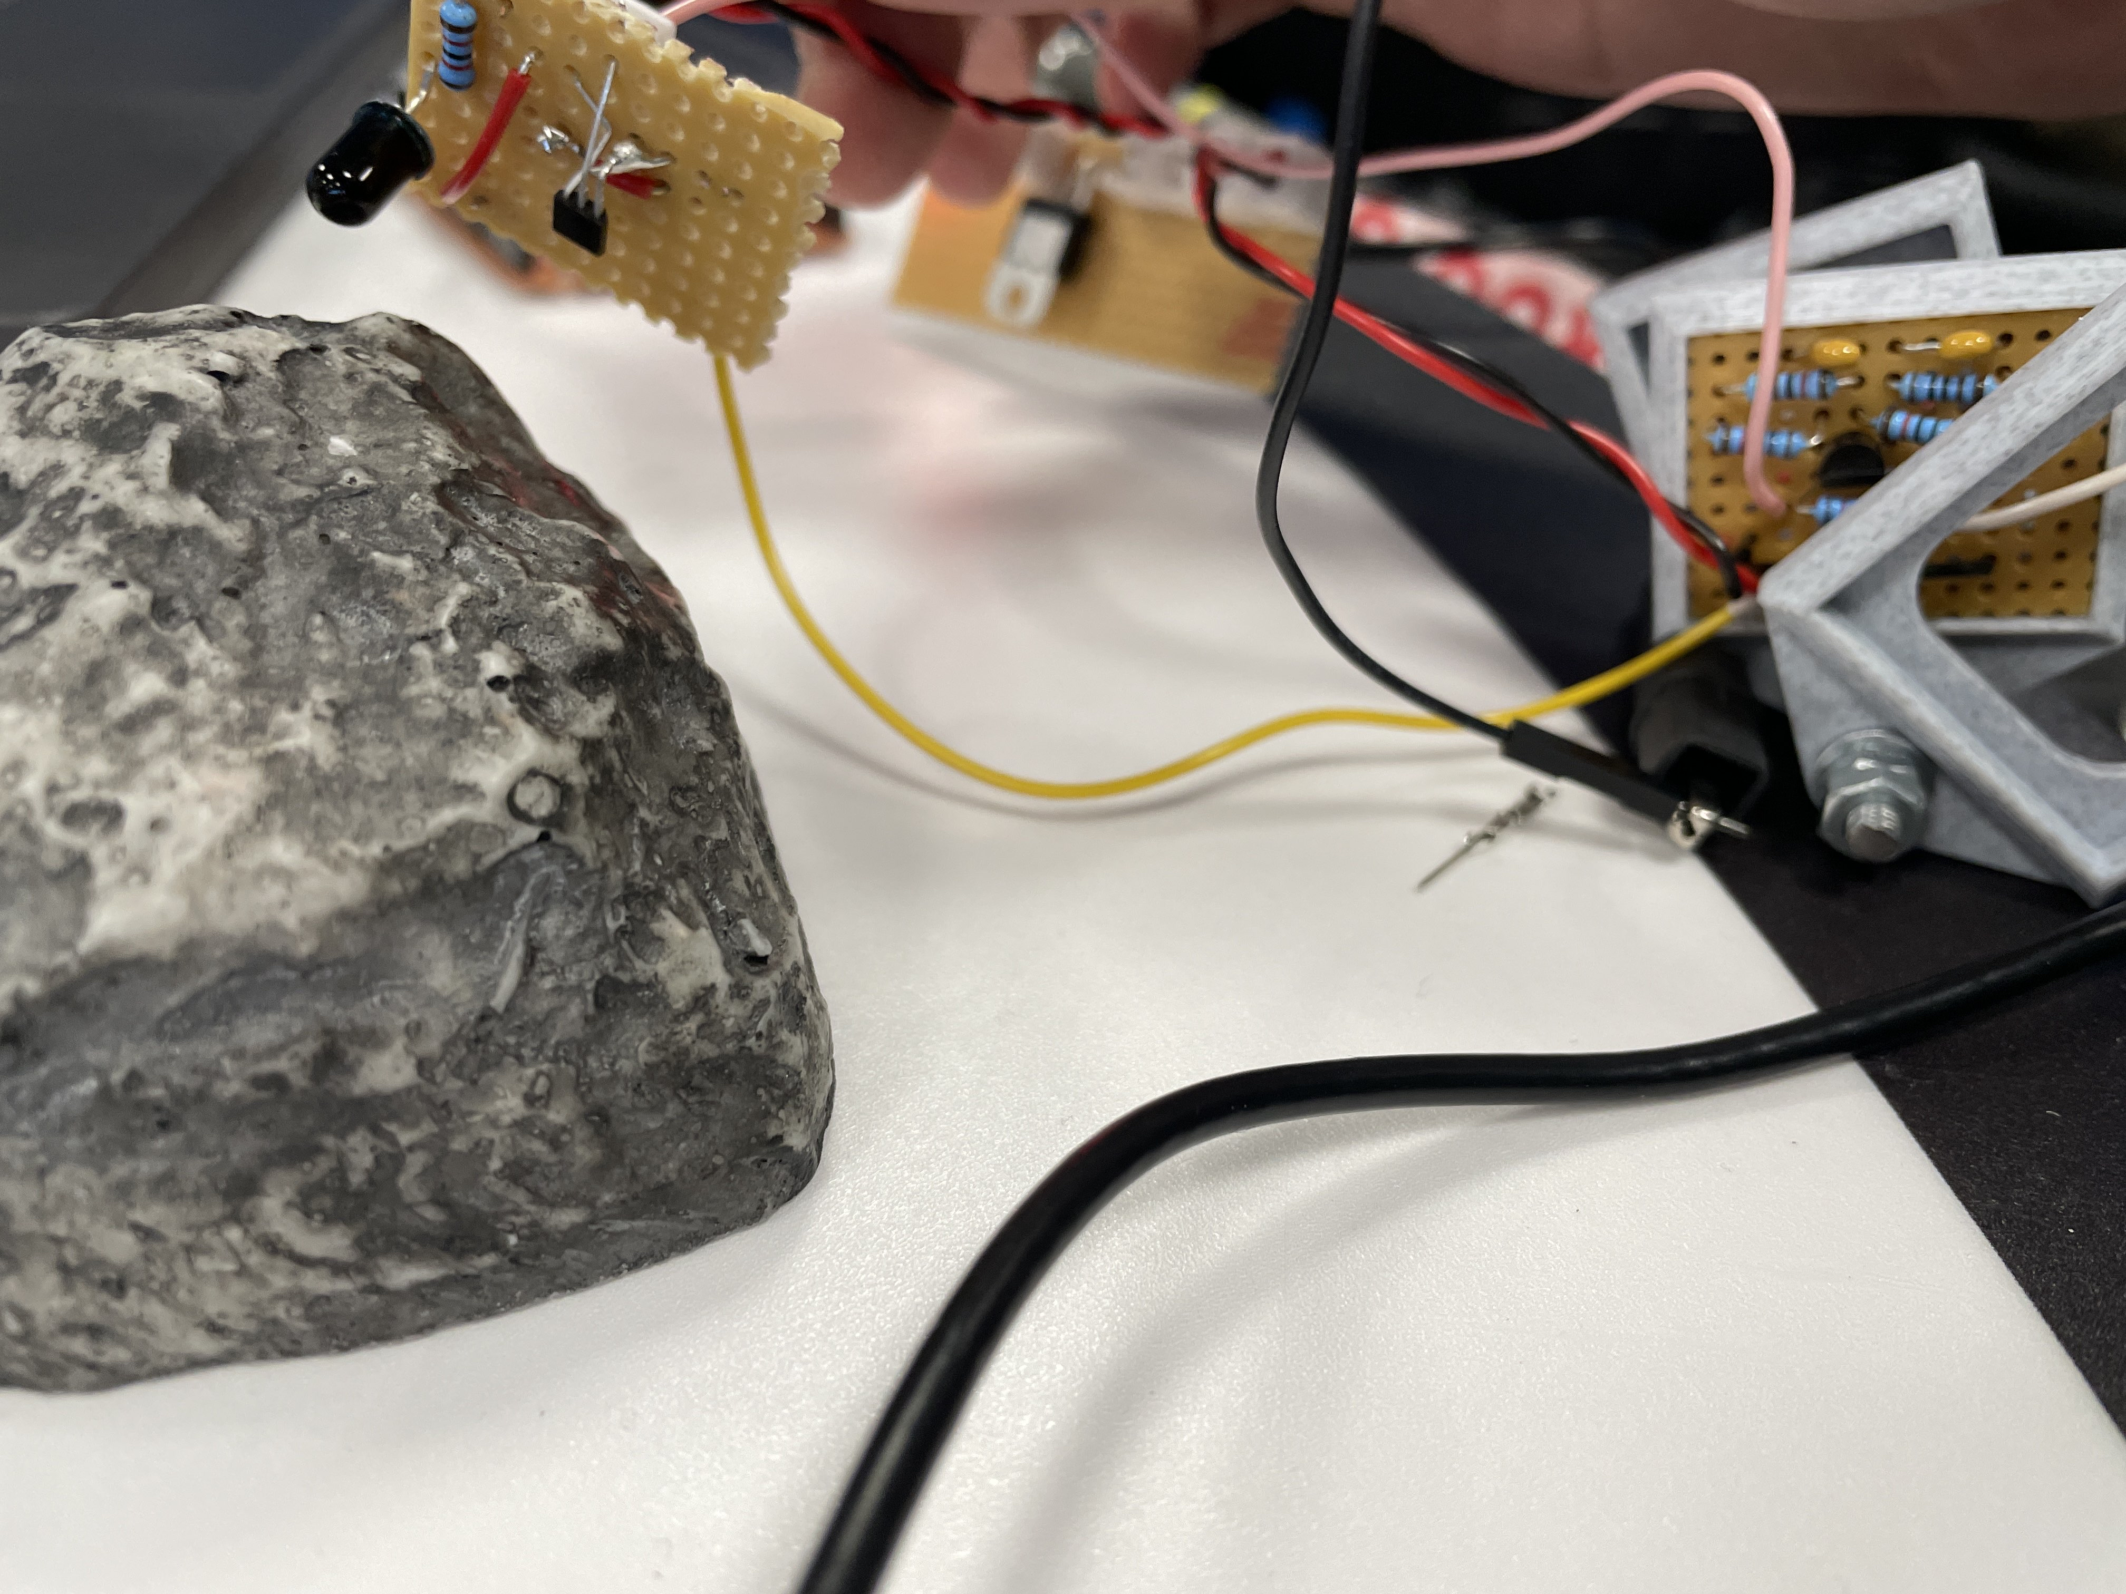

*figure 15 - test using IR sensor after amplification*

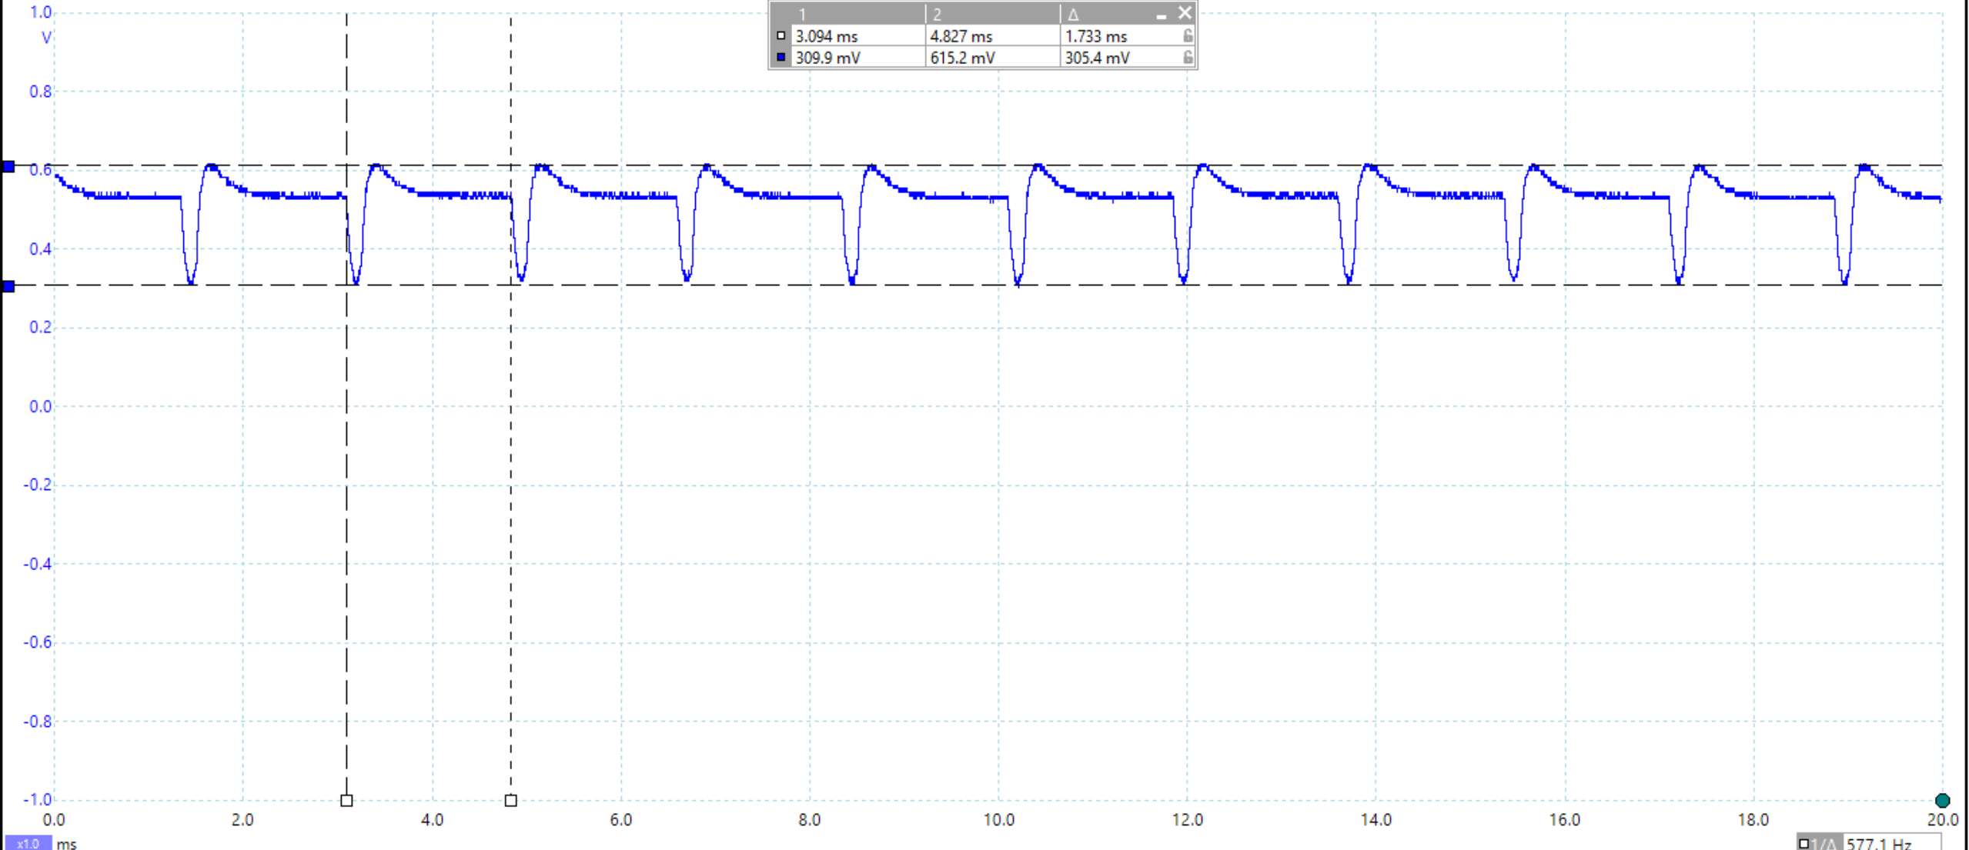

*figure 16 - testing result, signal with 305.4mV amplitude and 577.1Hz frequency*

With a greater amplitude, it was possible to detect and distinguish between IR signals at the two different frequencies using software at a greater range.

### Final Design

A 3D printed mount was designed to fit the IR sensor that had been soldered onto stripboard. In addition, the IR sensor and magnetic sensor were put on the same board to save space as shown in *figure 17*.

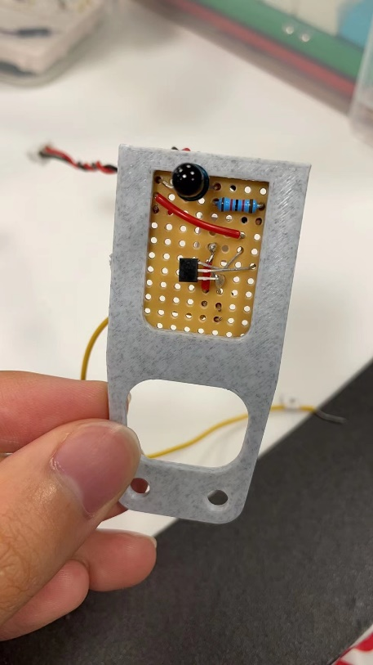

*figure 17 - the mount of IR and magnetic sensor*

The amplified signal is fed into the A5 pin on the Metro. A function was designed to get the type of the rock. The flow chart for this function is shown below in *figure 18*. More details are shown in the Sensor Rock Identification section later.

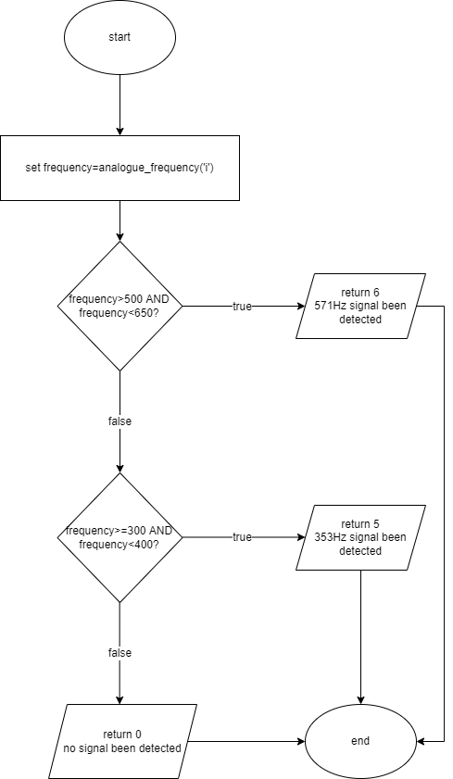

*figure 18 - flow chart for IR_detection*

## Radio

### Theory & Initial Design

The initial plan was to have a coiled wire antenna connected to two tuning circuits, one resonant at 61kHz, and one resonant at 89kHz. Then the signal from the tuning circuits would be amplified and envelope detected and then fed into the analogue pins of the Arduino. The frequency would then be obtained in software. The circuit that was designed is shown in *figure 19*.

The AM signal is generated by multiplying the carrier sine wave (61kHz or 89kHz) by a square wave at the signal frequency (151Hz or 239Hz).

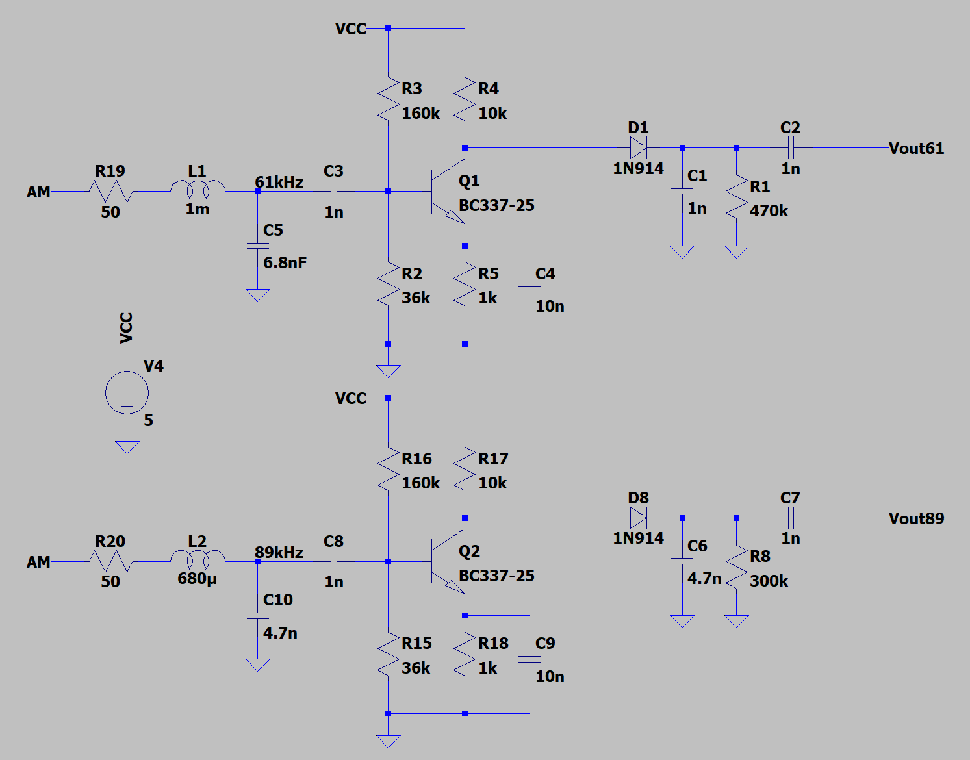

*figure 19 - initial radio circuit*

L1 and C5 (*figure 19*) form the 61kHz tuning circuit, and L2 and C10 form the 89kHz tuning circuit. These circuits have a peak in their frequency responses at the resonant frequency, fr, which can be used to filter out only the carrier frequencies of the two radio waves. fr is calculated using the following formula:

$$f_{r}=\frac{1}{2π\sqrt{LC}}$$

Their frequency response curves are shown in *figure 20.*

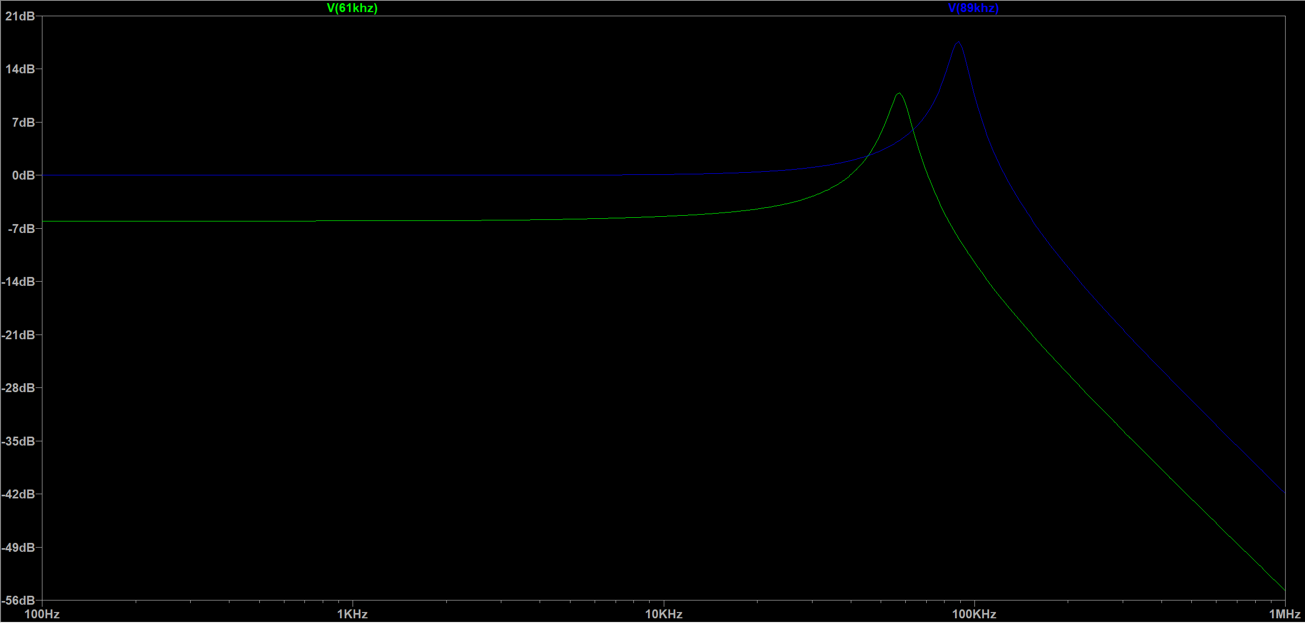

*figure 20 - tuning circuit frequency response curves*

For the amplification stage a common emitter (CE) amplifier (shown in *figure 21)* with emitter degeneration and an emitter capacitor was used to ensure high gain and temperature stability. The input has been capacitively coupled to the base of the BJT. An opamp was not used since the opamp that was available (LT1366) did not work well at frequencies as high as the radio carrier frequency. This circuit has a gain of about 40dB and the output provides the necessary DC bias for the envelope detector.

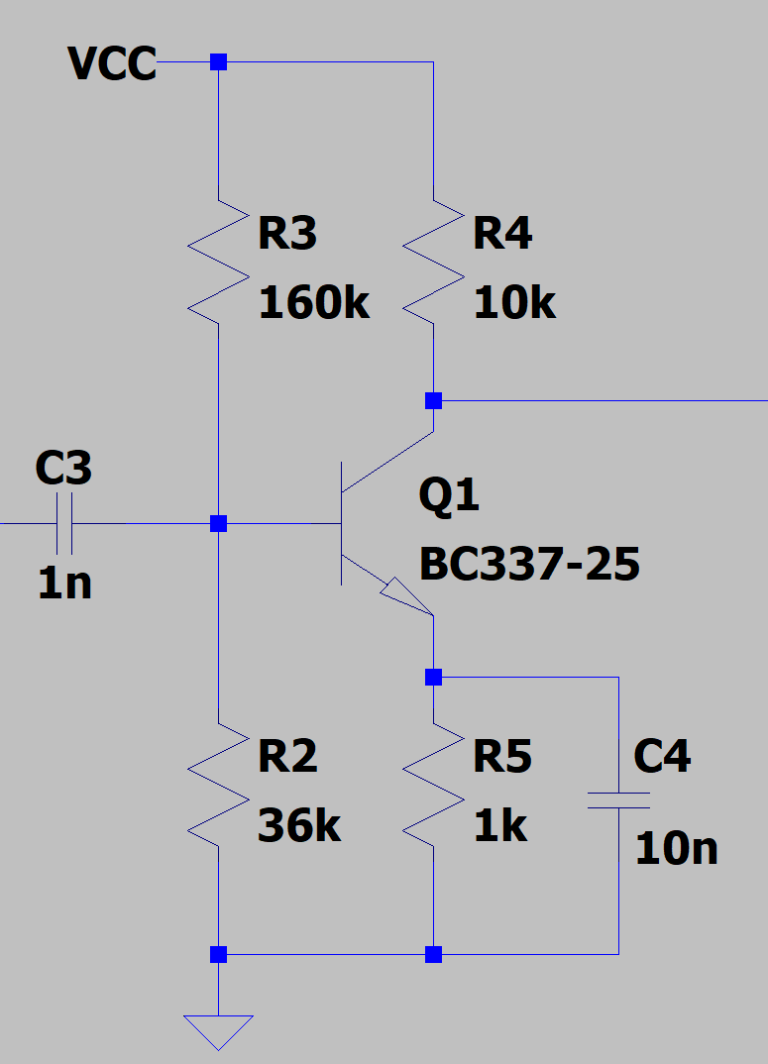

*figure 21 - CE amplifier*

The envelope detector consists of D1, C1 and R1 in *figure 19*, and is identical for both circuits. It was designed based on the diagram shown in *figure 22*.

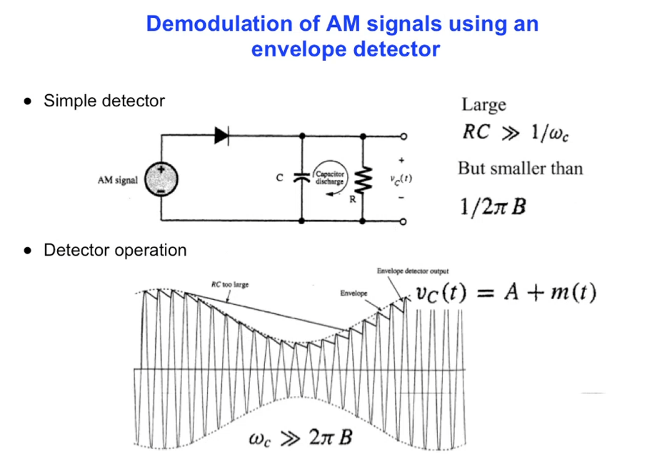

*figure 22 – Lecture Slide* [5]

The output was then coupled using a capacitor to remove the DC bias. The circuit was then simulated at the two different carrier frequencies:

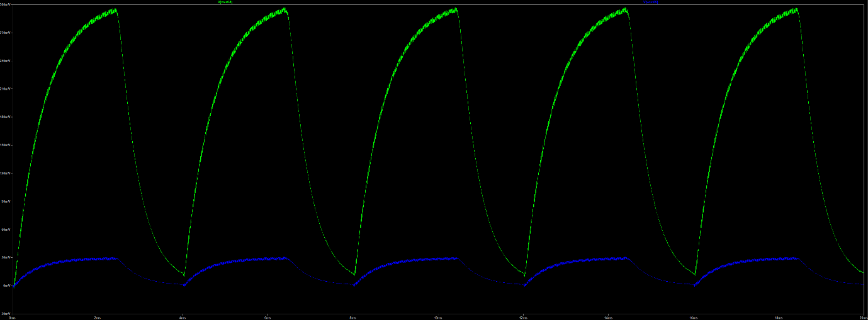

*figure 23 - demodulated 250Hz signal modulated at 61kHz carrier*

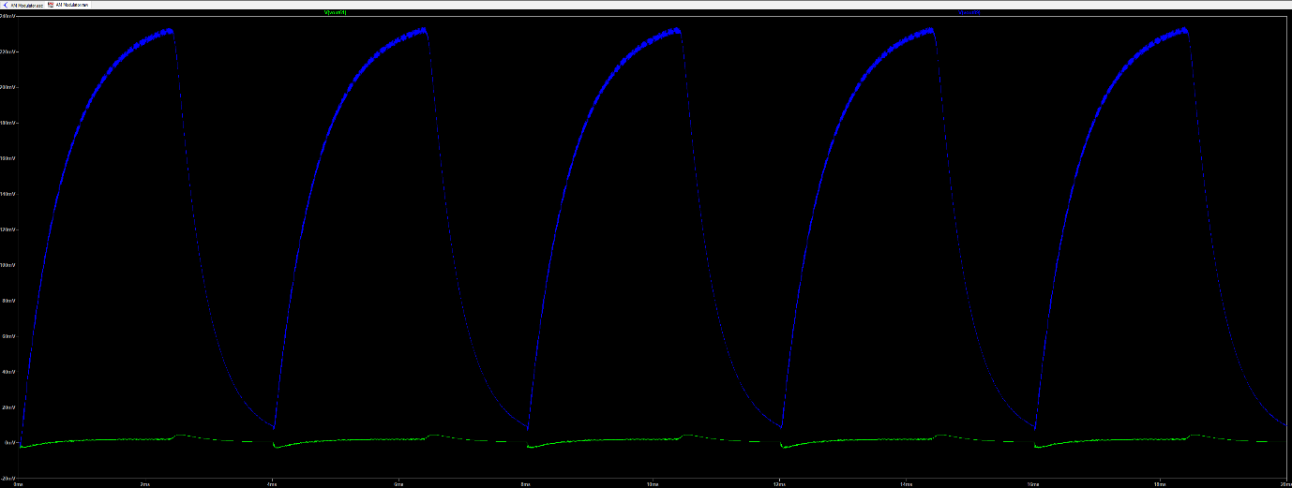

*figure* 24 *- demodulated 250Hz signal modulated at 89kHz carrier*

This show that this circuit works theoretically and as there is a clear signal, software can be used to find the frequency. However, when construction of the circuit was attempted, there were various issues.

### Final Design

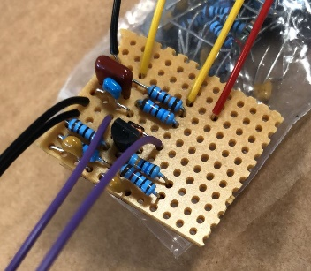The final design for the circuit is shown below in *figure 25*. It uses the same amplifier, and similar envelope detector, but the circuit is only repeated once. Using capacitive coupling to the input of the amplifier was found interfered with the resonance of the tuning circuit. Also, using a standard inductor as the antenna was found simpler than constructing a coiled wire antenna and worked just as well.

*figure 25 - radio circuit on stripboard*

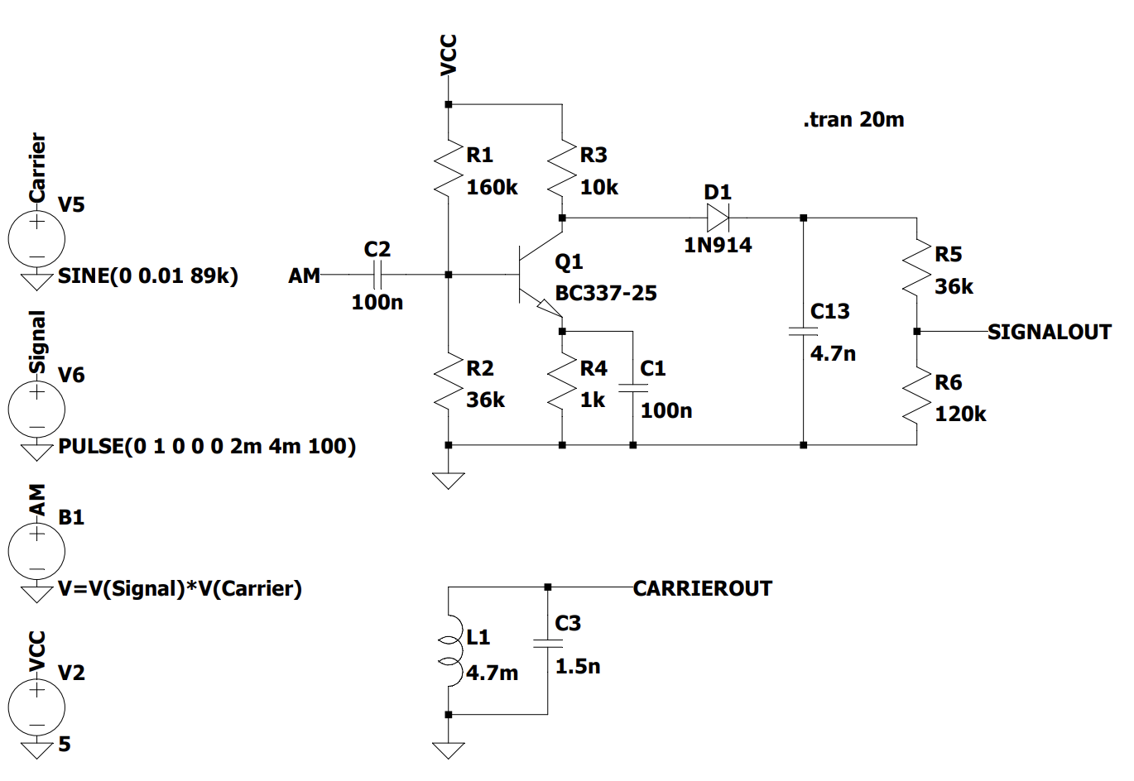The top circuit (*figure 27*) is connected to an inductor that provides the AM signal. This circuit amplifies radio waves at both carrier frequencies and demodulates them with an envelope detector. There is also a potential divider on the end that ensures the output voltage cannot exceed 3.3V.

*figure 26 - final radio circuit*

The lower circuit is resonant only at the 61kHz carrier (fr ≈ 60kHz) so is used to distinguish between carrier frequencies. This can be done since there will be a detectable voltage exclusively for a 61kHz carrier wave.

SIGNALOUT and CARRIEROUT are then fed into the A0 and A1 pins respectively on the Arduino. A function was used to get the signal frequency, and then the type of rock, as shown in *figure 26*. This is expanded upon later in the Sensor Rock Identification section.

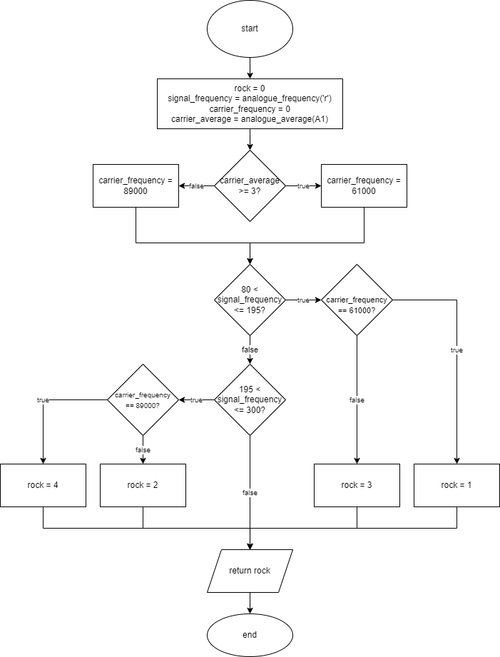

*figure 27 - radio_detect flowchart*

### Testing

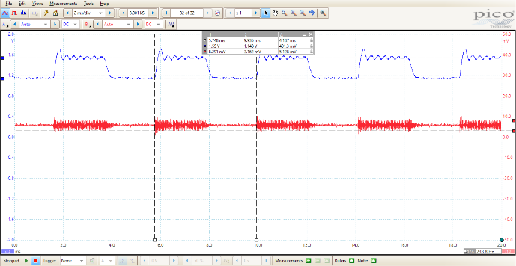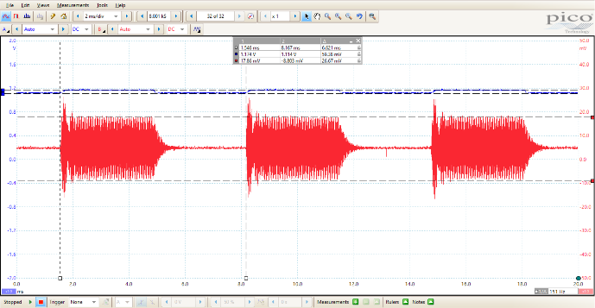

*figure 28 - 239Hz signal modulated at 89kHz*

*figure 29 - 151Hz signal modulated at 61kHz*

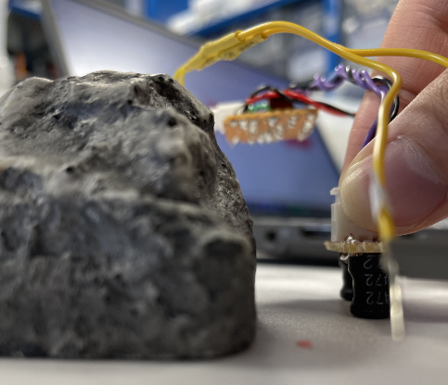The radio detection was tested thoroughly, and the result showed that it has a range of approximately 40mm from the outside of the Exorock and works best when raised to 25mm from the ground. *Figure 28* and *figure 29* show SIGNALOUT (blue) and CARRIEROUT (red) measured on the Picoscope. This data can be clearly interpreted in software and used to reliably determine the rock type.

*Figure 31* shows the carrier frequency in kHz in red and the signal frequency in Hz in blue measured by the Arduino. The spikes in carrier frequency are due to moving the sensor in the middle of the test.

*figure 30 - radio sensor next to the Exorock*

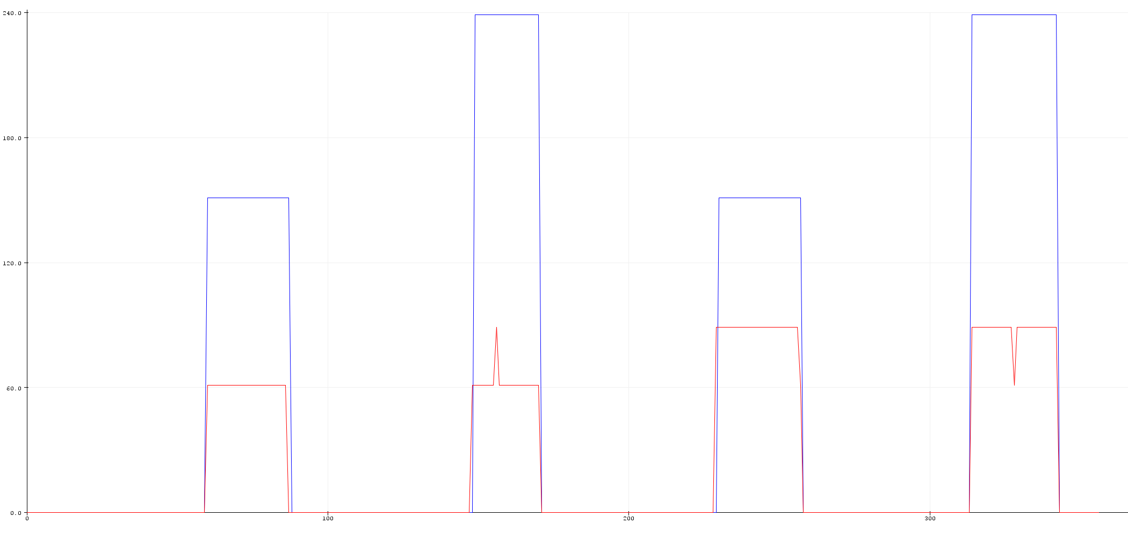

*figure 31 – Metro output*

More tests have been carried out later in the Final Build & Overall Testing section.

## Ultrasonic

### How It Works

For the ultrasonic sensor, the R40-16 was chosen, as shown in figure 32.

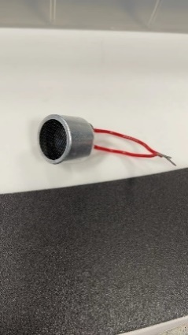

figure 32 - R40-16 ultrasound sensor

This receiver is designed to resonate at around 40kHz, and returns an electric signal when ultrasound is detected at that frequency. This is shown by the peak at around 40kHz in *figure 33*.

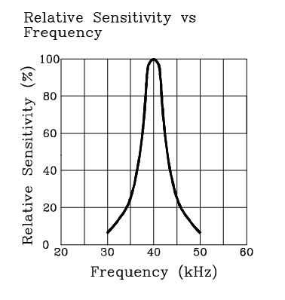

*figure 33 - sensitivity frequency relationship form R40-16 datasheet* [6]

A test with the R40-16 was conducted to determine the properties of the signal generated after detecting 40kHz ultrasound. The sensor was placed 3cm away from the signal source without the shell, as shown in *figure 34*. A sinusoidal signal with 39.9kHz frequency and 48.64mV peak-to-peak amplitude was returned. The results are shown in *figure 35*.

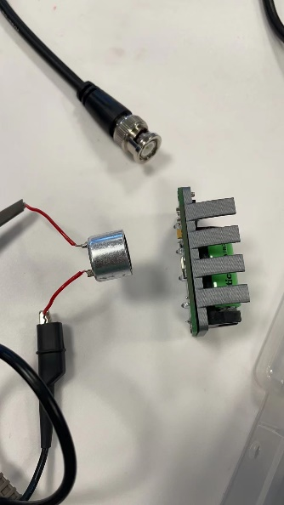

*figure 34 - test with bare signal source*

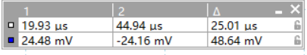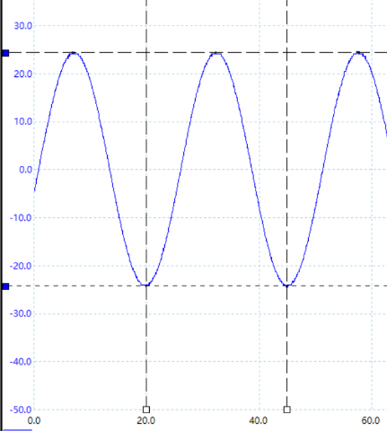

*figure 35 - the result waveform with 48.64mV amplitude and 40kHz frequency*

The same test was conducted with a covered signal source as shown in *figure 36*. This time the returned signal was only 928.1μV peak-to-peak amplitude and the shape of the signal could barely be determined. Hence, it was determined that amplification was necessary for this sensor to properly detect the signal.

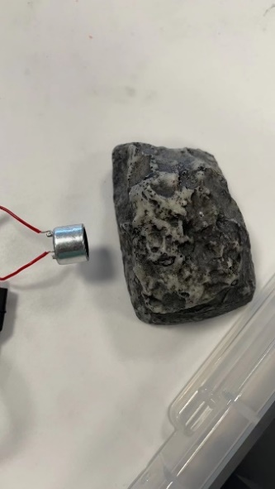 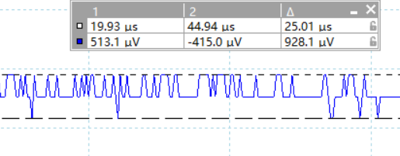

*figure 36 - test with signal source covered with rock shell*

### Amplification

A common emitter (CE) amplifier was designed for the ultrasonic sensor as shown in *figure 38*. The collector was biased at 1.9V and the quiescent collector current was 0.3mA. It uses emitter degeneration to increase temperature stability and for small signals the emitter is shorted to ground using a capacitor, increasing the gain. The gain at 40kHz was around 35dB as shown in *figure 37.*

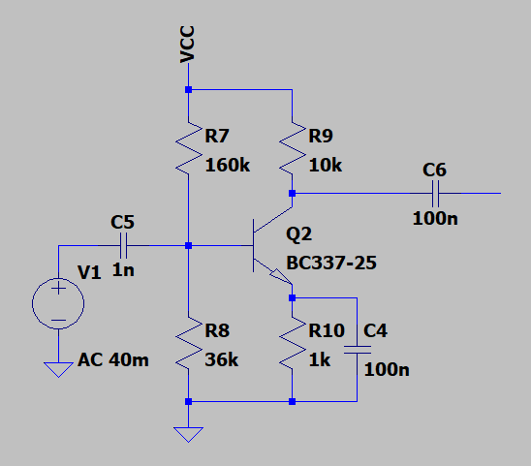

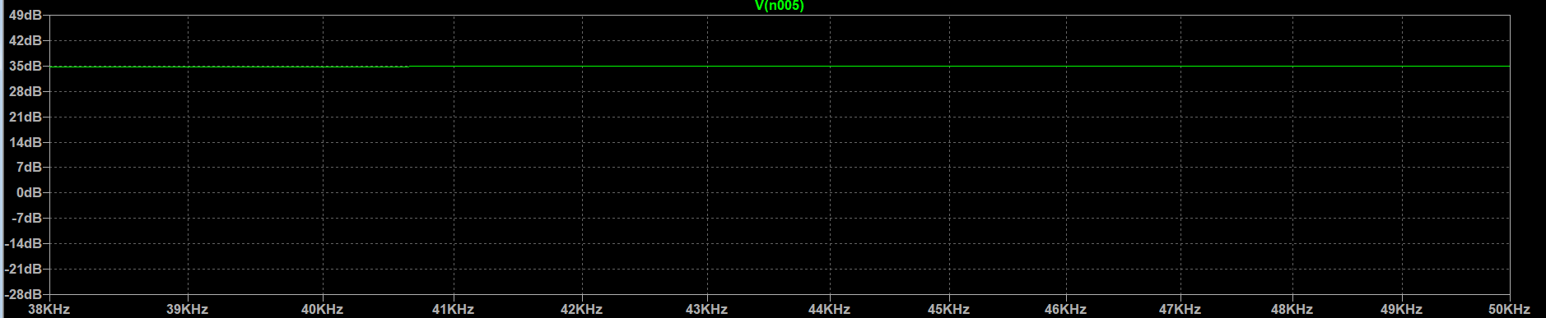

*figure 37 - simulation result at 40kHz*

*figure 38 - ultrasonic sensor CE amplifier circuit built in LTSpice*

The entire amplification circuit was implemented on stripboard, and tests were conducted. In addition, two R40-16s were connected, as shown in *figure 39,* to increase the field of detection.

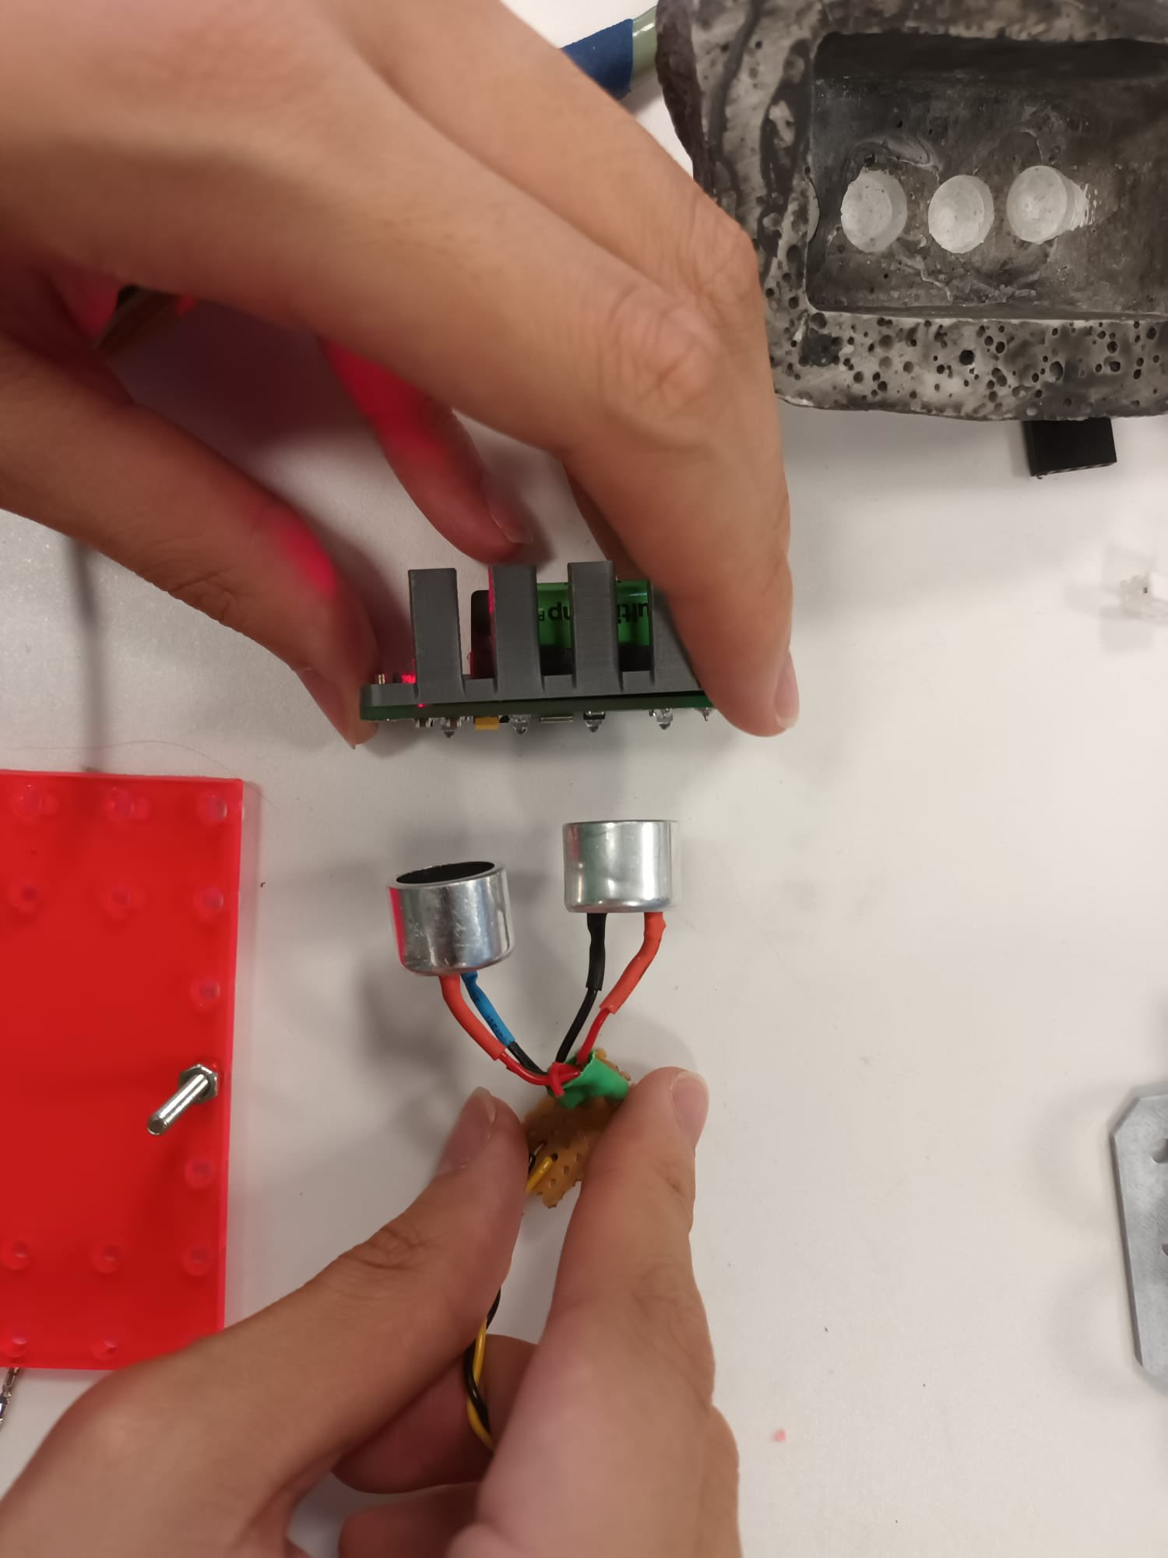

*figure 39 - test with bare signal source using amplification circuit and two R40-16s in parallel*

The returned signal was a sinusoidal wave with 40kHz frequency and 2.245V peak-to-peak. The results are shown in *figure 40*. The DC offset was not removed in the final design, instead, a potential divider was connected to limit the output voltage to the 3.3V maximum input voltage to the Metro.

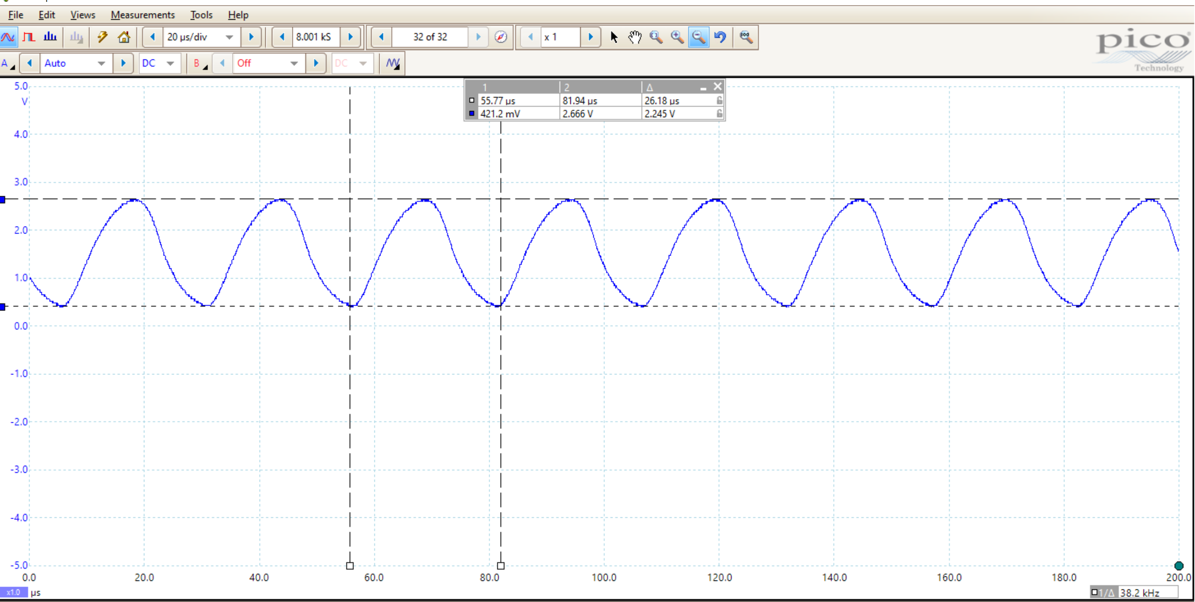

*figure 40 - test results after amplification without the rock shell*

Testing again with the cover, the output signal was 40kHz and 214.1mV peak-to-peak, shown in *figure 41*.

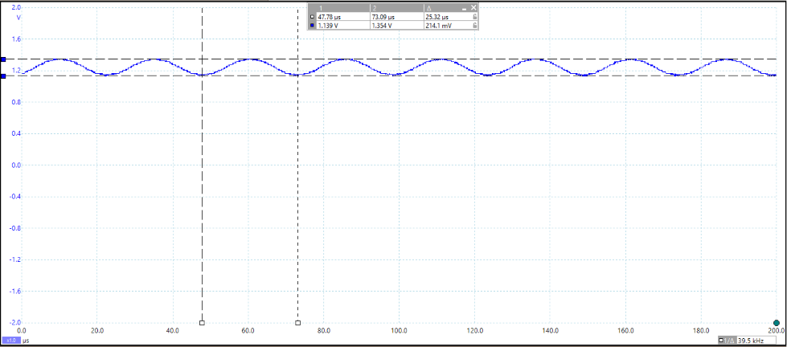

*figure 41 - test results after amplification with the rock shell*

Now that the sensor output had been amplified, it was possible to detect the ultrasonic wave, even with an obstruction between the source and receiver.

### Final Design

A holder was designed to fit two parallel R40-16 receivers. The holder also designed to fit the radio sensor so that space could be saved on the rover. The design is shown in *figure 42*.

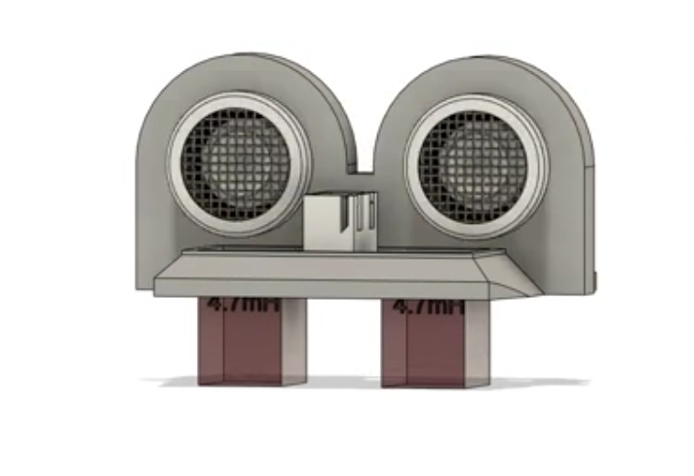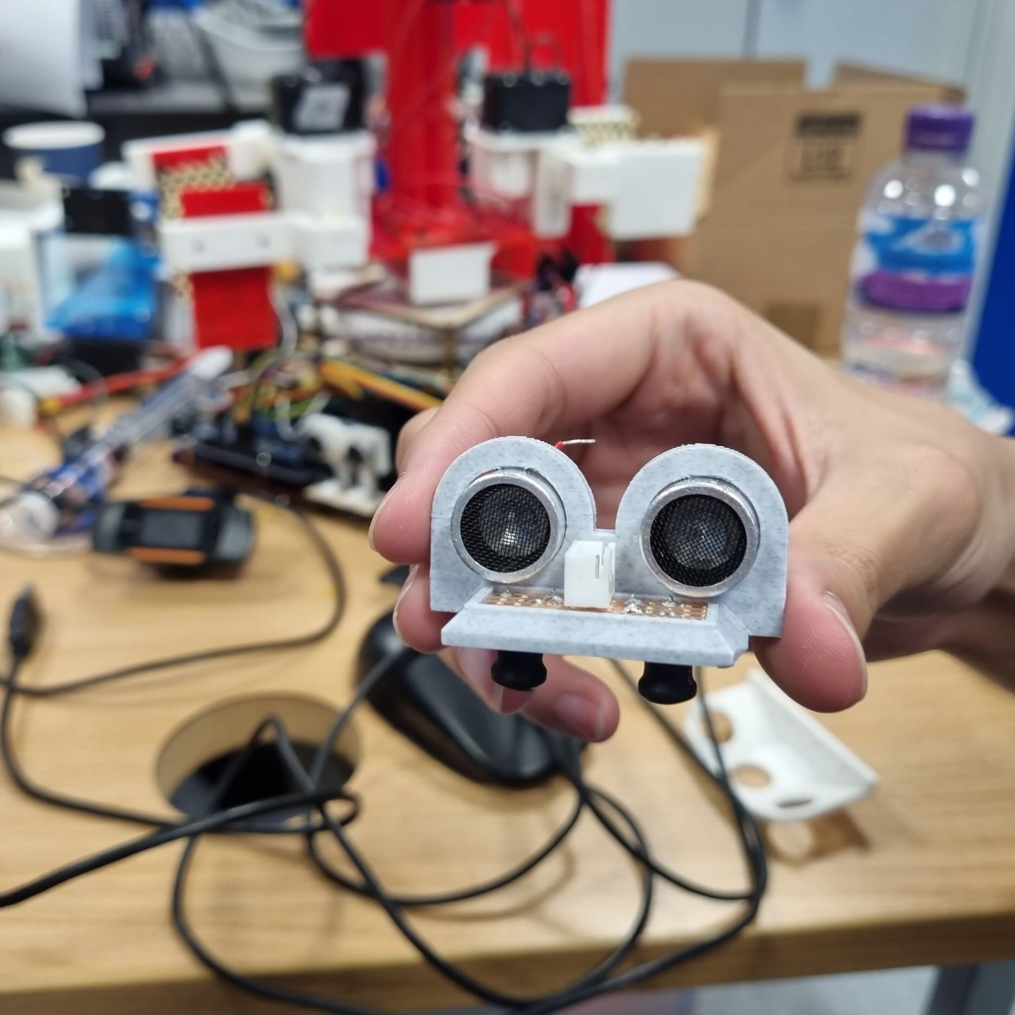

*figure 42 - left picture shows a CAD model of the holder; the right picture shows the actual 3D printed version*

For the software, a Boolean function was designed to return whether the sensor was detecting 40kHz ultrasound. The noise threshold was set at a standard deviation of 10 (corresponding to about 32mV) for this sensor, if the standard deviation of the signal is greater than the noise threshold, the function will return true. The flow chart of this function is shown in *figure 43*, and more details are shown later in the Sensor Rock Identification section.

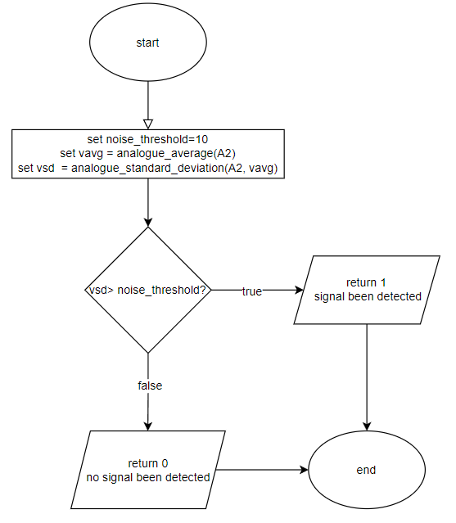

*figure 43 - flow chart for ultrasonic_detect function*

## Magnetic

The component that was to detect the magnetic field is a Hall effect sensor. The component AH49E linear Hall effect sensor was chosen because it can detect a static magnetic field and its direction at a suitable range and is small enough to fit on the rover. The integrated circuitry features low noise output, which makes it unnecessary to use external filtering. It also includes precision resistors to provide increased temperature stability and accuracy.

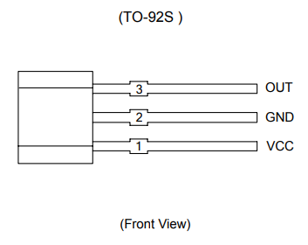

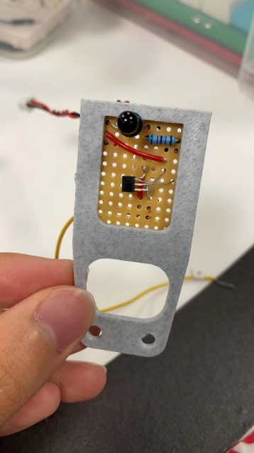*figure 44 - pin configuration of AH49E* [7]

A brief test on the Hall effect sensor verified that it worked as expected and did not need amplification or filtering. The best location for this sensor was found above the centre of the rock.

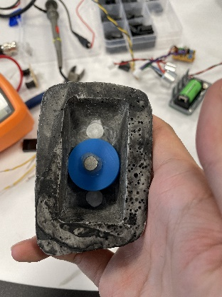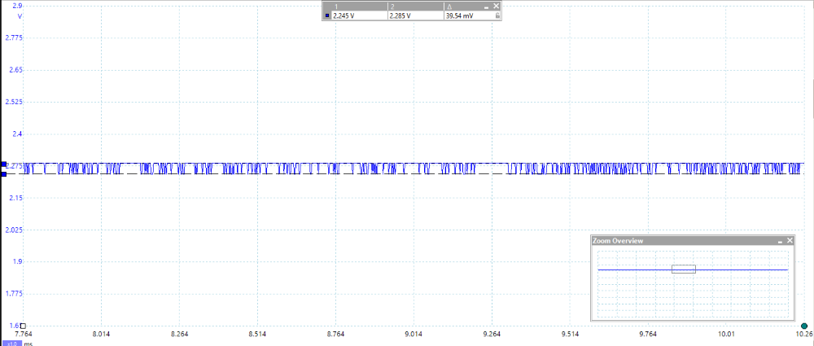The Hall effect sensor was soldered to the same piece of stripboard as the IR sensor to save space, connected the legs as required, and oriented it correctly. No extra amplifier or filter is needed for the signal.

*figure 45 - the stripboard containing the IR sensor and the hall effect sensor*

*figure 46 - magnet in the Exorock, oriented with the magnetic field down*

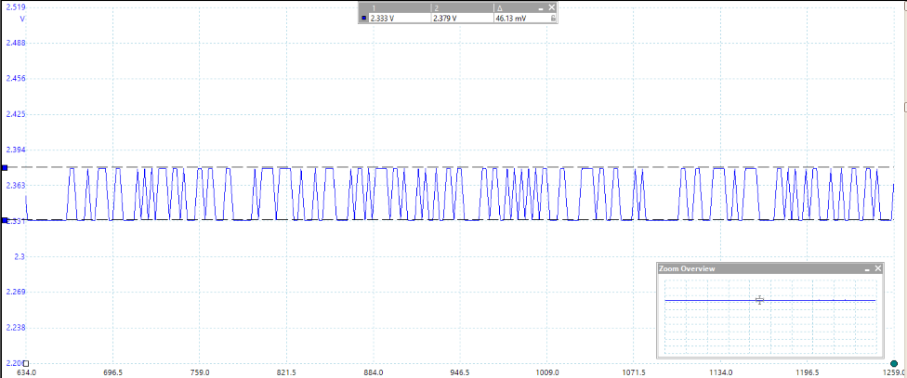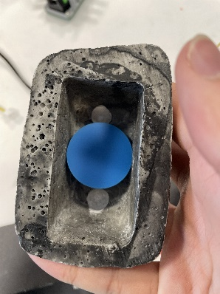The signal from the magnetic sensor is fed into the A4 pin on the Arduino. A function was designed to get the type of the rock, shown in *figure 48.* The average value is first obtained at room conditions and then used to determine the thresholds for upwards and downwards magnetic fields. The function is set so that the value for upper threshold is 6.5mV larger than the initial average and the value for lower threshold is 3.2mV lower than the initial average. More details are shown in the Sensor Rock Identification section.

*figure 47 - magnet in the Exorock, oriented with the magnetic field up*

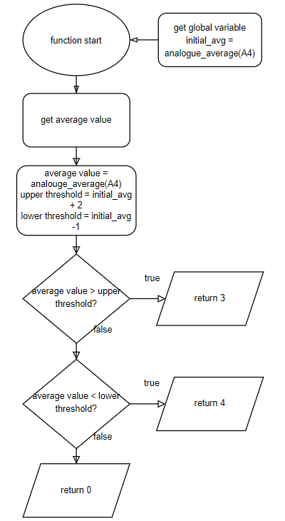

*figure 48 - magnetic rock identifier*

# Power

## Battery

To power the rover, a single non-rechargeable 9V battery from Amazon Basics [8] that was available was chosen, shown in *figure 49*. This battery does not have a datasheet due to Amazon relentlessly obfuscating their supply chain [9], and is not environmentally friendly. In the future this battery will be changed to a more environmentally friendly rechargeable one. The capacity of a typical 9V battery is about 500mAh. This means that since the rover draws about 1A of current on average while moving, the battery will last for half an hour of continuous use, which is more than long enough. The alternative that was available was 4 AA batteries in series giving 6V. However, this would take up more space, and would mean that the rover would move slower due to the lower voltage. The ideal solution, which may be upgraded to later, would be to use lithium ion or lithium polymer batteries or cells since they are light and rechargeable. However, they can be dangerous if not handled properly.

The 9V battery was mounted to the underside of the chassis using a 3D printed mount that was found on the internet [10] and modified to fit the rover, as shown in in *figure 50*.

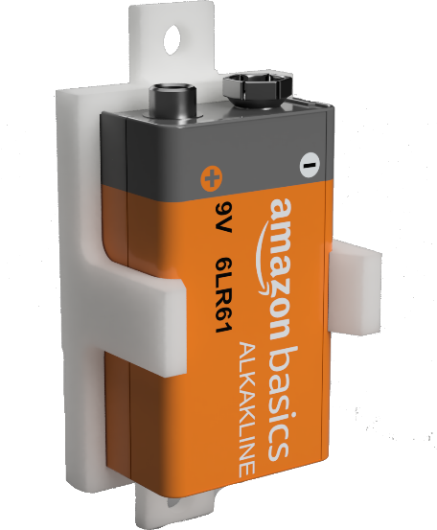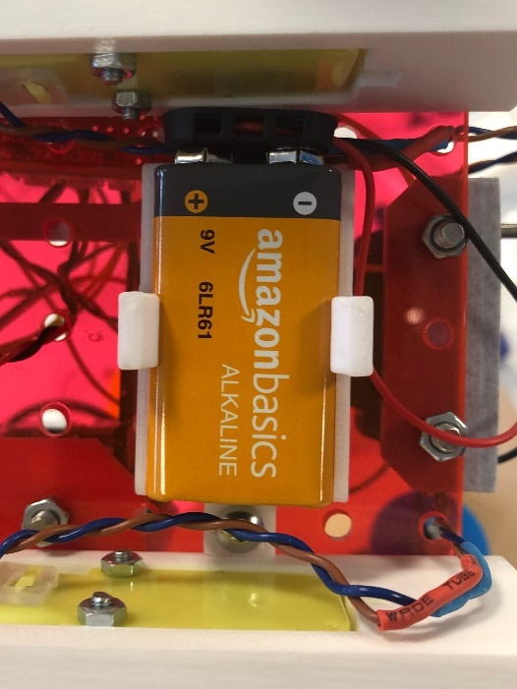

*figure 49 - battery holder on rover*

*figure 50 - battery holder CAD*

## Power Distribution

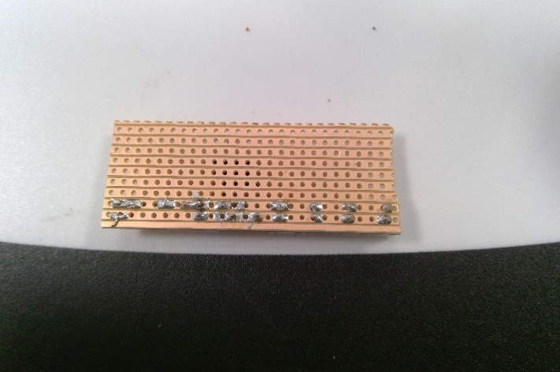The sensors and amplifiers needed power, so a power distribution board was made. The board consisted of two strips, 5V and ground, which would be connected to the 4 sensors in parallel. Although the Metro board had a voltage regulator, to make the power board modular and work with other boards as well, a voltage regulator was added separating the 5V input and the sensor connections as shown in *figure* 52. This also smooths the 5V supply.

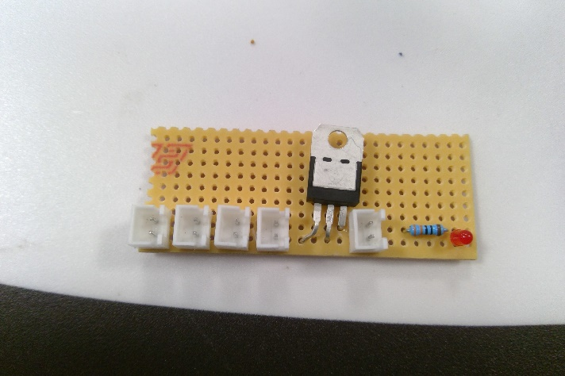

*figure 51 - power distribution board top*

figure 52 - power distribution board underside

To ensure the sensors were powered reliably while also being easily detachable, JST connectors were used on the board and the ends of the connecting sensor wires. The connectors required wires to be crimped which would make the connections secure and increase the robustness of the design. The connectors also emphasised the modularity of the design.

An LED was also added on the end of the board, as shown in *figure* 52, allowing it to be easily seen if the board was powered and allowed for easy testing and debugging. This also needed to be paired with a 330kΩ voltage limiting resistor.

# Drive

## Motors

Two Arduino TT motors were used in the rover. These motors have operating voltage from 3V to 12V, with a maximum power dissipation of 3W.

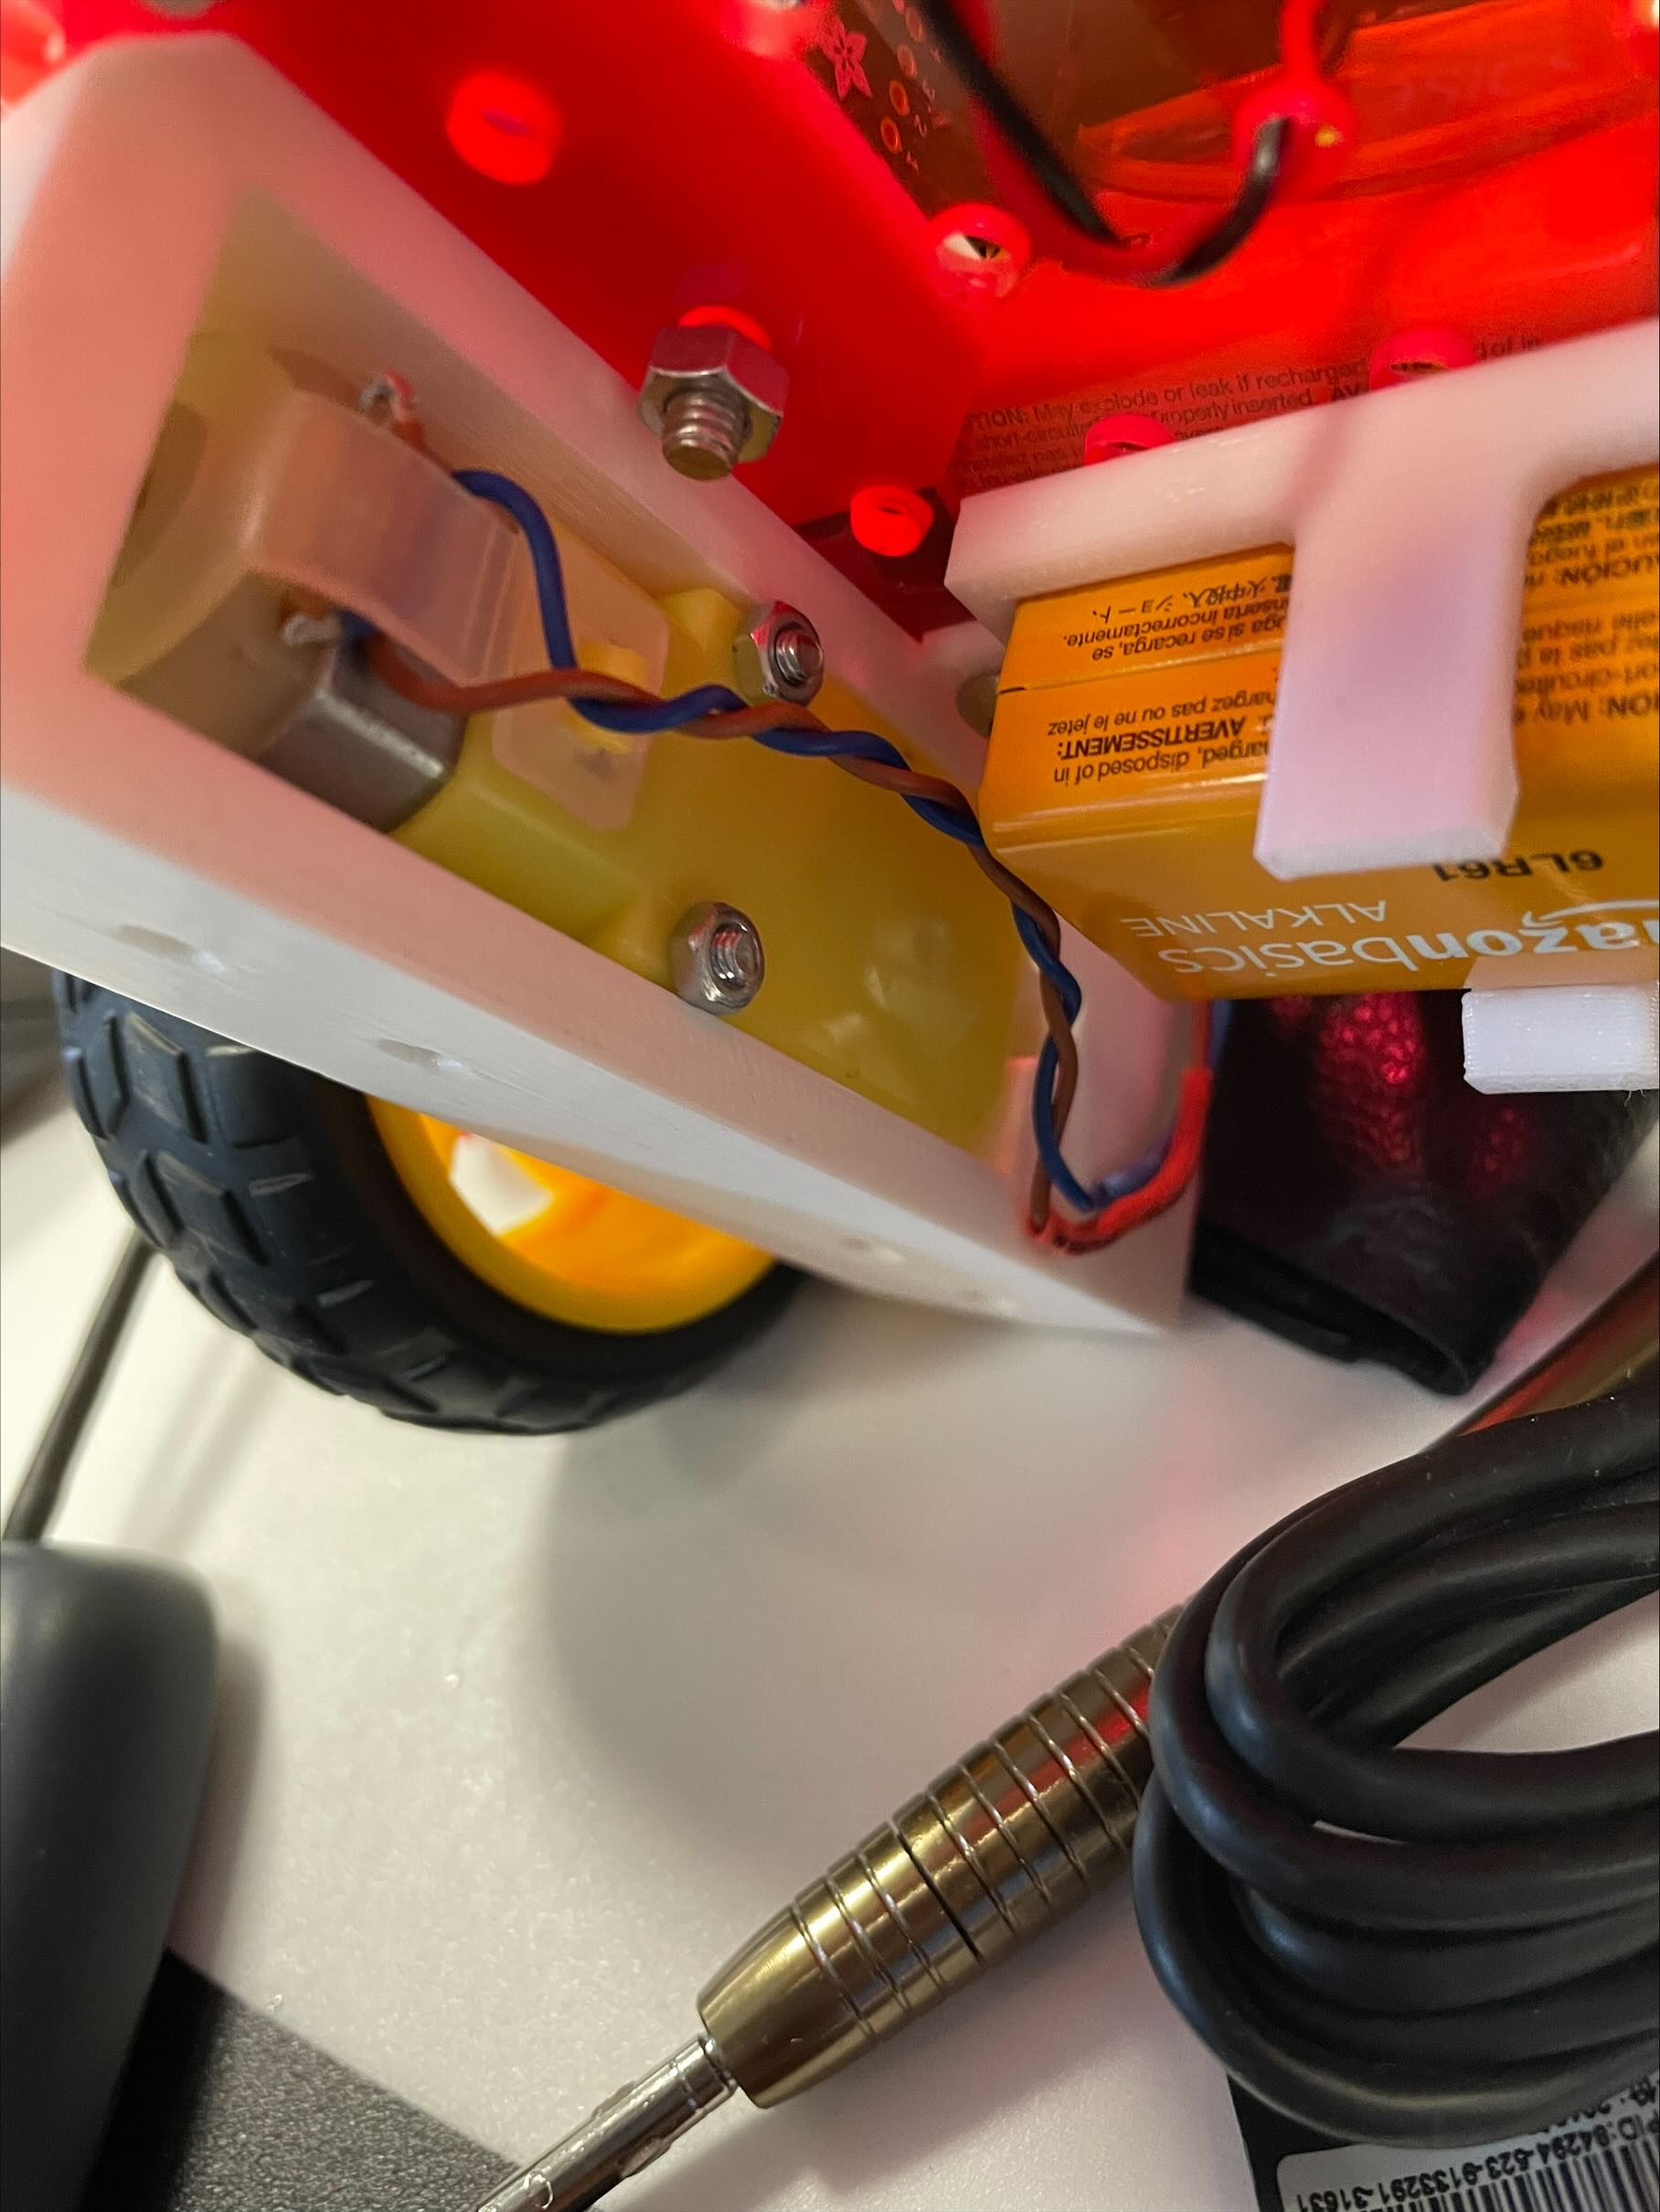

*figure 53 -Arduino TT motor*

There are two main reasons for using these motors in the rover:

* Previous experience in using Arduino TT motors in the EEEBug project
* These motors are cheap and readily available

## Motor Driver

The motor driver used was the L298N motor driver.

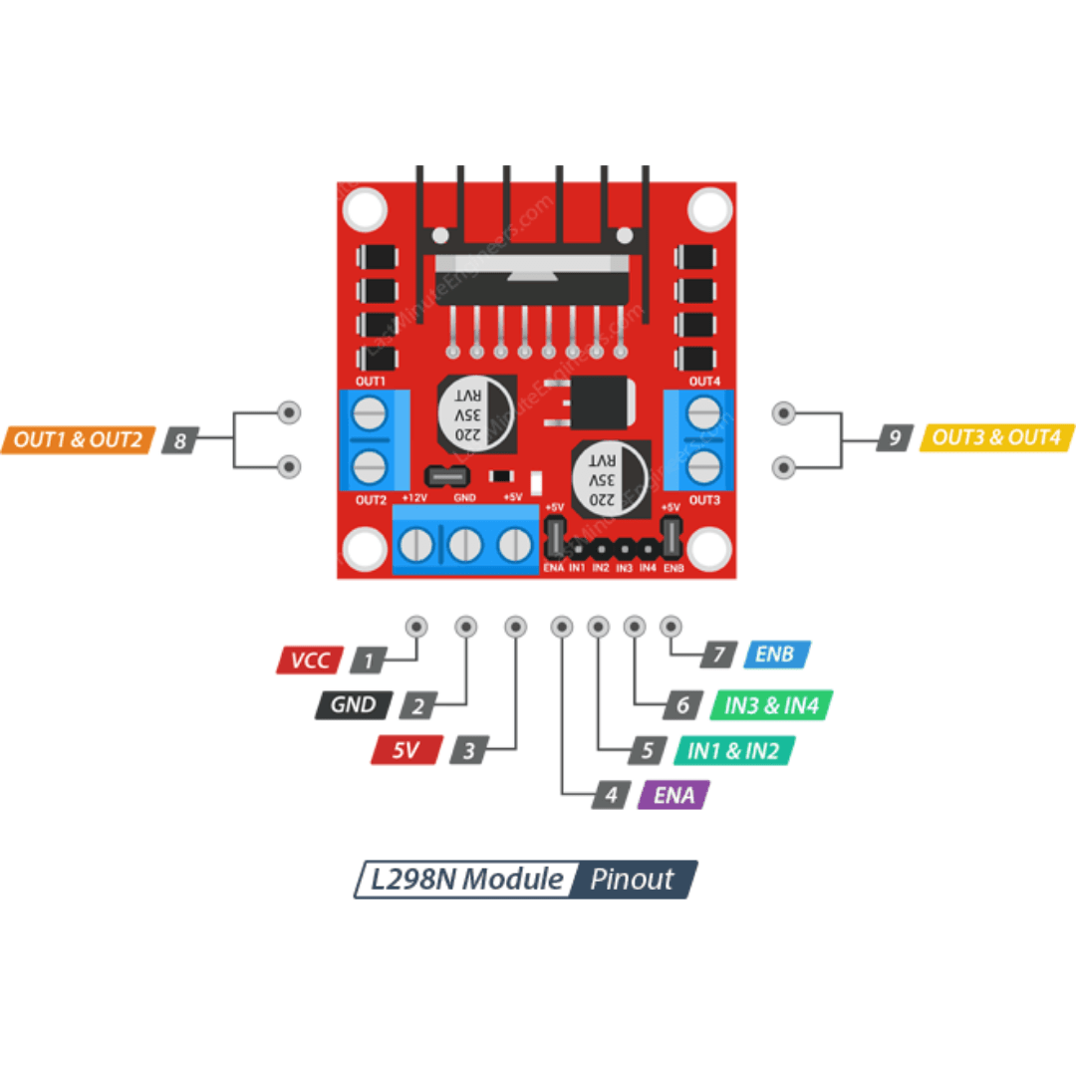

*figure 54 - L298N motor driver pinout* [11]

The L298N has an input voltage range from 3.2V to 40V and a maximum power dissipation of 20W which provides significant overheads for the rover. The reason this driver was used over the provided driver was due to four main reasons:

* Previous experience in using the L298N and a vast wealth of online documentation and specifications.
* Uncertainty in battery and motor choice, the option exists to upgrade both the power and motor systems easily.
* The L298N has an inbuilt 5V regulator which is compatible with the rest of the systems.
* Easily available, testing with it could start immediately.

A high-speed camera was used to measure the RPM of the wheel under load and a reasonable 96 RPM was measured, giving a theoretical maximum speed of 0.7m/s.

# CAD

## Design summary

The aim is to design a rover with an easy-to-assemble design and an efficient layout, thereby increasing the functionality of the rover to its maximum. The parts can be manufactured using a laser cutter or a 3D printer depending on the nature of the parts. The size and shape of the components needs to be considered, so that they will not interfere with each other’s function whilst fitting with each other well. Another equally important aspect is the balancing between size, weight, and durability. This needs careful measurements.

## Iteration 1

By planning the layout of all the components beforehand, the first iteration of the chassis was designed to be non-modular. This design was inspired by a typical RC car which is flat and is therefore stable due to its low centre of mass.

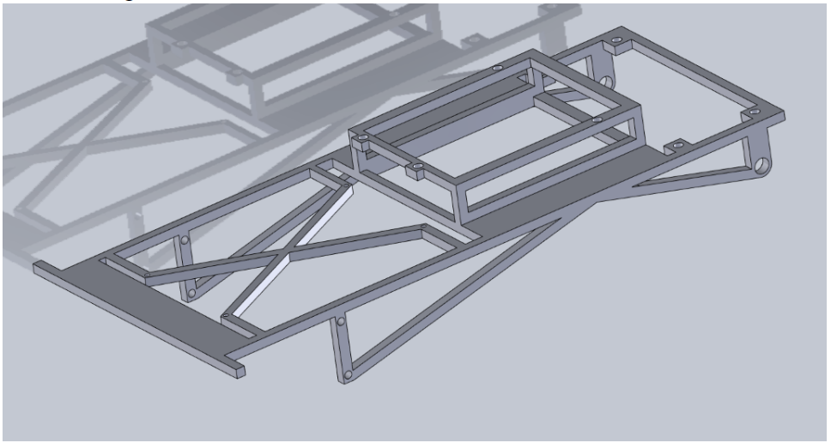

*figure 55 - chassis frame 1st design*

*figure 55* shows the whole chassis frame which would have to be divided before manufacturing.

The external hull of the rover was also made to fit the chassis frame, shown in *figure 56*.

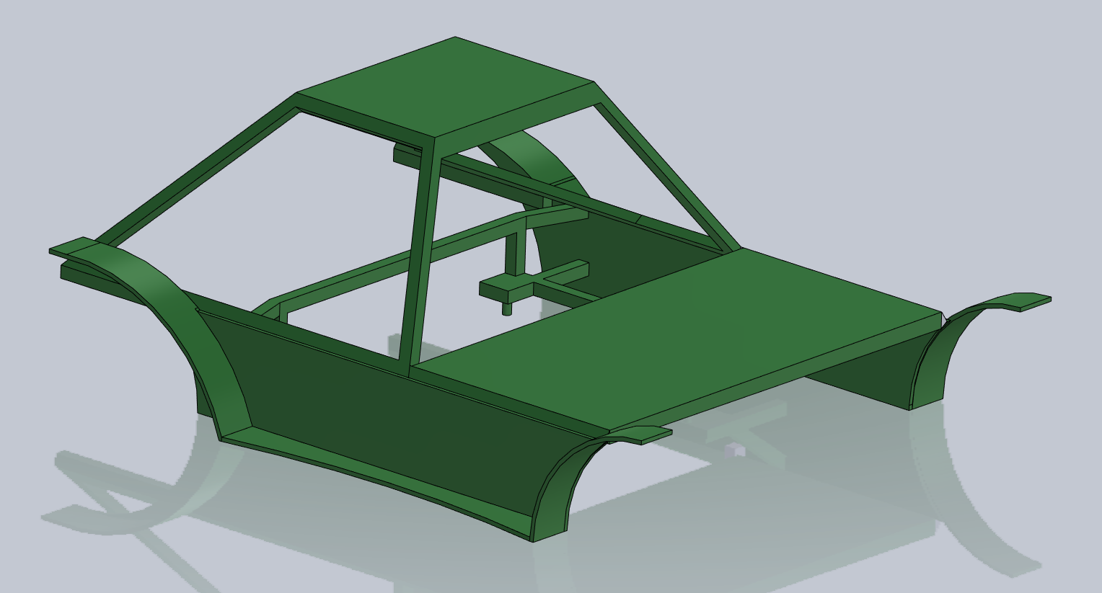

*figure 56 - chassis hull*

The advantages of this design are that it would be lightweight and visually appealing.

The disadvantages are that this design would be time consuming and difficult to manufacture, it is not modular, unnecessarily complex, and could not be made strong enough with the materials available.

## Iteration 2

This design is two differently sized rectangles spaced apart with the smaller rectangle mounted above the larger one, overhanging slightly, as shown in *figure 57*. The smaller rectangle houses the sensors while the larger houses everything else. The rectangles also have M4 holes spaced evenly apart (15mm centre to centre) to mount components modularly. Both boards would be laser cut from 3mm thick acrylic which would be suitably strong.

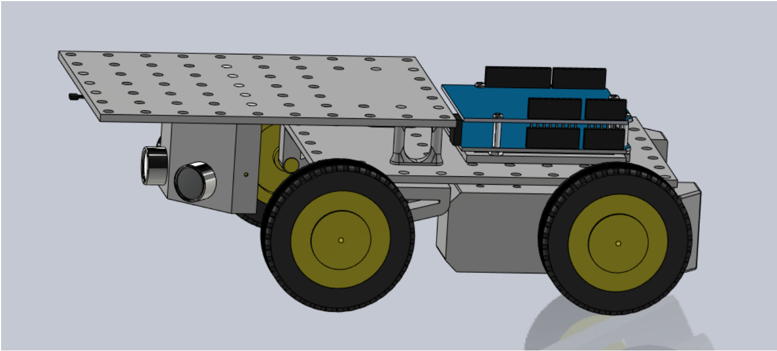

*figure 57 - chassis 2nd design*

Modular mounts need to be designed for each component, some of which are shown below.

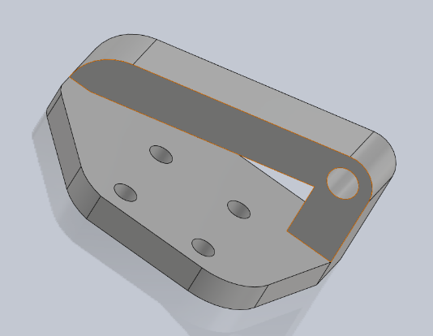

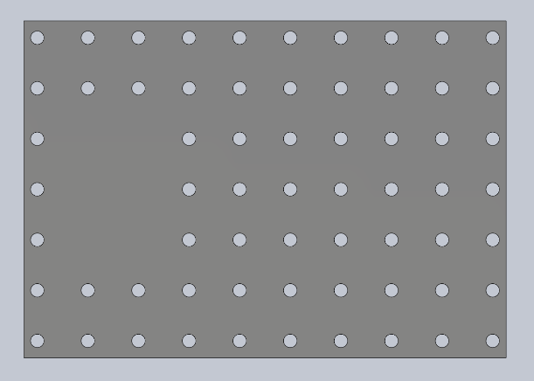

*figure 58 - front wheel mount*

*figure 59 - lower rectangle 100mm x 140mm, 7 x 10 holes*

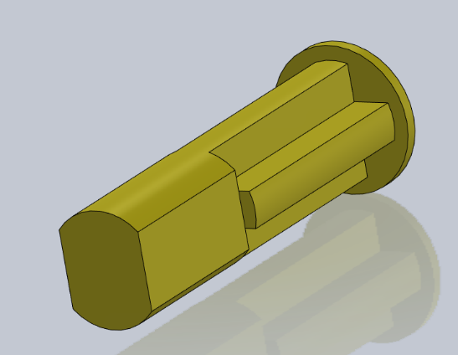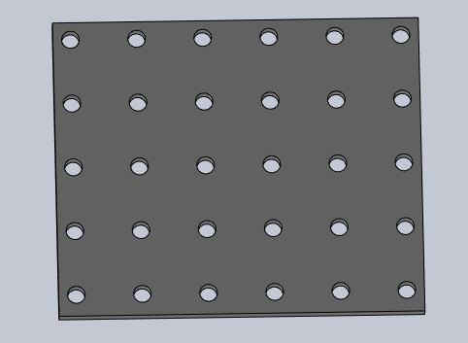

*figure 60 - wheel axel 17 x 4.81 mm diameter*

*figure 61 - upper rectangle 70mm x 80mm, 6 x 5 holes*

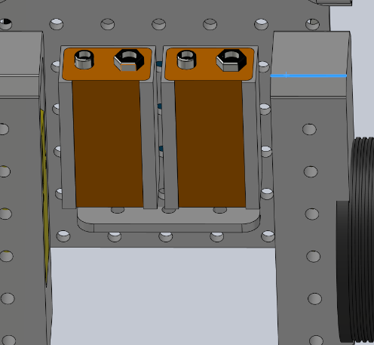

The advantages of this design are that it is strong, easy to manufacture, and modular.

The disadvantages are that it is less visually appealing than the first design, and it is not as enclosed which could reduce its durability.

*figure 62 - underside battery holder mount*

## Iteration 3

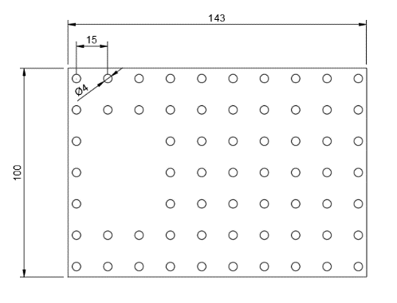The third iteration was designed for maximum flexibility in terms of mounting the separate modules and motors. This was done by adding standard mounting points as shown in *figure 63* (previously, M4 holes 15mm apart had been decided on). This system allowed new iterations of hardware such as motor mounts without the need to laser-cut the base again which would be a lengthy and expensive process.

The motors and front idler wheels were to be fixed onto the base via simple 3D printed mounts as shown in *figure 64*. The parts were printed in PLA at 20% infill to reduce print time and weight while maintaining an acceptable level of strength.

*figure 63 - base design with standard mounting points*

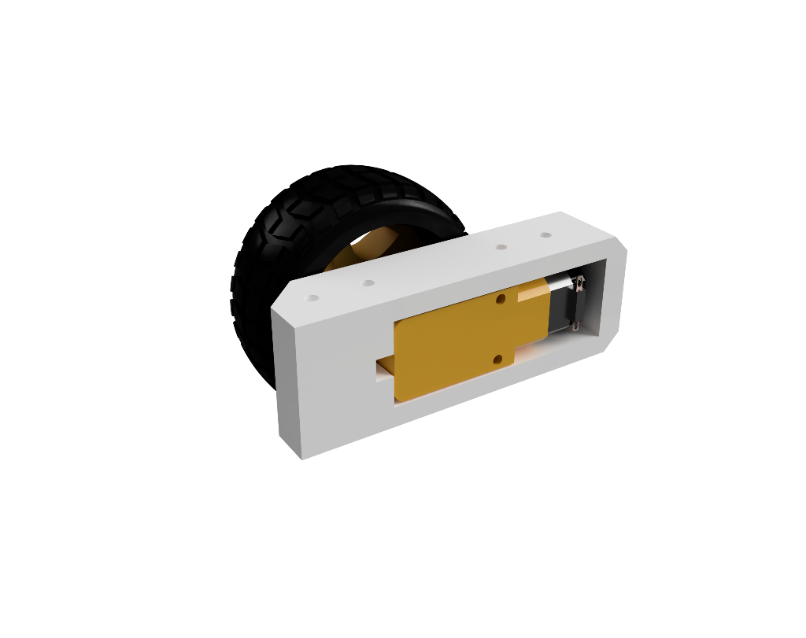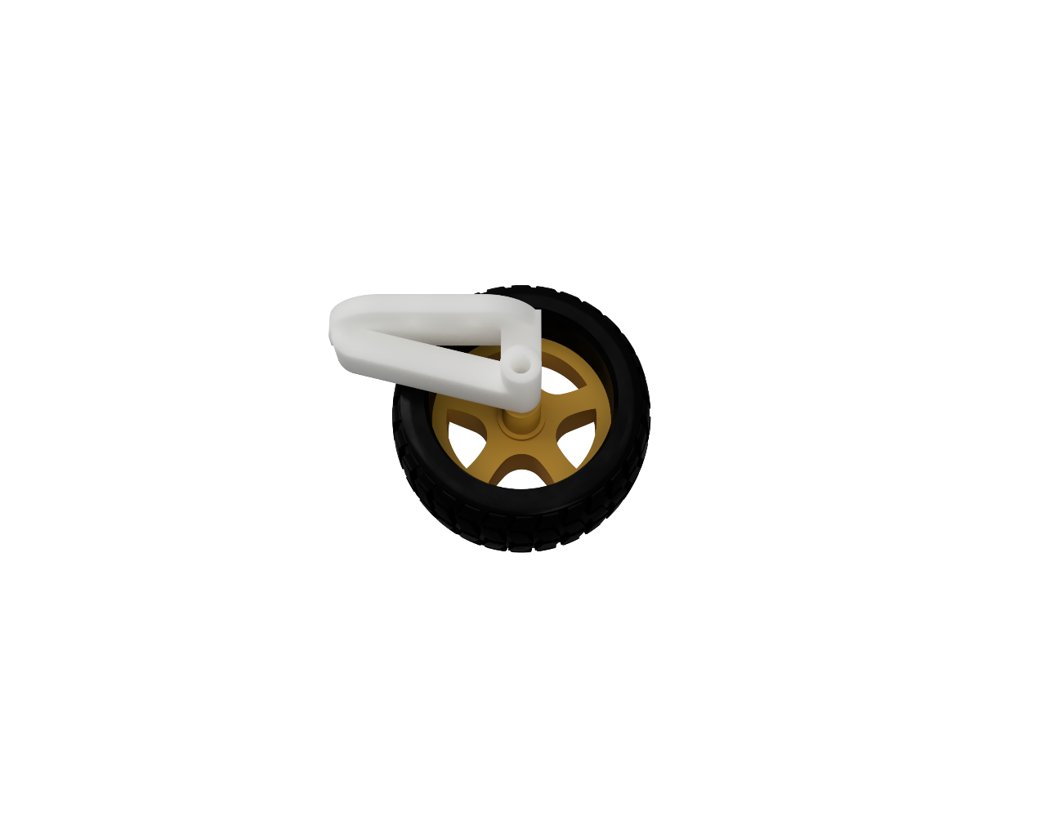

*figure 64 - motor mount (left) and idler (right)*

### Electronics Mounting

The electronics can be separated into 4 broad categories:

* Control – electronics needed to control the rover
* Power – electronics needed to power the rover
* Sensors – electronics used to detect signals from the rock
* 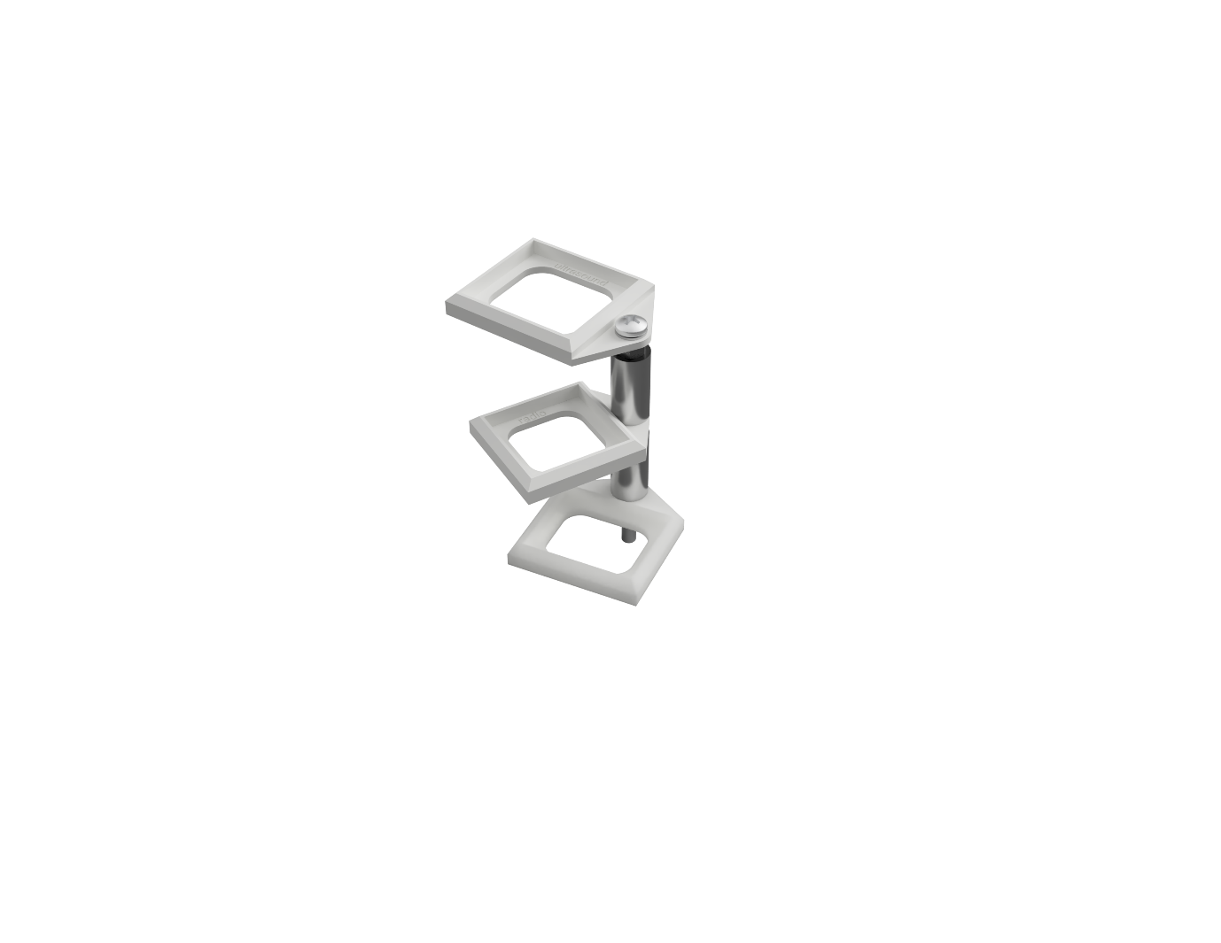Amplifiers – electronics needed to process signals from the rock

It was quickly apparent that there was not enough space to horizontally mount all the electronics on the base, this issue was solved by vertically mounting as many components as possible.

#### Amplification Rack

A staircase style rack to mount all the amplification boards was developed. They are stored densely while allowing each board to be easily accessed via rotation around a central screw, as shown in *figure 65*. Each individual bracket was 3D printed in PLA and mounted to a standard M4 bolt using nuts, washers, and spacers.

#### Sensor Mounts

Testing showed that the four sensors had to be placed in two groups for optimal detection of signals, see Sensors section. IR and magnetic should be placed directly above the rock, while radio and ultrasound should be placed to the side of the rock. CAD software was used to ensure correct positioning of the sensor mounts as shown in *figure 66*.

*figure 65 – 3D printed "staircase" amplification board mount*

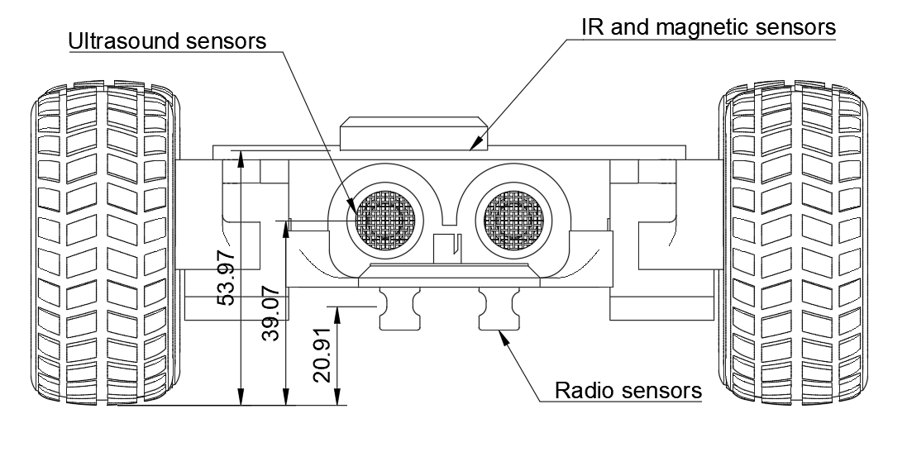

*figure 66 - CAD drawing used to ensure correct sensor placement*

#### Power Mounting

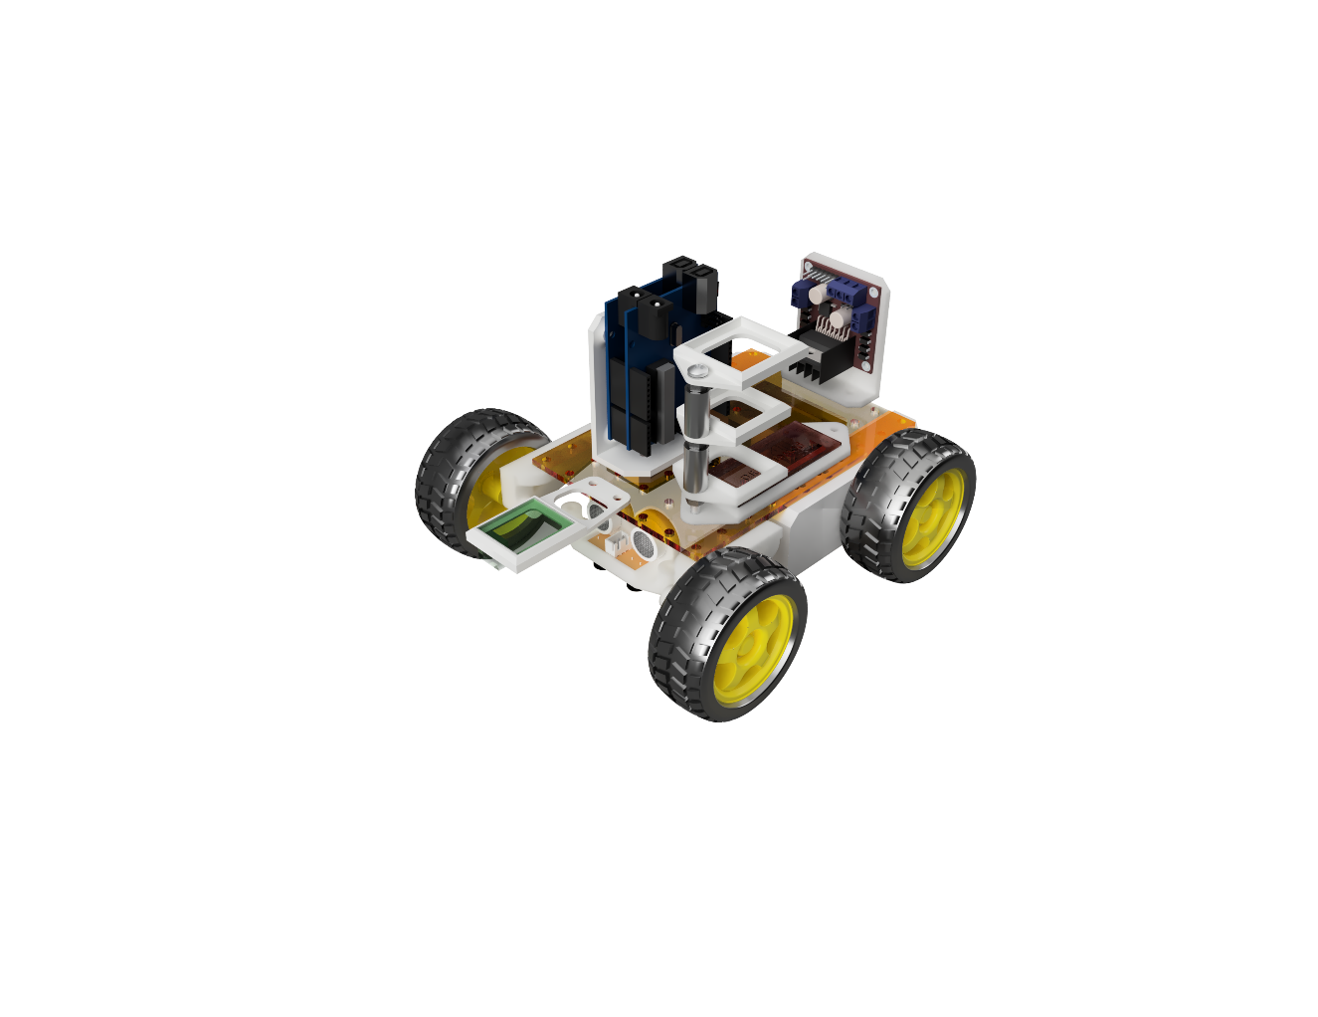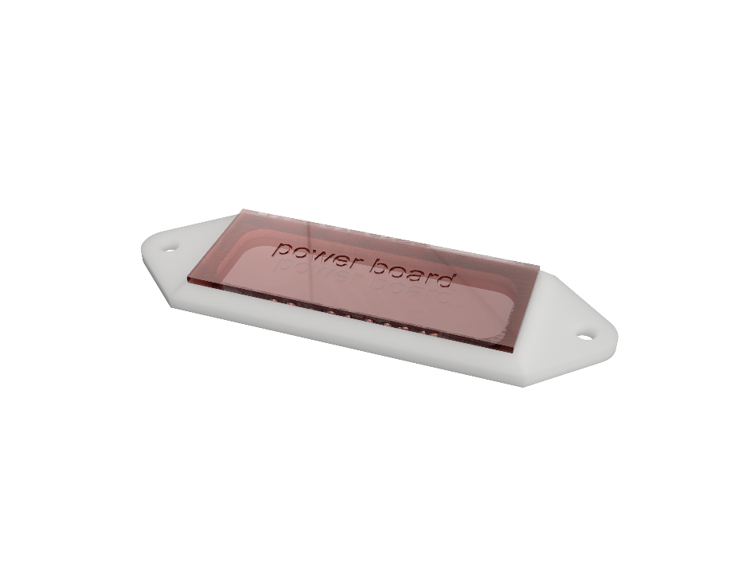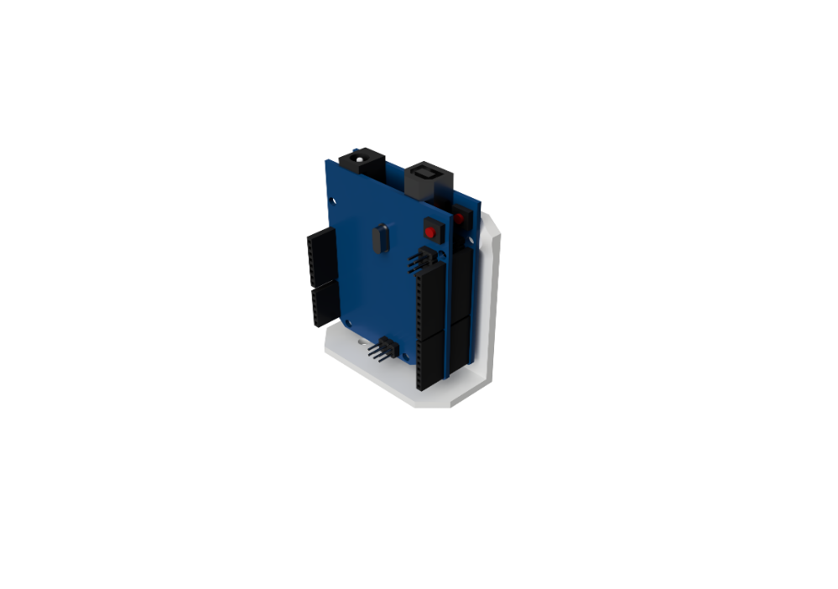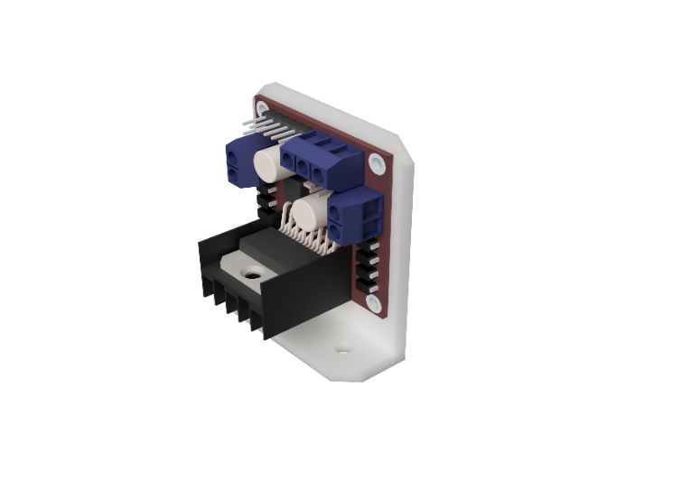The components used to deliver power to the rover were the battery and power distribution board. The design of the battery mount has already been detailed in *figure 50* and is used to mount the battery under the base, as shown in *figure 49*, this is because the battery does not need to be changed or modified frequently and would take up valuable accessible area on the top of the base. The power board is required to be accessed frequently to plug and unplug power connections to the amplification boards so must be mounted flat onto the base. This was done using a 3d printed bracket, as shown in *figure 68*, that can be screwed into the base.

*figure 67 - fully assembled rover in CAD*

*figure 68 - 3d printed bracket for the power board*

*figure 69 - vertically mounted control boards, Arduino (left) and motor driver (right)*

#### Control Mounting

The two control boards, Metro M0 with Wi-Fi shield and L298N motor driver, need to be mounted vertically to save space. This was done via L shaped brackets as shown in *figure 68*. This allows easy access to the Arduino pins and motor driver terminals while reducing their footprint on the base.

#### Assembly

CAD (Fusion360) was used to virtually arrange all the components to ensure that they would not require further modifications to fit with each other on the base, this is shown in *figure 69*. Then the base was laser cut, all the necessary parts were 3D printed and the rover was assembled according to the CAD arrangement. The physical assembly did not have any issues with conflicting parts as shown in figure 84.

# Programming

All the code used has been compiled into the following GitHub repository: <https://gitfront.io/r/user-4226714/ep3ixmVieoLK/EEEY1-G21-Final-Project/>.

## User Interface

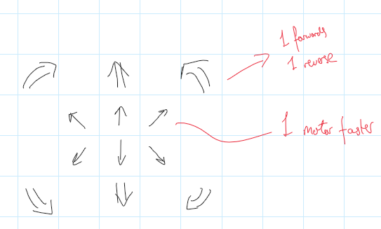In order to control the rover, as interface between the human controller and the device was needed. This can be done with HTML, giving the user a webpage with an array of buttons that carry out the required functions to control the rover accurately and quickly.

The user interface should be as simple as possible but still have enough functionality to sense all of the rocks as quickly as possible for the timed competition. This means including both fast and slow versions of movement commands.

In the initial iteration of the design, as shown in *figure 70*, it was being decided which buttons were required. It was known that forwards and backwards controls with turn functions were needed. fast controls for travel between rocks and slow controls, to precisely adjust the position of the sensors, were adopted. Having a toggle between fast and slow was considered, however this would create unnecessary complexity.

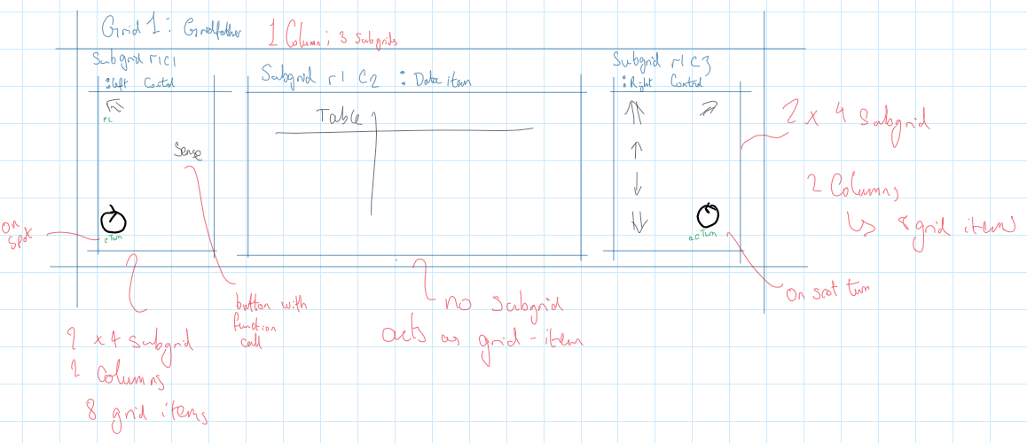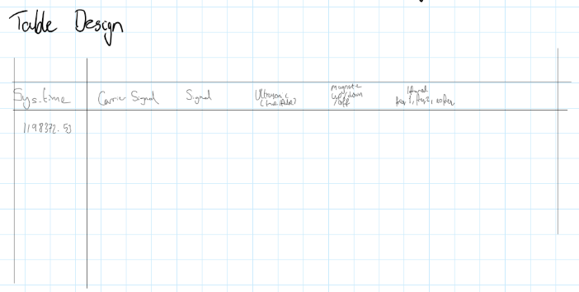

*figure 70 – initial UI design*

Upon analysis, two of the turning buttons in in *figure 70* (bottom left and right)were redundant so could be removed for further simplicity. It was also realised that the slow turning would be better implemented with a stationary rotate function, reducing the number of buttons, and making the UI simpler. These changes were implemented in the next iteration as shown in *figure 71*.

*figure 71 - UI design*

This iteration focused more on how the UI would be implemented, such as setting the border of the controller screen and creating a grid for the placement of buttons. It was decided to split the UI into three sections: Left side controls, results table, and the remaining controls. The results table subdivided into sections for each signal to detect, along with the time taken for each scan.

Although the design was altered slightly after implementation, there was now a design ready to be created in html. This design was implemented with stylistic choices and produced *figure 72*. The background was also made into a navy-blue colour to contrast with the large white buttons, making it easier for the controller to use. Simple, intuitive icons for each button were used and buttons were made on the edges so that the user could reach them easily on a touch screen.

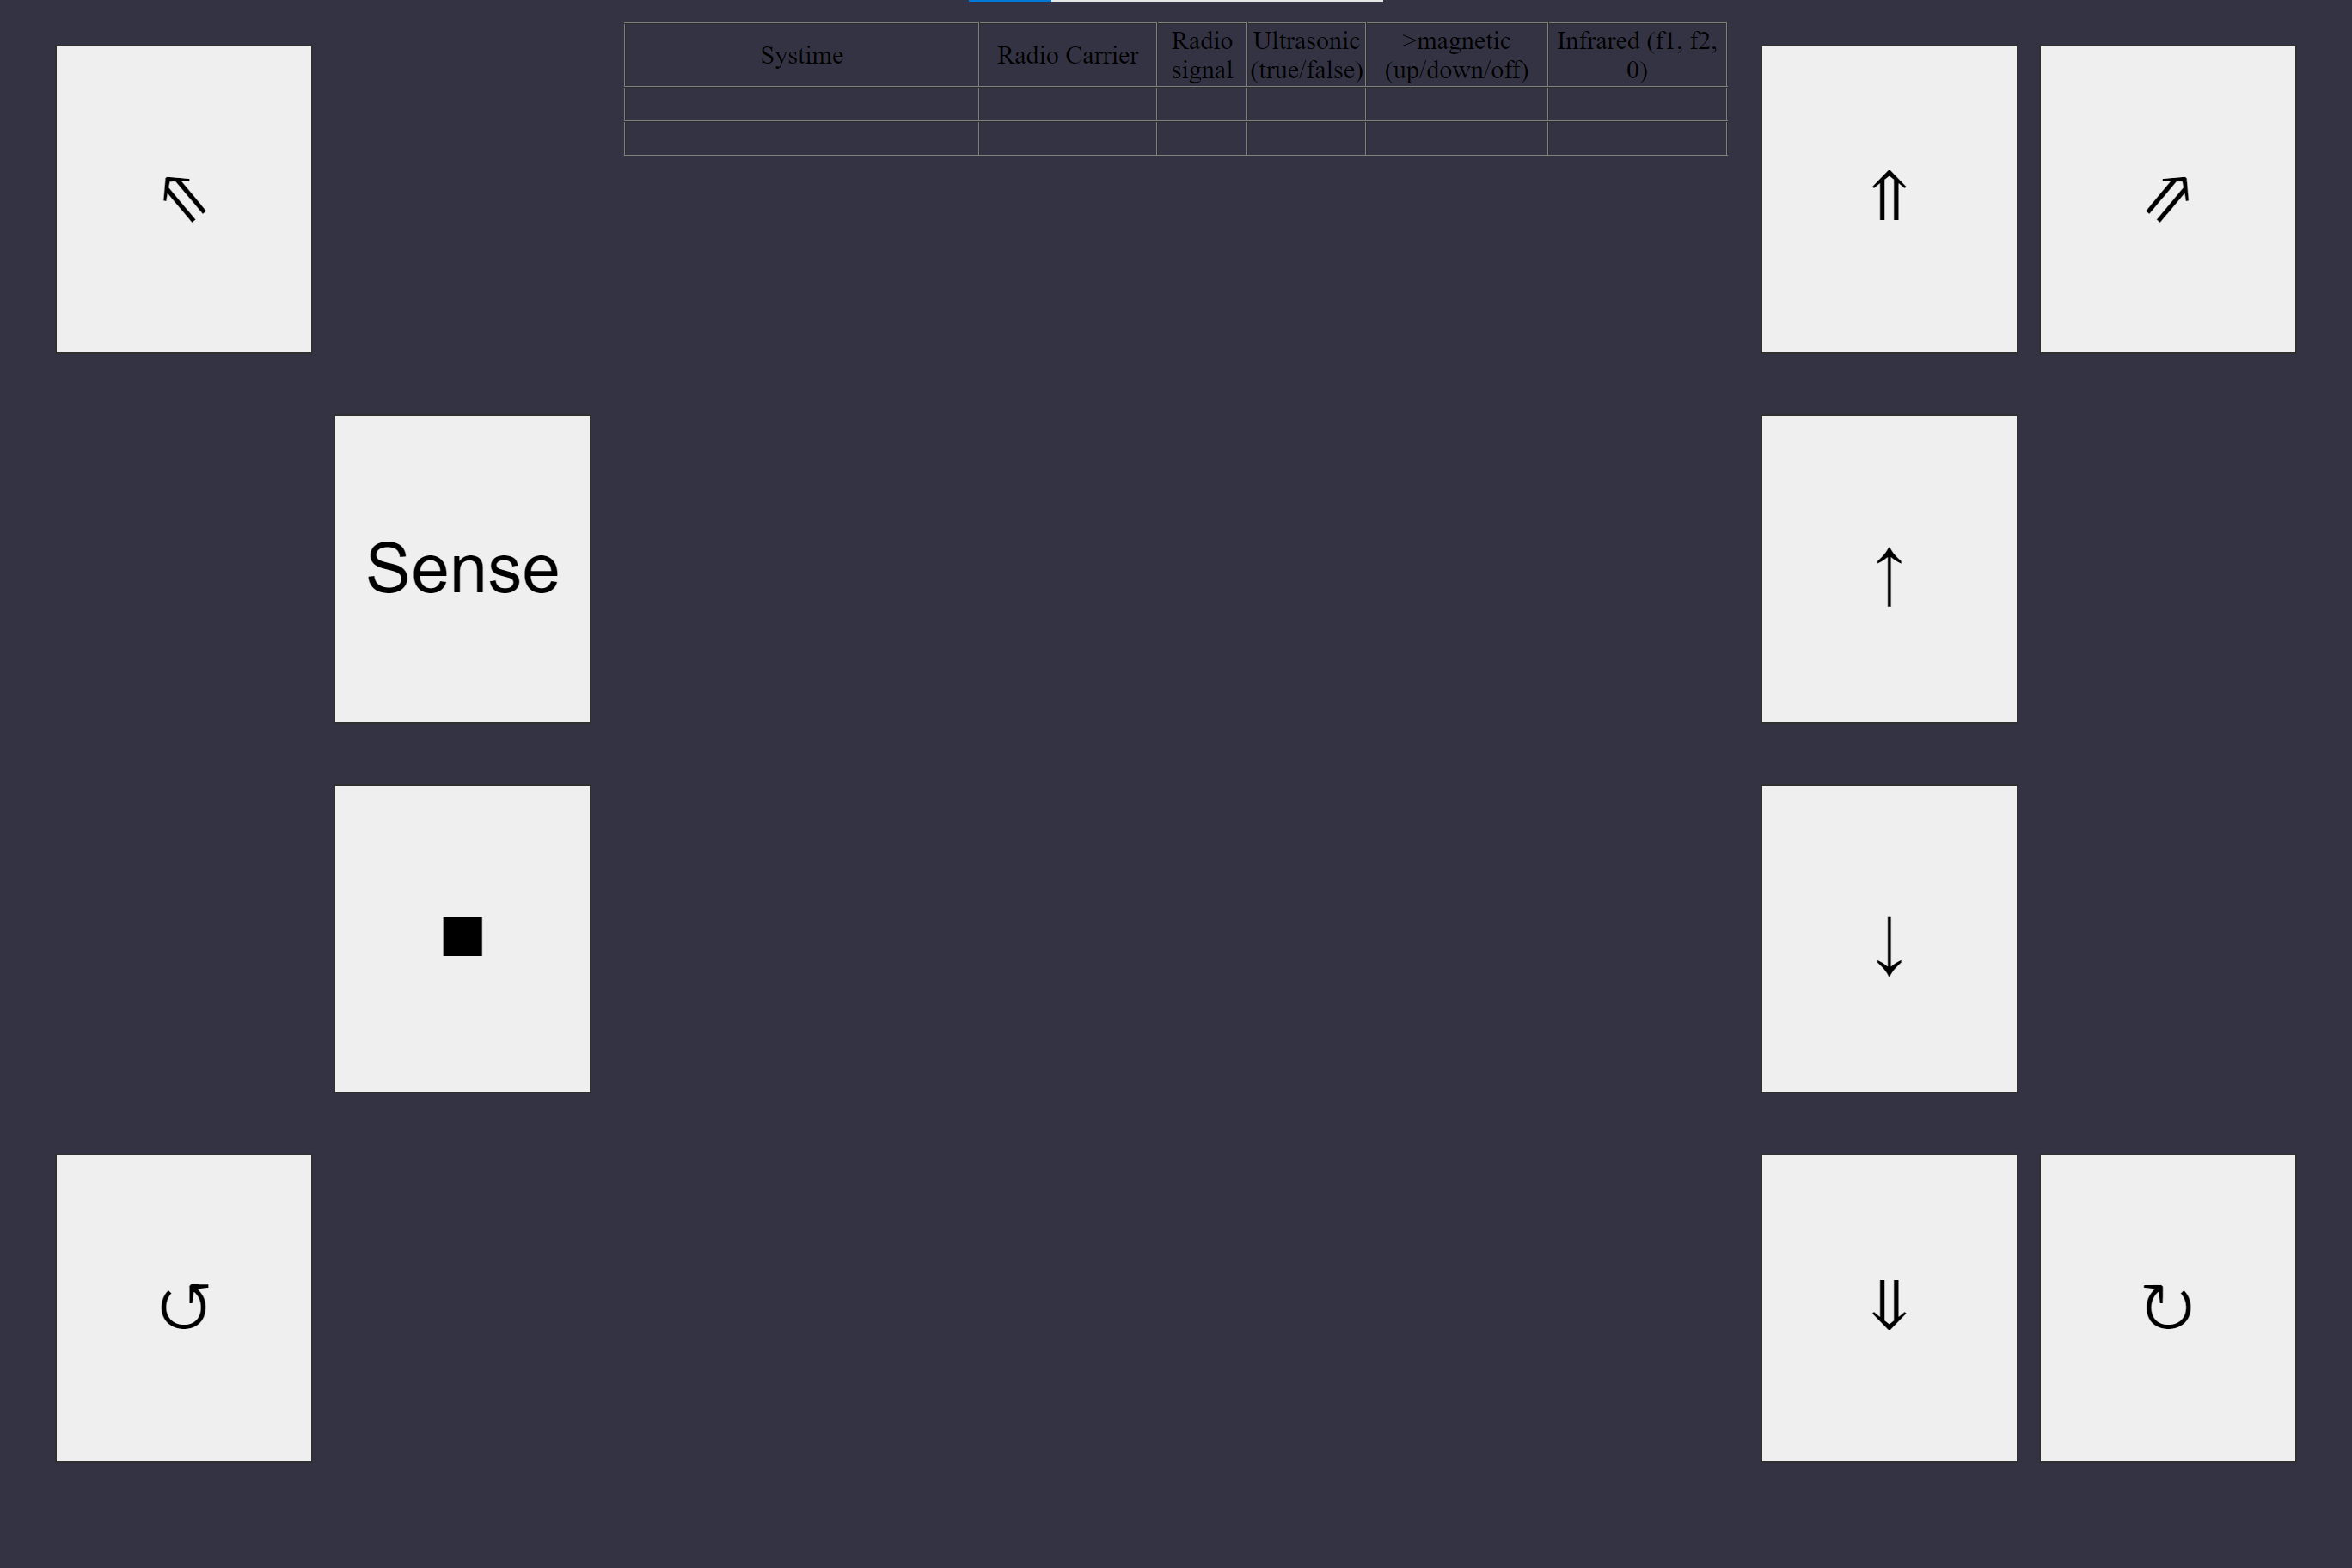

*figure 72 - UI design implementation*

After a review of the design, the text in the table should be a lighter colour or have a white background.

However, when trying to integrate the HTML webpage with the Arduino code, it was discovered the webpage HTML code was too large to be used. This is due to the size limit of character arrays. (char[] webpage). The maximum webpage size permitted was 1000 characters, and the initial webpage design (*figure 72*) was still 3713 characters long, having been reduced from 4200.

## Control

Due to issues with the ‘wifiwebserver’ library (both limitations on webpage size but also with style sheets rather than inline CSS), a decision was made to control the board using an Xbox controller instead of through the web server. The most prominent issue was the character limit. After diagnosis, it was discovered that the char array has a limit of 1000 characters. This meant that the design in *figure 72* was not possible due to it exceeding the character limit. By reducing the length of the webpage, it was possible to upload it, however this only gave the functionality of 4 buttons. To solve this, an attempt to create multiple char arrays, each with a different part of the server was made. This would successfully update but would not connect. It would eventually time out when connection was attempted.

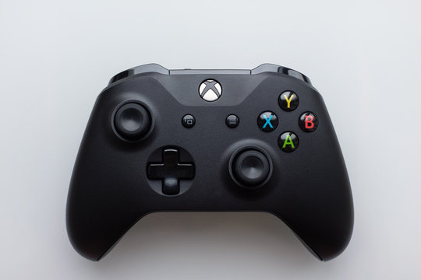

*figure 73 - Xbox controller example*

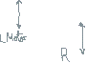

Python was chosen to interface with the Xbox controller and communicate with the Arduino. This decision was made because of the pygame library having extensive support for windows joysticks, reducing the complexity of the code required. As the decision between UDP and HTTP communication had yet to be decided with this new revision, it was decided that the program would decode the analogue controller inputs and send the corresponding function name as a string to the server.

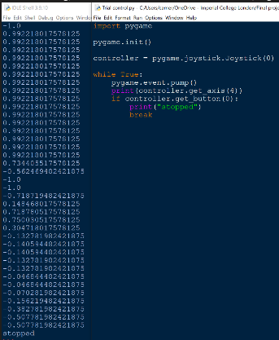

*figure 74 – Python HTTP testing*

For functionality, two analogue joysticks on the Xbox controller were chosen for motor control. With the y plane of each determining the corresponding motor power and direction.

Both a higher and lower speed was written for the main directions of travel, as well as clockwise and anticlockwise rotation (on the spot). These functions would be determined by having 4 thresholds, high+ low+, high- and low-. These were chosen to be ±0.1 and ±0.6 from testing. (There was a +0.03 offset bias for nominal operation).

This led to the initial design, which had problems due to the initial documentation having the wrong axis labelled, also the axis direction being the wrong way round. After these were fixed the following was written (*figure 75*)

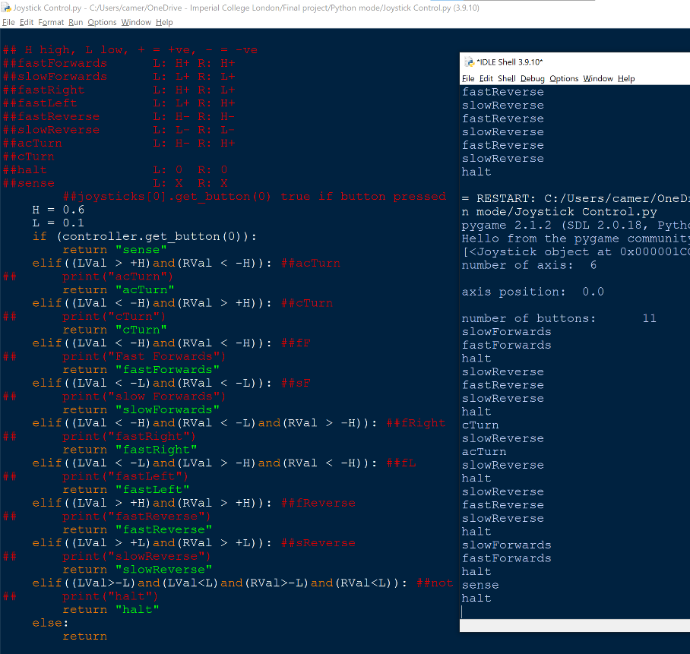

*figure 75 - joystick control testing results*

To communicate with the Arduino, it was originally decided to use UDP, but it was later decided to use HTTP as the port number is not required to send data and it could be implemented using the sockets library.

The only problem with this method, is that it uses a post function, which expects a reply from the Arduino server. During testing, only the halt, LEDOn (testing) and LEDOff (testing) functions would receive a reply from the Arduino server.

One simple error with the code was due to the wrong label within the registering of callbacks for HTTP requests. This was simply resolved by changing the request reference for cTurn.

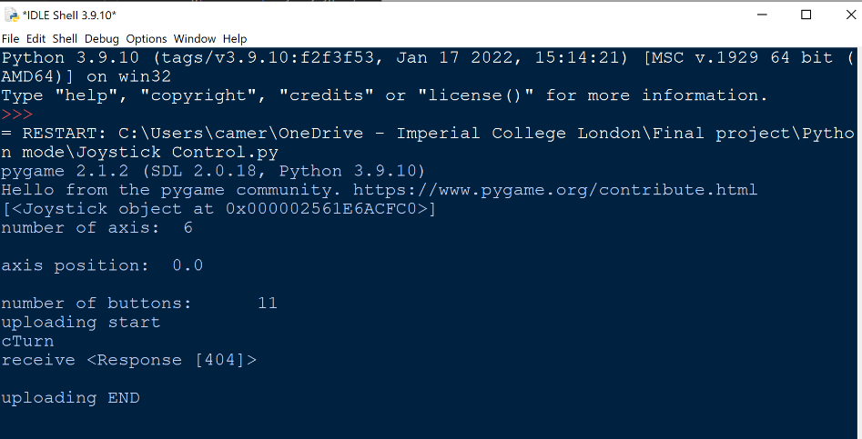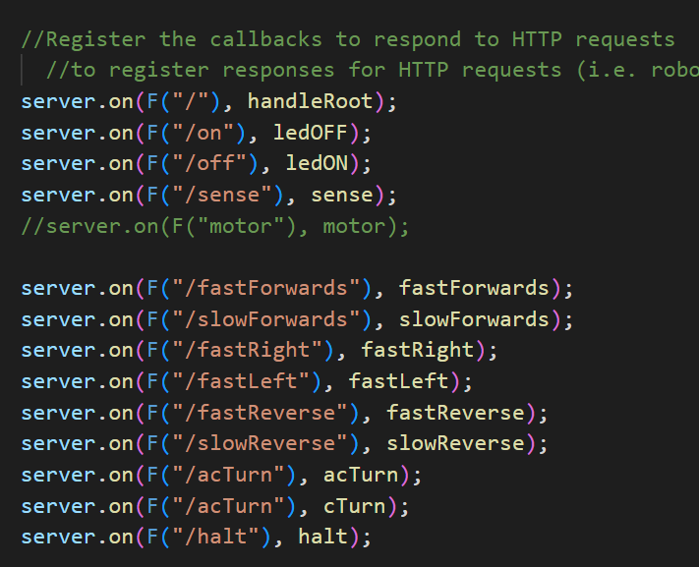

*figure 76 - Arduino python communication error*

Again, the code was not working due to the webpage exceeding the size limit. An attempted solution was to upload the webpage as two parts, unfortunately the issue persisted. As of 18/06/22, this issue is yet to be solved. See in *figure 78*, this was initially attempted within design iteration 1, splitting the document into webpage head, body L & R and script.

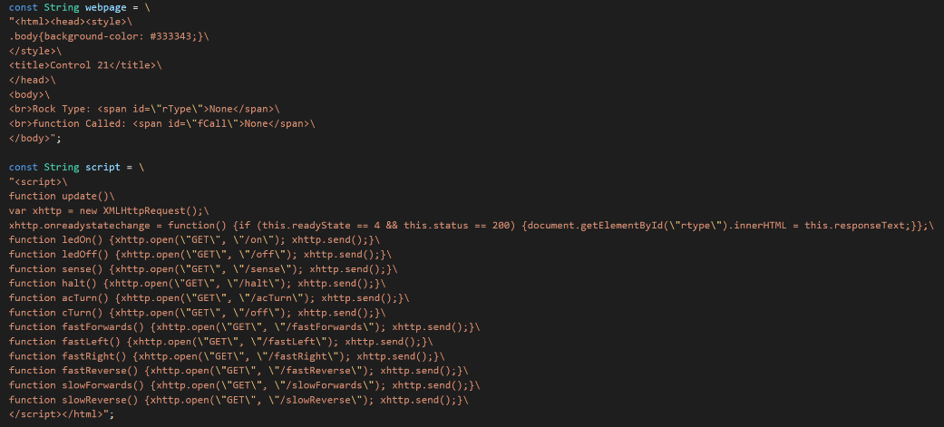

*figure 78 - splitting the webpage into multiple parts*

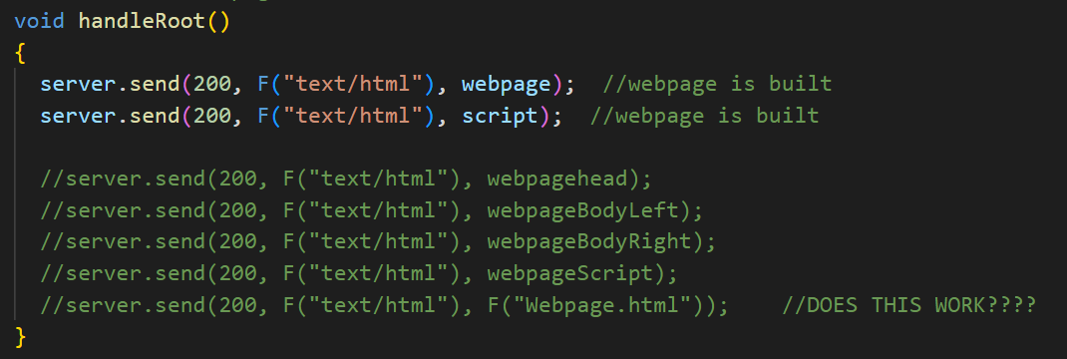

*figure 78 - sending the webpage to the client*

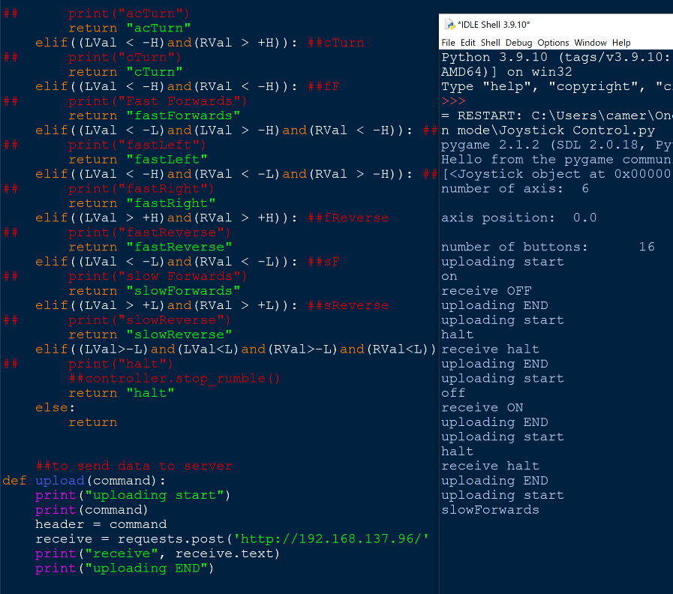

figure 79 - python code no response from server (arduino)

The most recent issue with the code is that when the python communicates with the Arduino, as previously stated, it does not receive a response from any functions other than LEDOn, LEDOff and Halt. This causes the program to await a response until it times out.

The issue as shown in figure 79 is possibly due to the code still exceeding the character limit as shown in *figure 80*. The solution would be to use abbreviations of the function names for HTTP requests, shown in *figure 81*.

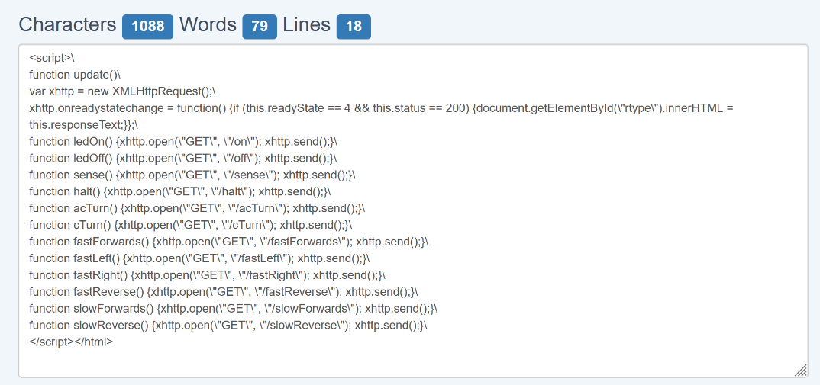

*figure 80 - HTML script length*

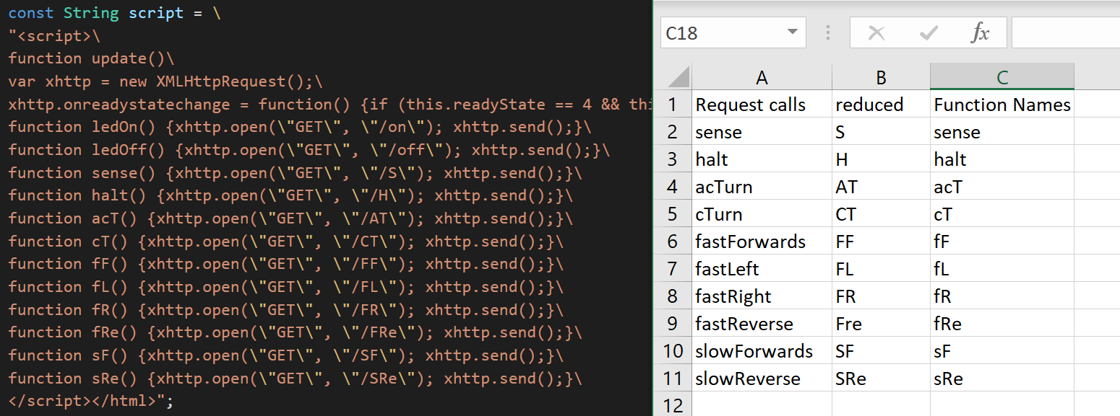

*figure 81 - abbreviated function names*

The abbreviated function names were implemented in the Arduino, HTML, and python code. This fixed this problem which was experienced by reducing the length of the HTML code. For future revisions, UDP will be implemented.

### UDP Implementation

The first revision of the UDP is to establish connection between the client and server (below *figure 82* )

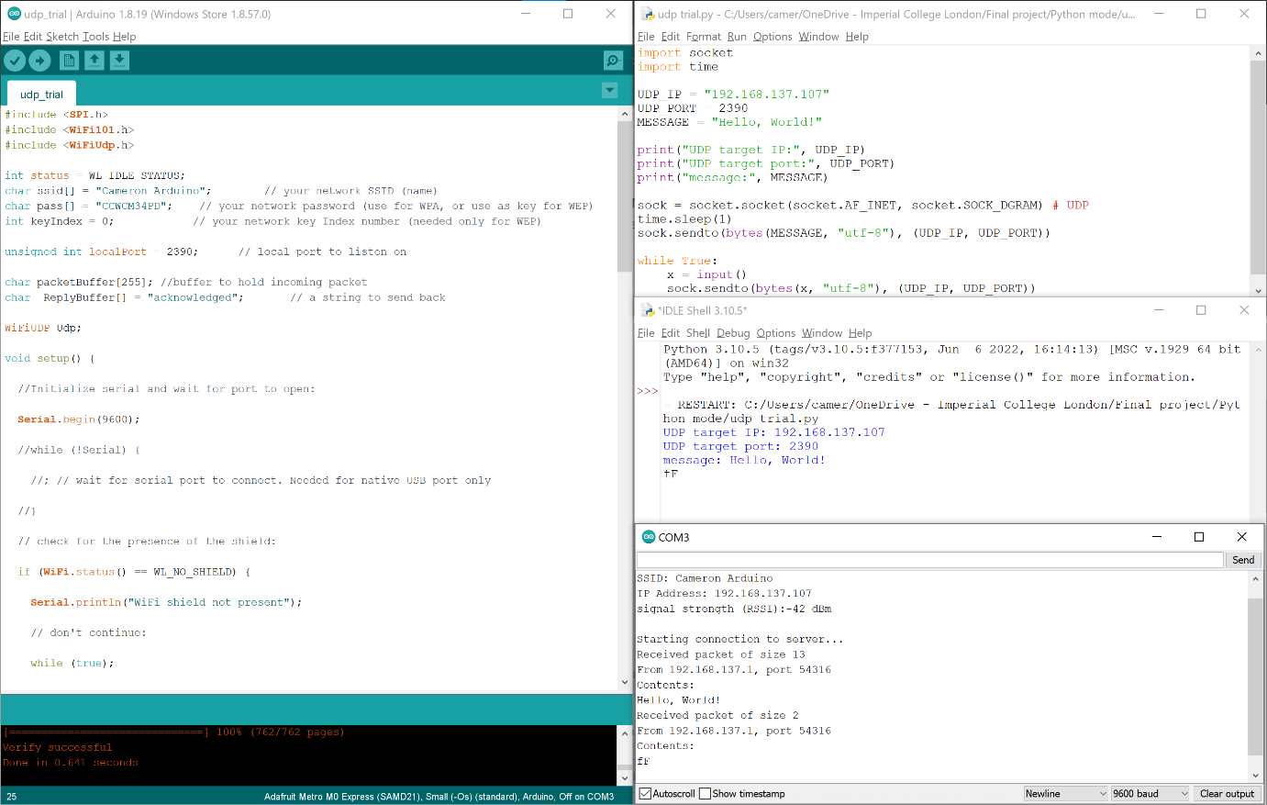

*figure 82 - successful UDP trial*

As shown, the UDP implementation makes use of the ‘WifiUDP’ library. The variable ‘localport’ is used to create the socket on the Arduino for the Python client to connect to and send data to. This was then implemented within the main program, allowing for more seamless rover control. This method over HTTP allows for a greater rate of data transfer, this is due to UDP being connectionless, not requiring acknowledgements as HTTP does. The reduced code is as follows:

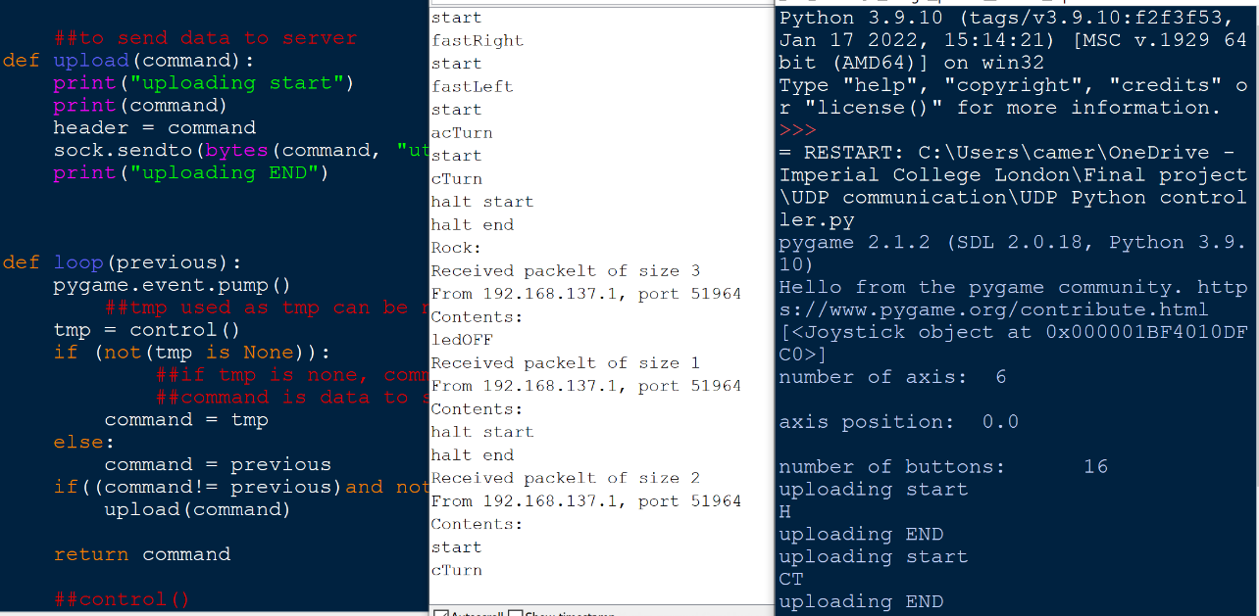

*figure 83: successful UDP implementation*

## Sensor Rock Identification

The functions for the individual sensors have been shown as a flowchart in each of the sensors’ subsections earlier in this document. They all return a number, except in the case of ultrasound which returns true if there is an ultrasound signal detected and false if only background noise is detected. The number returned corresponds to a certain rock shown in *figure 82*.

|  |  |
| --- | --- |
| **Rock Type** | **Rock Number** |
| Gaborium | 1 |
| Lathwaite | 2 |
| Adamantine | 3 |
| Xirang | 4 |
| Thiotimoline | 5 |
| Netherite | 6 |

*figure 84 - rock types*

Each of the sensor functions also uses a combination of the following functions:

* **analogue_average** – returns the average value read by the analogRead() function over 500 samples from a specified pin.
* **analogue_standard_deviation** – returns the standard deviation of 500 samples from a specified pin using the average value and the following formula:
$$σ=\sqrt{\frac{{Σ(x-\overline{x})}^{2}}{n} }$$

* **analogue_frequency** – returns the frequency of the signal on an analogue pin, given the type of signal. The type of signal determines the noise threshold and which pin is used. It determines frequency by checking consecutive points to see if they cross from below to above the average, and how frequently this happens in 500 timed samples.

The flowcharts for each of these functions are included in Appendices B, C, and D respectively.

|  |  |
| --- | --- |
| **Output Number** | **Meaning** |
| -1 | Inconsistent Data |
| 0 | No Rock |
| 1 | Gaborium |
| 2 | Lathwaite |
| 3 | Adamantine |
| 4 | Xirang |
| 5 | Thiotimoline |
| 6 | Netherite |

The final function that determines the rock type is called **identify**. It attempts to identify the rock based on data from all the sensors. It checks if any of the first properties (see *figure 1* for properties) are detected, and if they are, it checks if the second property is also detected. If it is, or if there is no second property, then that rock’s number is returned. If there is an inconsistency, then the rock type is set to -1 and the program attempts to identify the rock again. The maximum number of attempts is five, after which -1 is returned. If nothing is sensed over five attempts, then 0 is returned instead. The flowchart for this function is included in the Appendix E: Identify Algorithm Flowchart.

*figure 85 - identify output table*

# Final Build & Overall Testing

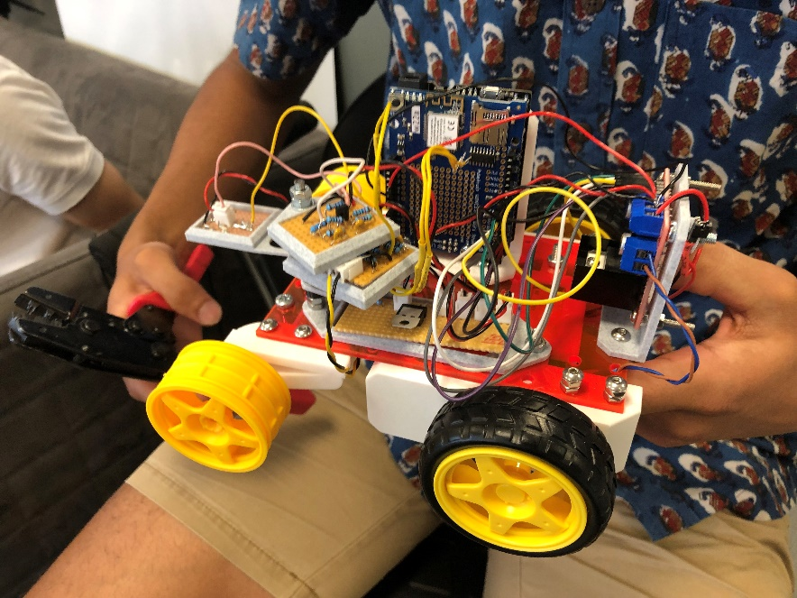

*figure 86 - assembled rover*

Tests were conducted with the rover’s sensors by placing the rock in 4 different locations and testing whether it was able to detect the rock type. The results are shown in *figure 85*.

|  |  |  |  |  |  |
| --- | --- | --- | --- | --- | --- |
| **Position**  **Testing** |  | |  | Left |  |
| **Radio1** | |  |  |  |  |
| **Radio2** | |  |  |  |  |
| **Radio3** | |  |  |  |  |
| **Radio4** | |  |  |  |  |
| **Ultrasound1** | |  |  |  |  |
| **Ultrasound2** | |  |  |  |  |
| **Ultrasound3** | |  |  |  |  |
| **Ultrasound4** | |  |  |  |  |
| **Ultrasound5** | |  |  |  |  |
| **Ultrasound6** | |  |  |  |  |
| **Infrared5** | |  |  |  |  |
| **Infrared6** | |  |  |  |  |
| **Magnetic up** | |  |  |  |  |
| **Magnetic down** | |  |  |  |  |

*figure 87 - individual function testing*

The blue lines on the graphs represent an output of 7, which is the control output that has been set to keep the y-axis of the graphs constant. The red line on the graph represents the testing output, which will change according to the function that is being tested.

For all the detect functions, it is shown that the output is 0 when the rock is not present in the range of the respective sensors. This is expected since nothing significant should be detected.

For the radio detect function, different outputs can be seen depending on the type of rock. The output is 1, 2, 3, 4, with rocks 1, 2, 3 and 4, respectively. The output is similar when the rock is positioned at the left and the right of the sensor. This is the ideal result. However, there are also unexpected drops on the waves. This anomaly will be negated by the identify function, which was explained previously.

For the ultrasound detect function, it is designed as a Boolean function, meaning that the output will be 1 when an ultrasound signal is present, and 0 otherwise. For rocks 1 and 6, The output is 1. This means that it is detecting an ultrasound signal. It also shows the same result when the rock is put on the left and right of the sensor. This result is as expected. For the other 4 types of rocks, it is shown that the output is 0 with occasional random spikes. This anomaly will also be negated by the identify function.

For the infrared detect function, the expected output corresponds to the number of the rock, assigned in *figure 83*. The results show an output of 5 when the rock is set at type 5, and an output of 6 when the rock is set at type 6. It exhibits the same output when the rock is put at the left and right of the sensor. This result is as expected.

For the magnetic detect function, the expected output also corresponds to the assigned number of the rock. When the rock is right below the magnetic sensor, the output is 3 when the magnetic field is pointing up and the output is 4 when the magnetic field is point down. This result is as expected. However, the output is 0 when the rock is moved either to the left or to the right, no matter whether the magnetic field is pointing up or down. An explanation for this is that the sensor is not able to detect the magnetic field when it is not perpendicular to the magnet, or that the magnet is not able to produce a strong enough magnetic field for the sensor to detect in this position.

In conclusion, the results from the testing of the individual functions were as expected, with a few anomalies that will not affect the final result.

The identify function which uses all the sensors to determine the rock type was tested next. The results are shown in *figure 86*.

|  |  |  |  |
| --- | --- | --- | --- |
| Rock Setting | Testing Result | Rock Setting | Testing Result |
| No rock |  | Rock 4 |  |
| Rock 1 |  | Rock 5 |  |
| Rock 2 |  | Rock 6 |  |
| Rock 3 |  |  |  |

*figure 88 - identify function testing*

It is noticeable that there are some spikes in the output of the identify function. It was assumed these are due noise, but the spikes are insignificant to the outcome, as the function is correct the vast majority of the time.

# Conclusions & Future Work

To conclude, the goals set out in the Specification section will be evaluated.

* **Mineral identification:** As outlined above in the Final Build & Overall Testing section, mineral identification could be done reliably and a reasonable distance.
* **Weight and cost effectiveness:** The rover is exceptionally light and weighed around 420g. It was also inexpensive, only costing around £10 to produce.
* **Manoeuvrability:** The rover is manoeuvrable and capable of navigating around large obstacles in order to get to Exorocks due to the high motor voltage supplied by the 9V battery.
* **Robustness and quality:** The rover is durable, as all components are firmly attached to the frame. The main point of failure were the wires, which need to be considered again.
* **Intuitive and easy-to-use remote-control interface:** Since it was decided to use an Xbox controller to operate the rover, the interfacing is very user friendly as most people have previous experience using an Xbox controller before.

For possible future work on the rover, there are a few options, such as:

* **Create a PCB** for all the sensor circuits. The main advantage of a PCB is that they are lighter, more compact, and more durable than circuits made on stripboard, all of which are key factors in a moon rover. An issue was found during testing that the connecting wires were prone to breaking. This was because single core wire had been used, and since they were being twisted frequently, they succumbed to work hardening [12], becoming brittle and eventually breaking. A PCB is one solution to this since it would eliminate the need for so many wires, and therefore points of failure. This could be manufactured in the Advanced Hackspace, or the remainder of the budget could be used to order one from a PCB printing company.
* Another option to fix this issue is to **redo all connections**. More time could be spent on resoldering and re-crimping many of the wires to use multi-strand wire wherever the wire does not have to be single core (such as plugging into the Arduino pins). multistrand wire is more flexible, and a break within one strand does not cause a break in the circuit, thus making it better suited to this purpose. The wires could also be made all exactly the right lengths which would make the rover more visually appealing and easier to maintain and fix.
* As was mentioned in the Battery section, **the non-rechargeable 9V battery should be replaced** with a more environmentally friendly option, such as a lithium-ion or lithium polymer battery. These offer desirable advantages, as previously mentioned, at the cost of being more expensive and hazardous to handle.
* As mentioned in the Motor Driver section, the specifications of the L298N are excessive for how they have been utilised in the rover. A **smaller motor driver** such as the MX1508 [13] could be used to save space and weight on the rover, while keeping the performance similar.
* The current rover uses the standard large yellow wheels that introduce a great source of friction. This affects the manoeuvrability of the rover, preventing it from being able to make turns with small radii. It also means that the front non driven wheels are dragged when making the drive motors turn in opposite directions. One solution for the latter issue would to be use a timing belt or front axle with differential to also drive the front wheels, however this would add weight, cost, and another point of failure. As the rover does not require the extra friction provided by large wheels (especially as the only benefit of thicker non driven wheels would be for stability), a suitable solution would be to **3D print omni-wheels**, allowing the driven wheels to turn the rover unimpeded.

# Bill of Materials

Electronics:

|  |  |
| --- | --- |
| Quantity | Description |
| 2 | Adafruit metro express |
| 3 | Stripboard |
| 2 | 9V alkaline battery [8] |
| 1 | 1 nF ceramic capacitor |
| 1 | 1.5 nF ceramic capacitor |
| 1 | 4.7 nF ceramic capacitor |
| 1 | 10 nF ceramic capacitor |
| 5 | 100 nF ceramic capacitor |

|  |  |
| --- | --- |
| 1 | Diode |
| 1 | L298N Motor Driver [11] |
| 2 | 4.7 mH inductor |
| 1 | OP593 IR Phototransistor [4] |
| 1 | BC337-40 NPN transistor [14] |
| 2 | BC337-25 NPN transistor [14] |
| 1 | 50 Ω resistor |
| 6 | 1 kΩ resistor |
| 4 | 10 kΩ resistor |
| 1 | 12 kΩ resistor |
| 2 | 36 kΩ resistor |
| 1 | 51 kΩ resistor |
| 1 | 62 kΩ resistor |
| 1 | 120 kΩ resistor |
| 2 | 160 kΩ resistor |
| 2 | R40-16 Ultrasound sensor [6] |
| 1 | AH49E linear Hall effect sensor [7] |
| 2 | Motor |

Mechanical:

|  |  |
| --- | --- |
| Quantity | Description |
| 1 | Arduino mount |
| 2 | Axle |
| 3 | Amplifier tray |
| 1 | Battery holder |
| 1 | Magnetic & IR sensor holder |
| 2 | Motor casing |
| 2 | Idler |
| 1 | Motor driver mount |
| 17 | M3 nut |
| 1 | Power board tray |
| 25 | M3 bolt |
| 4 | Tyre |
| 1 | Ultrasound & radio sensor holder |
| 4 | Wheel |

# Appendices

## Text Description automatically generatedAppendix A: Project Brief

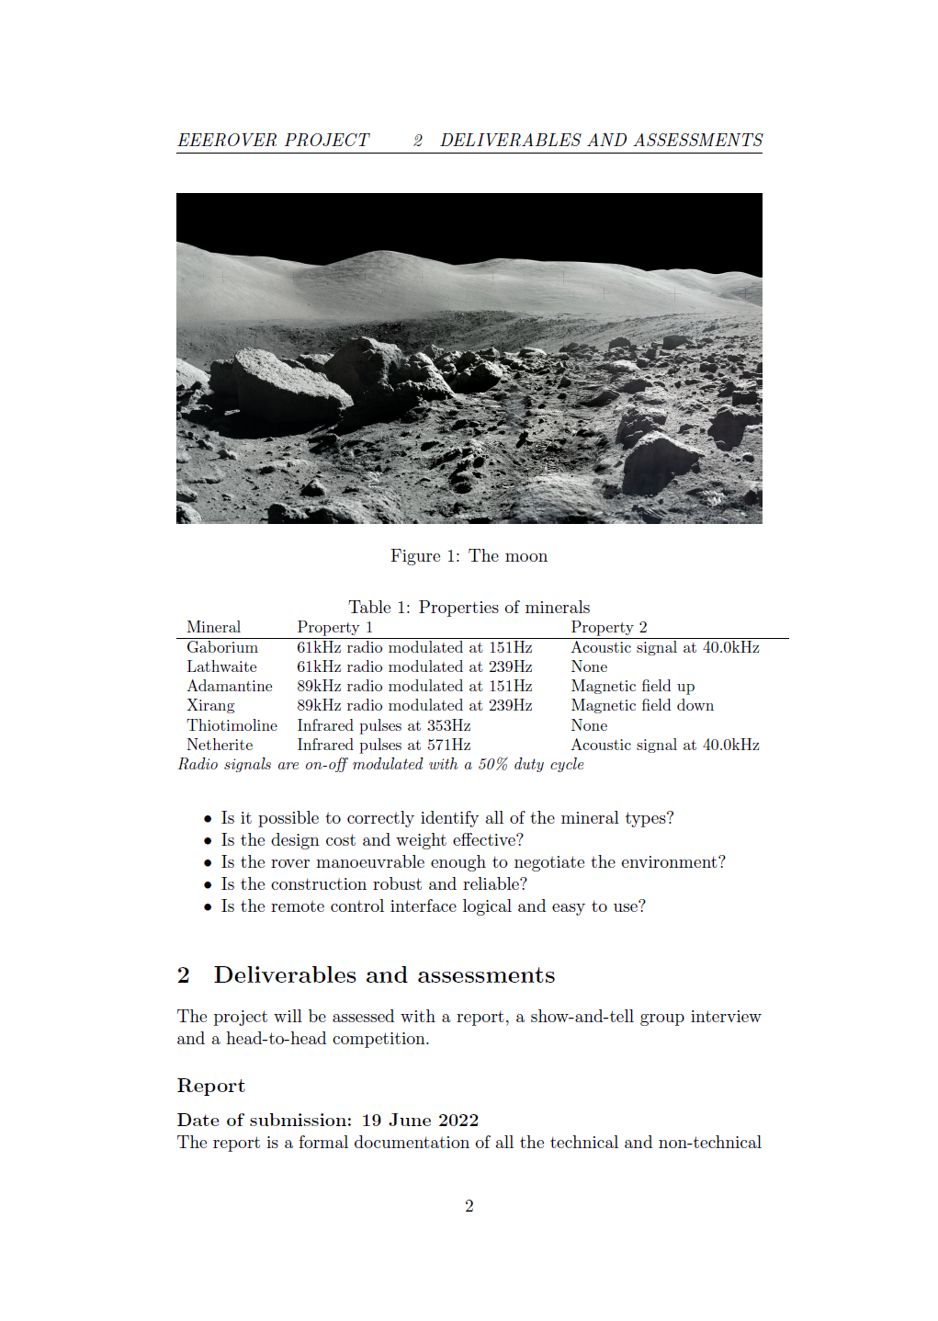

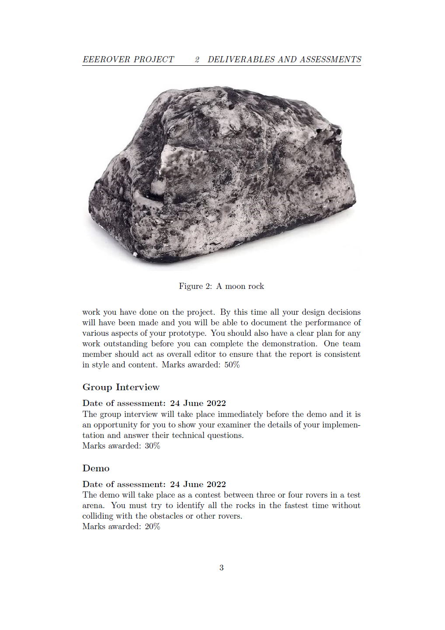

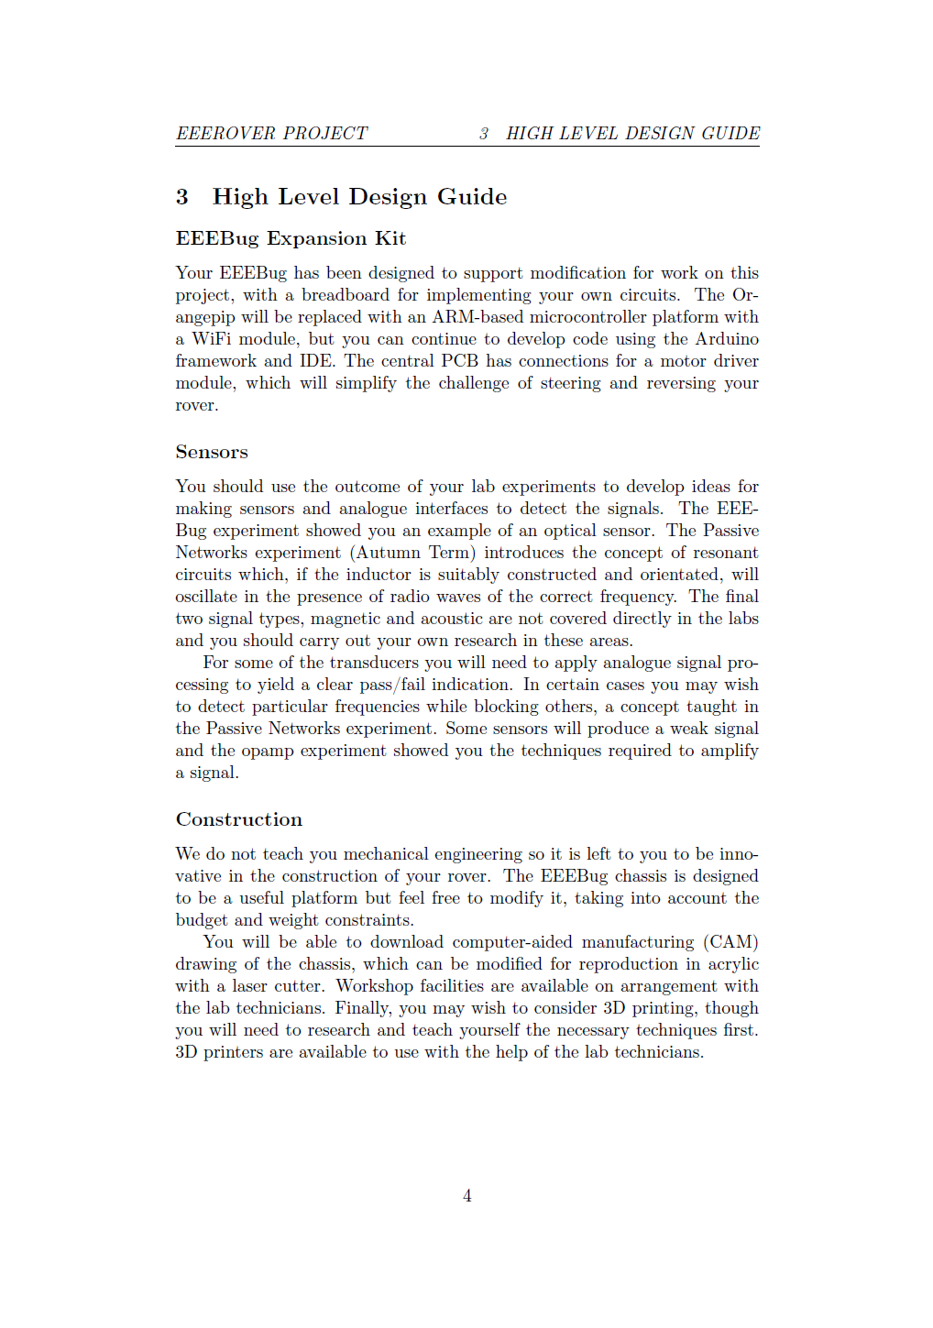

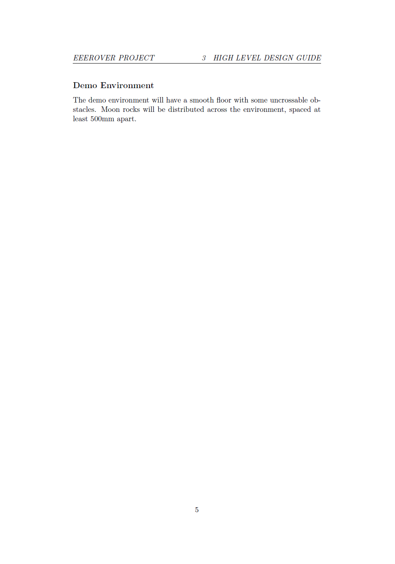

## Appendix B: analogue_average Flowchart

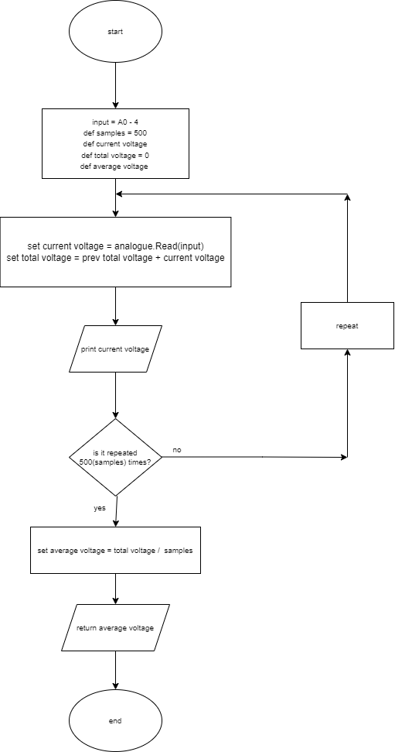

## Appendix C: analogue_standard_deviation Flowchart

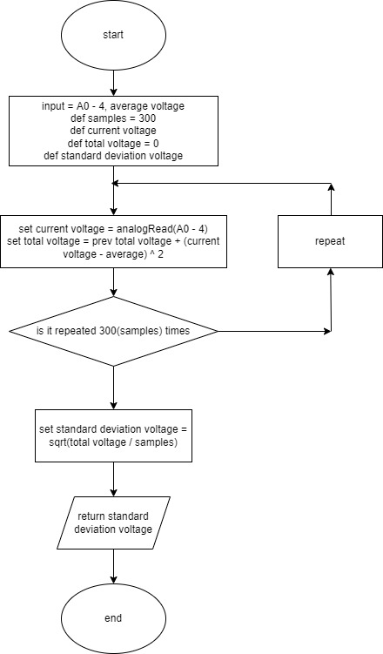

## Appendix D: analogue_frequency Flowchart

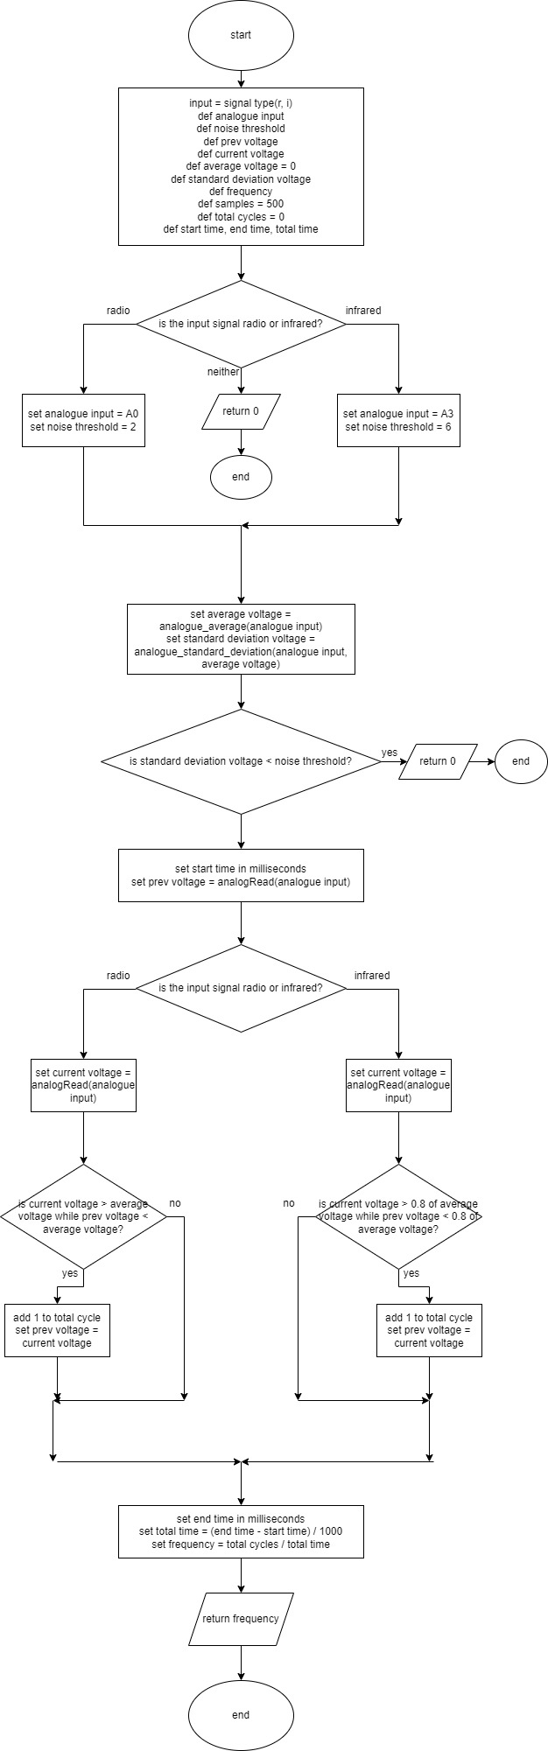

## Appendix E: Identify Algorithm Flowchart

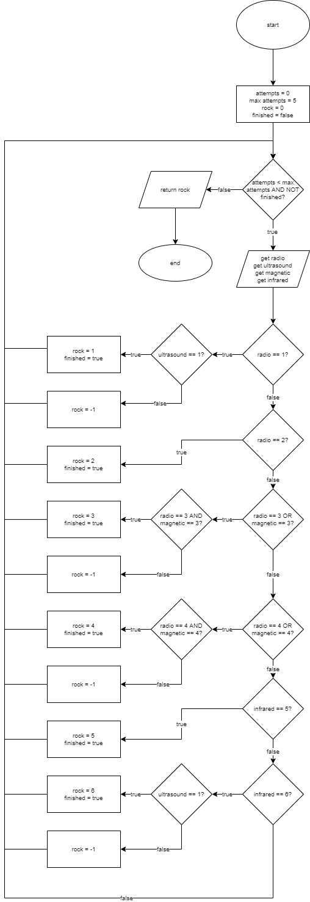

# Bibliography

|  |  |
| --- | --- |
| [1] | E. Stott, “GitHub - Technical Guide,” May 2022. [Online]. Available: https://github.com/edstott/EEERover/blob/main/doc/README.md. |
| [2] | “When2meet,” 8 degrees, LLC, [Online]. Available: https://www.when2meet.com/?About. [Accessed 14 5 22]. |
| [3] | Vertex42, “Simple Gantt Chart,” Vertex42, 12 3 2021. [Online]. Available: https://www.vertex42.com/ExcelTemplates/simple-gantt-chart.html. [Accessed 16 5 2022]. |
| [4] | TT Electronics, *NPN Plastic Silicon Phototransistor,* 2019. |
| [5] | K. K. Leung, *EE1: Introduction to Signals and Communications [Lecture],* p. 33. |
| [6] | Waitrony Company Limited, *Ultrasonic Transducer.* |
| [7] | AZ-Delivery, *KY-035 Hall Sensor Magnetisch Modul (analog) Datenblatt.* |
| [8] | Amazon, [Online]. Available: https://www.amazon.co.uk/AmazonBasics-Everyday-Alkaline-Batteries-4-Pack/dp/B0774D64LT/ref=sr_1_6?keywords=9v%2Bbattery&qid=1655560658&sprefix=9v%2Caps%2C64&sr=8-6&th=1. [Accessed 18 6 2022]. |
| [9] | S. Emerson, “OneZero,” 30 10 2019. [Online]. Available: https://onezero.medium.com/unraveling-the-secret-supply-chain-behind-an-amazonbasics-battery-e7b9ead4d72e. [Accessed 17 6 2022]. |
| [10] | SG-Freak, “GrabCAD,” 27 2 2018. [Online]. Available: https://grabcad.com/library/9-volt-block-batteriehalter-kl-pp-1. [Accessed 11 6 2022]. |
| [11] | Handson Technology, *L298N Dual H-Bridge Motor Driver.* |
| [12] | The Editors of Encyclopaedia Britannica, “Britannica,” Encyclopedia Britannica, 4 2 2020. [Online]. Available: https://www.britannica.com/technology/work-hardening. [Accessed 17 6 2022]. |
| [13] | H. Trolove, “www.techmonkeybusiness.com,” Tech Monkey Business, 4 2018. [Online]. Available: https://components101.com/sites/default/files/component_datasheet/MX1508-DC-Motor-Driver-Datasheet.pdf. [Accessed 18 6 2022]. |
| [14] | ON Semiconductor, “BC337 Datasheet,” ON Semiconductor, 11 2013. [Online]. Available: https://www.onsemi.com/pdf/datasheet/bc337-d.pdf. [Accessed 18 6 2022]. |

# Table of Figures

*figure 1 - rock properties* [1] 1

[*figure 2 - contents of expansion kit* 4](https://imperiallondon-my.sharepoint.com/personal/mhy21_ic_ac_uk/Documents/report%2017%206%2022.docx#_Toc106570580)

[*figure 3 - motor schematic* 4](https://imperiallondon-my.sharepoint.com/personal/mhy21_ic_ac_uk/Documents/report%2017%206%2022.docx#_Toc106570581)

[*figure 5 – When2meet table* 5](https://imperiallondon-my.sharepoint.com/personal/mhy21_ic_ac_uk/Documents/report%2017%206%2022.docx#_Toc106570582)

[*figure 4 - project management Gantt chart* 5](https://imperiallondon-my.sharepoint.com/personal/mhy21_ic_ac_uk/Documents/report%2017%206%2022.docx#_Toc106570583)

*figure 6 - OP593 infrared phototransistor* [4] 6

*figure 7 - wavelength response curve from OP593 datasheet* [4] 6

*figure 8 - sensor circuit, the NPN transistor represents OP593 in this case* 7

*figure 9 - test with bare signal source* 7

*figure 10 - testing result, 4.245V amplitude and 577Hz frequency* 7

*figure 11 - the rock shell, the circled areas are more transparent* 8

*figure 12 - testing result, signal with 81.58mV amplitude and 563.2Hz frequency* 8

*figure 13 - the amplification circuit for IR detection* 9

*figure 14 - simulation result, about 25dB at the signal frequency* 9

*figure 15 - test using IR sensor after amplification* 9

*figure 16 - testing result, signal with 305.4mV amplitude and 577.1Hz frequency* 10

*figure 17 - the mount of IR and magnetic sensor* 10

*figure 18 - flow chart for IR_detection* 11

*figure 19 - initial radio circuit* 12

*figure 20 - tuning circuit frequency response curves* 13

*figure 21 - CE amplifier* 13

*figure 22 – Lecture Slide* [5] 14

*figure 23 - demodulated 250Hz signal modulated at 61kHz carrier* 14

*figure* 24 *- demodulated 250Hz signal modulated at 89kHz carrier* 14

[*figure 25 - radio circuit on stripboard* 15](https://imperiallondon-my.sharepoint.com/personal/mhy21_ic_ac_uk/Documents/report%2017%206%2022.docx#_Toc106570603)

[*figure 26 - final radio circuit* 15](https://imperiallondon-my.sharepoint.com/personal/mhy21_ic_ac_uk/Documents/report%2017%206%2022.docx#_Toc106570604)

[*figure 27 - radio_detect flowchart* 16](https://imperiallondon-my.sharepoint.com/personal/mhy21_ic_ac_uk/Documents/report%2017%206%2022.docx#_Toc106570605)

[*figure 28 - 239Hz signal modulated at 89kHz* 17](https://imperiallondon-my.sharepoint.com/personal/mhy21_ic_ac_uk/Documents/report%2017%206%2022.docx#_Toc106570606)

[*figure 29 - 151Hz signal modulated at 61kHz* 17](https://imperiallondon-my.sharepoint.com/personal/mhy21_ic_ac_uk/Documents/report%2017%206%2022.docx#_Toc106570607)

[*figure 30 - radio sensor next to the Exorock* 17](https://imperiallondon-my.sharepoint.com/personal/mhy21_ic_ac_uk/Documents/report%2017%206%2022.docx#_Toc106570608)

*figure 31 – Metro output* 17

figure 32 - R40-16 ultrasound sensor 18

*figure 33 - sensitivity frequency relationship form R40-16 datasheet* [6] 18

*figure 34 - test with bare signal source* 18

*figure 35 - the result waveform with 48.64mV amplitude and 40kHz frequency* 19

*figure 36 - test with signal source covered with rock shell* 19

[*figure 37 - simulation result at 40kHz* 19](https://imperiallondon-my.sharepoint.com/personal/mhy21_ic_ac_uk/Documents/report%2017%206%2022.docx#_Toc106570615)

[*figure 38 - ultrasonic sensor CE amplifier circuit built in LTSpice* 19](https://imperiallondon-my.sharepoint.com/personal/mhy21_ic_ac_uk/Documents/report%2017%206%2022.docx#_Toc106570616)

*figure 39 - test with bare signal source using amplification circuit and two R40-16s in parallel* 20

*figure 40 - test results after amplification without the rock shell* 20

*figure 41 - test results after amplification with the rock shell* 20

*figure 42 - left picture shows a CAD model of the holder; the right picture shows the actual 3D printed version* 21

*figure 43 - flow chart for ultrasonic_detect function* 21

*figure 44 - pin configuration of AH49E* [7] 22

[*figure 45 - the stripboard containing the IR sensor and the hall effect sensor* 22](https://imperiallondon-my.sharepoint.com/personal/mhy21_ic_ac_uk/Documents/report%2017%206%2022.docx#_Toc106570623)

[*figure 46 - magnet in the Exorock, oriented with the magnetic field down* 22](https://imperiallondon-my.sharepoint.com/personal/mhy21_ic_ac_uk/Documents/report%2017%206%2022.docx#_Toc106570624)

[*figure 47 - magnet in the Exorock, oriented with the magnetic field up* 23](https://imperiallondon-my.sharepoint.com/personal/mhy21_ic_ac_uk/Documents/report%2017%206%2022.docx#_Toc106570625)

*figure 48 - magnetic rock identifier* 23

[*figure 49 - battery holder on rover* 24](https://imperiallondon-my.sharepoint.com/personal/mhy21_ic_ac_uk/Documents/report%2017%206%2022.docx#_Toc106570627)

[*figure 50 - battery holder CAD* 24](https://imperiallondon-my.sharepoint.com/personal/mhy21_ic_ac_uk/Documents/report%2017%206%2022.docx#_Toc106570628)

[*figure 51 - power distribution board top* 25](https://imperiallondon-my.sharepoint.com/personal/mhy21_ic_ac_uk/Documents/report%2017%206%2022.docx#_Toc106570629)

[figure 52 - power distribution board underside 25](https://imperiallondon-my.sharepoint.com/personal/mhy21_ic_ac_uk/Documents/report%2017%206%2022.docx#_Toc106570630)

*figure 53 -Arduino TT motor* 25

*figure 54 - L298N motor driver pinout* [11] 26

*figure 55 - chassis frame 1st design* 27

*figure 56 - chassis hull* 28

*figure 57 - chassis 2nd design* 28

[*figure 58 - front wheel mount* 29](https://imperiallondon-my.sharepoint.com/personal/mhy21_ic_ac_uk/Documents/report%2017%206%2022.docx#_Toc106570636)

[*figure 59 - lower rectangle 100mm x 140mm, 7 x 10 holes* 29](https://imperiallondon-my.sharepoint.com/personal/mhy21_ic_ac_uk/Documents/report%2017%206%2022.docx#_Toc106570637)

[*figure 60 - wheel axel 17 x 4.81 mm diameter* 29](https://imperiallondon-my.sharepoint.com/personal/mhy21_ic_ac_uk/Documents/report%2017%206%2022.docx#_Toc106570638)

[*figure 61 - upper rectangle 70mm x 80mm, 6 x 5 holes* 29](https://imperiallondon-my.sharepoint.com/personal/mhy21_ic_ac_uk/Documents/report%2017%206%2022.docx#_Toc106570639)

[*figure 62 - underside battery holder mount* 29](https://imperiallondon-my.sharepoint.com/personal/mhy21_ic_ac_uk/Documents/report%2017%206%2022.docx#_Toc106570640)

[*figure 63 - base design with standard mounting points* 30](https://imperiallondon-my.sharepoint.com/personal/mhy21_ic_ac_uk/Documents/report%2017%206%2022.docx#_Toc106570641)

[*figure 64 - motor mount (left) and idler (right)* 30](https://imperiallondon-my.sharepoint.com/personal/mhy21_ic_ac_uk/Documents/report%2017%206%2022.docx#_Toc106570642)

[*figure 65 – 3D printed "staircase" amplification board mount* 30](https://imperiallondon-my.sharepoint.com/personal/mhy21_ic_ac_uk/Documents/report%2017%206%2022.docx#_Toc106570643)

*figure 66 - CAD drawing used to ensure correct sensor placement* 31

[*figure 69 - fully assembled rover in CAD* 31](https://imperiallondon-my.sharepoint.com/personal/mhy21_ic_ac_uk/Documents/report%2017%206%2022.docx#_Toc106570645)

[*figure 67 - 3d printed bracket for the power board* 31](https://imperiallondon-my.sharepoint.com/personal/mhy21_ic_ac_uk/Documents/report%2017%206%2022.docx#_Toc106570646)

[*figure 68 - vertically mounted control boards, Arduino (left) and motor driver (right)* 31](https://imperiallondon-my.sharepoint.com/personal/mhy21_ic_ac_uk/Documents/report%2017%206%2022.docx#_Toc106570647)

[*figure 70 – initial UI design* 32](https://imperiallondon-my.sharepoint.com/personal/mhy21_ic_ac_uk/Documents/report%2017%206%2022.docx#_Toc106570648)

[*figure 71 - UI design* 32](https://imperiallondon-my.sharepoint.com/personal/mhy21_ic_ac_uk/Documents/report%2017%206%2022.docx#_Toc106570649)

*figure 72 - UI design implementation* 33

[*figure 73 - Xbox controller example* 34](https://imperiallondon-my.sharepoint.com/personal/mhy21_ic_ac_uk/Documents/report%2017%206%2022.docx#_Toc106570651)

[*figure 74 – Python http testing* 34](https://imperiallondon-my.sharepoint.com/personal/mhy21_ic_ac_uk/Documents/report%2017%206%2022.docx#_Toc106570652)

[*figure 75 - joystick control testing results* 34](https://imperiallondon-my.sharepoint.com/personal/mhy21_ic_ac_uk/Documents/report%2017%206%2022.docx#_Toc106570653)

[*figure 76 - Arduino python communication error* 35](https://imperiallondon-my.sharepoint.com/personal/mhy21_ic_ac_uk/Documents/report%2017%206%2022.docx#_Toc106570654)

[*figure 78 - splitting the webpage into multiple parts* 35](https://imperiallondon-my.sharepoint.com/personal/mhy21_ic_ac_uk/Documents/report%2017%206%2022.docx#_Toc106570655)

[*figure 78 - sending the webpage to the client* 35](https://imperiallondon-my.sharepoint.com/personal/mhy21_ic_ac_uk/Documents/report%2017%206%2022.docx#_Toc106570656)

[figure 79 - python code no response from server (arduino) 35](https://imperiallondon-my.sharepoint.com/personal/mhy21_ic_ac_uk/Documents/report%2017%206%2022.docx#_Toc106570657)

[*figure 80 - HTML script length* 36](https://imperiallondon-my.sharepoint.com/personal/mhy21_ic_ac_uk/Documents/report%2017%206%2022.docx#_Toc106570658)

[*figure 81 - abbreviated function names* 36](https://imperiallondon-my.sharepoint.com/personal/mhy21_ic_ac_uk/Documents/report%2017%206%2022.docx#_Toc106570659)

[*figure 82 - successful UDP trial* 38](https://imperiallondon-my.sharepoint.com/personal/mhy21_ic_ac_uk/Documents/report%2017%206%2022.docx#_Toc106570660)

*figure 83 - rock types* 39

*figure 84 - identify output table* 39

*figure 85 - assembled rover* 40

*figure 86 - individual function testing* 41

*figure 87 - identify function testing* 43